1 - 3 Ring Zip Up Binder
2 - Packets of Wide Rule Notebook paper
1 - Centimeter Paper (Graph Paper)
2 - Sets of 5 Dividers
1 - Zip Up Pencil Bag
1 - Box of #2 Pencils
2 - Pink Erasers
1 - Hand Held Pencil Sharpener
1- Pack of Map Colors
1 - Ruler (inchers and centimeters)
1 - Pair of Scissors
6 - Composition Tablets
1 - Black Marble Journal for Science
1 - Pack of Red checking pens
4 - Containers of Clorox Disinfecting Wipes
2 - Boxes of Tissue
1 - Box of Quart Ziploc Bags
1 - Box of Gallon Ziploc Bags
6 - Sheet Protectors
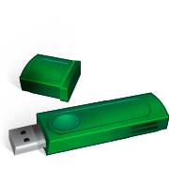
1 - Set of Ear phones for computer
1 - USB Flash Drive

