2016-2017 Pre-Kindergarten School Supply List

- BOX OF CRAYONS 24 CT
2 GLUE STICKS 0.32 OZ.
- KLEENEX 100 CT
- ZIPLOC BAGS GALLON SIZE – 20 CT
- ANTIBACTERIAL LIQUID HAND SOAP W/PUMP
- CLOROX WIPES
1 SCISSORS BLUNT TIP (If your child is left handed, PLEASE purchase left handed scissors)
1 1” REST MAT QUAD FOLD 48X21
1 ASST. PLASTIC POCHET ONLY FOLDER
1 BABYWIPES SOFT PACK 80 CT
1 12X18 CONTRUCTION PAPER 50 CT
1 EARBUD HEAD PHONES

The classroom community will share all supplies.
Note: Please send a complete change of clothes in a Ziploc bag labeled with your child’s first and last name. (pants, shirt, socks, and underwear)

2016-2017 Kindergarten School Supply List

24 NO 2 PRESHARPENED YELLOW PENCIL
2 BOX OF CRAYONS 24 CT
6 GLUE STICKS 0.32 OZ
1 KLEENEX 100 CT
- EXPO BLACK CHISEL TIP DRY ERASE MARKER
1 PACK (REAM) WHITE COPY PAPER
- ZIPLOC BAGS QUART SIZE 25 CT
- ZIPLOC BAGS GALLON SIZE 20 CT
- ANTIBACTERIAL LIQUID HAND SOAP
2 CLOROX WIPES 35 CT
1 LARGE BACKPACK – NON-ROLLING
1 SCISSORS BLUNT TIP (If your child is left handed, PLEASE purchase left handed scissors)
2 PINK BEVEL ERASER
1 NOTEBOOK – (red baseline with dotted midline and space on top to draw a picture (see image below) If you can’t find the first one, the other notebook pictured is okay.)

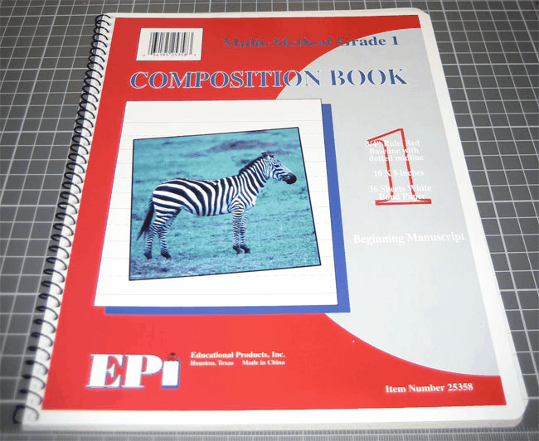
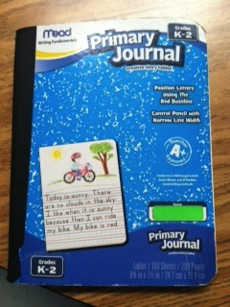

The classroom community will share all supplies.
Note: Please send a complete change of clothes in a Ziploc bag labeled with your child’s first and last name. (pants, shirt, socks, and underwear)

  - 1st Grade School Supply List

- 8x10 ¾” SPIRAL NOTEBOOK RED BL RED MARGIN 36CT
- 8X10 ½” RULED SPIRAL NOTEBOOK RED BL 36 CT
- WIDE RULE BLACK MARBLE COMP BOOK 100CT
- NO2 PENCIL
- 1” BLACK HARDBACK VINYL BINDER
- EXPO BLACK CHISEL TIP DRY ERASE MARKER
- 5 TAB MULTI COLORED INDEX PAPER DIVIDERS
- KLEENEX 100 CT
- PINK BEVEL ERASER
- PENCIL CAP ERASERS
- 7” PRESHARPENED COLORED PENCILS 12 CT
- SHARP 5” SCISSORS
- ASST POCKET AND BRAD FOLDER
- GLUE STICKS 0.32 OZ
- 9X12 CONSTRUCTION PAPER 50 CT
- 9x12 MANILA PAPER 50 CT
- ZIPLOC BAGS QUART SIZE 25 CT
- ZIPLOC BAGS GALLON SIZE 20 CT
- ASST PLASTIC SCHOOL BOX
- BOX OF CRAYONS 24 CT
- ANTIBACTERIAL LIQUID HAND SOAP
2 CLOROX WIPES 35 CT
- BABYWIPES SOFT PACK 80 CT
- EARBUDS HEAD PHONES

  - 2nd Grade School Supply List

24 NO 2 PRESHARPENED YELLOW PENCIL
- 7” PRESHARPENED COLORED PENCILS 12 CT
- PINK BEVEL ERASER
- WIDE RULE BLACK MARBLE COMP BOOK 100CT
- MEAD 8X10 ½” SPIRAL NOTEBOOK 5X5 GRAPH 100CT
- KLEENEX 100 CT
- ASSORTED POCKET ONLY FOLDER
- WIDE RULE 8X10 ½” FILLER PAPER 120CT
- GLUE STICKS 0.32 OZ
- 9X12 ASST CONSTRUCTION PAPER 50 CT
- CLOROX WIPES 35 CT
- ANTIBACTERIAL LIQUID HAND SOAP
- ZIPLOC BAGS GALLON SIZE 20 CT
- ZIPLOC BAGS QUART SIZE 25 CT
- BOX OF CRAYONS 16 CT
- 9x12 MANILA PAPER 50 CT
- 9x12¾” MCL TABLET K-1ST GRADE
- BLUNT 5” SCISSORS
- EXPO BLACK CHISEL TIP DRY ERASE MARKER
- EARBUDS HEAD PHONES

2016-2017 3rd Grade School Supply List

- SPIRAL NON-PREF RED WIDE RULE NOTEBOOK 70CT
- SPIRAL NON-PREF WIDE RULE NOTEBOOK 70CT
- RED POCKET AND BRAD FOLDER
- BLUE POCKET AND BRAD FOLDER
- YELLOW POCKET AND BRAD FOLDER
- GREEN POCKET AND BRAD FOLDER
- PURPLE POCKET AND BRAD FOLDER
- 7MM MECHANICAL PENCIL
- WIDE RULE 8X10½” FILLER PAPER 120CT
- 7” PRESHARPENED COLORED PENCILS 12 CT
- 1.5” HARDBACK VINYL BINDER
- 3” HARDBACK VINYL BINDER
- PAPER TOWELS 85 CT
- KLEENEX 100 CT
- GLUE STICKS 0.32 OZ
- SHARP 5” SCISSORS
- PENCIL SHARPENER W/ RECEPTACLE
- 12” 1/16” STANDARD / METRIC PLATIC RULER
- ZIPLOC BAGS QUART SIZE 25 CT
- SINGLE HIGHLIGHTER IN ASSORTED COLORS
- 9X12 ASST CONSTRUCTION PAPER 50 CT
- 3X5 RULED WHITE INDEX CARDS 100CT
- MANILA 1/3 CUT LETTER SIZE FILE FOLDERS
- ANTIBACTERIAL LIQUID HAND SOAP
- CLOROX WIPES 35 CT
- PINK BEVEL ERASER
- PENCIL CAP ERASERS
- NO 2 PRESHARPENED PENCIL
- GRAPH FILLER PAPER 4 SQUARES/INCH W/ HOLES 50CT
- 8X10½ SPITAL 4X4 GRAPH PAPER 100CT
- BOX OF CRAYONS 24 CT
- EARBUDS HEAD PHONES

2016-2017 4th Grade School Supply List

- NYLON PENCIL BAG, CLEAR TOP W/ GROMT 7¼X10¼
- PENCIL SHARPENER W/ RECEPTACLE
- NO 2 PRESHARPENED PENCIL
- 7” PRESHARPENED COLORED PENCILS 12 CT
- PINK BEVEL ERASER
- PENCIL CAP ERASERS
- EXPO BLACK CHISEL TIP DRY ERASE MARKER
- FLUORESCENT YELLOW HIGHLIGHTER
- RED MEDIUM PEN
- 1” HARDBACK VINYL BINDER
- 5 TAB MULTI COLORED INDEX PAPER DIVIDERS
- YELLOW POCKET AND BRAD FOLDER
- BLUE POCKET AND BRAD FOLDER
- GREEN POCKET AND BRAD FOLDER
- SPIRAL NON-PREF WIDE RULE NOTEBOOK 70CT
- 8X10½ SPITAL 4X4 GRAPH PAPER 100CT
- CENTIMETER SQUARE GRAPH PAPER 100CT
- 9X12 ASST CONSTRUCTION PAPER 50 CT
- 4X6 RULED WHITE INDEX CARDS 100CT
- 3X3 PASTEL POST IT NOTES 4/50 SHEET PADS
- KLEENEX 100 CT
- GLUE STICKS 0.32 OZ
- PAPER TOWELS 85 CT
- BOX OF RECLOSEABLE SANDWICH BAGS 50CT
- 12” 1/16” STANDARD / METRIC PLATIC RULER
- ANTIBACTERIAL LIQUID HAND SOAP
- CLOROX WIPES 35 CT
- EARBUDS HEAD PHONES

2016-2017 5th Grade School Supply List

- NO 2 PRESHARPENED PENCIL
- 2” HARDBACK HEAVY DUTY D-RING BINDER
- 8 TAB MULTI COLORED INDEX PAPER DIVIDERS
- 8X10½ SPITAL 4X4 GRAPH PAPER 100CT
- WIDE RULE BLACK MARBLE COMP BOOK 100CT
- PENCIL CAP ERASERS
- 12” 1/16” STANDARD / METRIC PLATIC RULER
- 6” PROTRACTOR - CLEAR
- GREEN PLASTIC POCKET AND BRAD FOLDER
- BLUE PLASTIC POCKET AND BRAD FOLDER
- ORANGE PLASTIC POCKET AND BRAD FOLDER
- 8 1/2x11 TOP LOAD CLEAR SHEET PROTECTOR
- 4OZ ELMER’S GLUE
- EXPO BLACK CHISEL TIP DRY ERASE MARKER
- COLOR FINE TIP DRY ERASE MARKER
- 7” PRESHARPENED COLORED PENCILS 12 CT
- FLUORESCENT YELLOW HIGHLIGHTER
- 8X10½ COLLEGE RULE FILLER PAPER 200CT
- 9X12 ASST CONSTRUCTION PAPER 50 CT
- SHARP 5” SCISSORS
- WATERLESS HAND SANITIZER W/ PUMP 8OZ
- CLOROX WIPES 35 CT
- KLEENEX 100 CT
- ZIPLOC BAGS QUART SIZE 25 CT
- ZIPLOC BAGS GALLON SIZE 20 CT
- EARBUDS HEAD PHONES

