Objective Sheet: Eating – Name ______________________
Chapters 12, 16 & 20 Date _______________ Period __

- Describe the problem, consequence and possible solutions to Colony Collapse Disorder in the US commercial bee population.

- What five factors determine whether a dose of a toxin is harmful?
- What is the difference between water-soluble toxins and fat-soluble toxins?
- What is the difference between bioaccumulation and biomagnification?
- Contrast anatagonistic chemical interactions with synergistic interactions.
- What is the difference between an acute effect and a chronic effect?
- Describe three ways the human body protects itself from harmful toxins or effects.
- What is an LD₅₀?
- Distinguish between a linear dose-response model and a threshold dose-response model. .
- Differentiate between toxic chemicals, hazardous chemicals, mutagens, teratogens, carcinogens, and neurotoxins.
- Describe the precautionary principle.

- Briefly describe the history of the development of pesticides, comparing first and second generation pesticides.
- What does it mean for a pesticide or chemical to be persistent in the environment?
- Compare contact and systemic herbicides.
- Explain the arguments for using pesticides. List five characteristics of the ideal pesticide.
- Describe the consequences of relying heavily on pesticides. Describe the pesticide treadmill. Briefly describe the threat of pesticides to wildlife and human health.
- Who was Rachel Carson and what was her contribution to our understanding of the environment?

- How are fossil fuels involved in food production and how does our dependence on monoculture perpetuate this situation?
- Why is lack of agricultural diversity a concern? Why should we be concerned about loss of genetic diversity in agricultural crop strains?
- Describe the role of corn in the Western diet.
- What four crops provide most of the world’s food?
- What is a subsidy and how does it encourage monoculture? List foods that are commonly grown in monoculture.

- What are the consequences of the Western diet?
- What is a food desert?
- Contrast “whole” foods and processed foods, both in what they are and in their health and environmental impacts.
- How has fast food changed the production of food?

- What is sustainable agriculture, why is it important and what are its major components?
- What is organic farming, and what are the benefits of organic foods? Explain why organic foods often cost more than conventional foods.
- What are some advantages and disadvantages of “eating locally” and “eating in season”? How can a Houstonian eat this way?
- Explain how Community Supported Agriculture works.
- Define integrated pest management. Identify and describe physical, biological and chemical IPM strategies.

- How are Genetically Modified Organisms created? Give several examples of GMOs.
- What are the pros and cons of GMO technology?
- How are GMOs different from traditional cross breeding?
- Describe the current debate on mandatory labeling of GMOs in the US.
- Compare the first and second Green Revolutions.

- What are some of the harmful environmental effects of industrial meat production?
- How are CAFO’s contributing to bacterial resistance to antibiotics, and why are antibiotics used in these facilities?
- What are some advantages of a meat-based diet?
- How does a vegetarian diet change the total amount of calories available for human consumption?
- Describe the sustainable practices used to raise meat on Polyface Farm.
- How can Houstonians find sustainably-raised animal products?
- Describe the tradeoffs of relying on fish farms for a protein source.

- What do the letters in the conceptual formula I=PAT stand for? Use the formula to describe the typical American diet compared to diets in other nations.
- What are some simple “food rules” for finding more sustainable food in a typical grocery store?

Monday Nov 10  Video discussion: Bees and Botany of Desire – big issues in food production  HW – Read Sec 16-1 to 16-3 in text (pgs 397 – 404)Answer objectives #2-11; | Tuesday Nov 11  Notes: Pesticides, Monocultures and Fossil Fuels  HW – Study objectives #1-22 for quiz | Wednesday Nov 12/ Thursday Nov 13  Quiz – Obj #1-22  Assign GMO Discussion  Notes: Consequences of the Western Diet  Go over Population Test  HW – Begin preparation for GMO discussion | Friday Nov 14  Notes: Sustainable Agriculture  Assign Farmer’s Market Challenge; picture due to HUB by Dec 12th  HW – complete preparation for GMO discussion
Monday Nov 17  GMO class discussion: Should GMOs be labeled in the US?  HW – Complete Free Response question on GMOs | Tuesday Nov 18  GMO Free Response due  Notes: Meat Production  HW – study for Quiz Obj #23-31 | Wednesday Nov 19/Thursday Nov 20  Quiz – Obj #23-31  Notes: Urban Agriculture and sustainability | Friday Nov 21  Notes: Food Rules and Sustainable Agriculture  Assign Eating Interview due Dec 1  HW – Schedule interview time with family member
Monday Nov 24  Review Day  HW – Study for Multiple Choice test | Tuesday Nov 25  TEST – Food and Eating  HW – Complete Eating Interview | Thanksgiving break! I am thankful for the opportunity to teach and learn with you! ☺ ☺ ☺  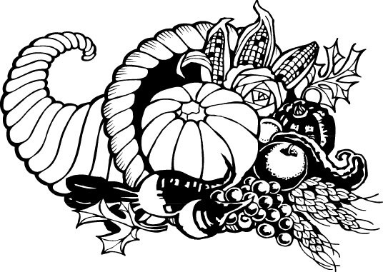
Monday Dec 1  Eating Interview Due – MAJOR GRADE | Start Air Pollution unit/ Farmer’s Market Challenge Due Dec 12th

