Westside High School Lesson Plan

Teacher Name: | Reginald Martin | Unit Name and #: | Dining Like a Diplomat
Course: | Practicum II-Culinary Arts | Dates: | January 6-9, 2014

Monday | Daily Objective: Demonstrate Proper Table Settings
Monday | Learning Activities:  - View PowerPoint  - Discuss Lesson for the week
Monday | Assessment Methods:  Checks for Understanding:
Monday | Materials:
Monday | Follow Up/HW:
Tuesday | Objective: Demonstrate Types of Napkin Folding
Tuesday | Learning Activities:  - Create Mise En Place Plan Checklist for Setting Tables  - Practice Napkin Fold
Tuesday | Assessment Methods:  Checks for Understanding:
Tuesday | Materials:
Tuesday | Follow Up/HW:
Wednesday /Thursday | Objective: Demonstrate Table Etiquette
Wednesday /Thursday | Learning Activities:  - Set Up Dining Room  - Practice Serving Guest
Wednesday /Thursday | Assessment Methods:  Checks for Understanding:
Wednesday /Thursday | Materials:
Wednesday /Thursday | Follow Up/HW:
Friday | Objective: Review Business Procedures and Best Practices when dining out.
Friday | Learning Activities:  - Review and Take Quiz  - Set Up Kitchen for service  - Take inventory and order food
Friday | Assessment Methods:  Checks for Understanding:
Friday | Materials:
Friday | Follow Up/HW:

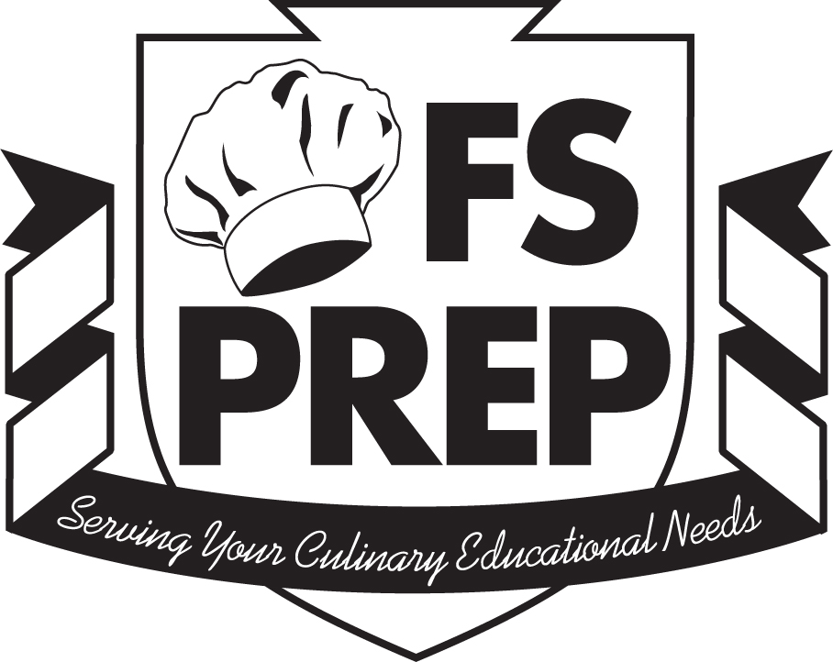 Elective Lessons:
Dining Like A Diplomat

Length of Class: 1 session
Class Duration: 90 minutes
Lecture: 40 minutes
Instructor Demo: 20 minutes
Student Activity: 30 minutes

Student Objectives:
- Demonstrate proper table settings for various types of service
- Identify the uses of the elements of table settings: silverware, glassware, china and dishes, and serving utensils.
- Discuss the basic rules of table settings.
- Demonstrate three napkin folds.
- Demonstrate and discuss the basic rules of table etiquette.
- Demonstrate and discuss the rules of table etiquette as they apply to job interviews and business dining.
- Demonstrate and discuss the rules of table etiquette as they apply to special occasions.

TEKS Alignment:

Culinary Arts:
(3)(D); (6)(F),(L); (8)(A),(B); (11)(G),(H)

Practicum in Culinary Arts I:
(2)(A),(E),(G),(H); (10)(F),(L)

Restaurant Management:
(2)(D,(E); (5)(B),(C),(D),(E); (6)(F); (7)(A),(B),(D); (11)(A)
Foodservice Prep
Texas Restaurant Association
Education Foundation

Elective Lessons:
Dining Like a Diplomat

Instructor’s Note: This lesson may be paired with Dining Room Simulations lesson in
Operations Section.

Lecture & Lab Guide

- Introduction
- This lecture covers the basics of dining etiquette, both from the point of view of a server and a guest.
- The importance of this knowledge to the establishment and the server.
- The importance of this knowledge to the student’s personal and professional life.

- Table Settings
- Equipment and Materials:
  - Silverware
  - Glassware
  - China and Dishes
  - Centerpieces
  - Serving Utensils

- The Basic Rules of Table Settings
- Placement of utensils, glassware, china, and centerpieces
- Order of use
- Reading a place setting
- Class Practice – Table Setting

- Napkins Folds and Placement See: Napkin Folds, p. E-48
- Napkins placement and etiquette.
- Instructor Demonstration – Napkin Folding
  - Napkin Fold #1
  - Napkin Fold #2
- Class Practice – Napkin Folding

- The Basic Rules of Table Etiquette
  - Reading the Table Setting
  - Napkin Use
  - Use of Silverware
  - Body Language at the Table
  - When You Have Finished

- Table Etiquette for Job Interviews and Business Dining
- Why are meals part of job interviews/business?
- The role of the host
- Etiquette during the meal
- Excusing yourself from the table
- Summoning the server
- Ending the meal
- What if you spill something, or other minor disasters
Foodservice Prep
Texas Restaurant Association
Education Foundation

- (Optional Topics): Special Occaisions
- Platter Service
- Making Toasts
- Introductions
- Class Pracitce – Platter Service, Toasts, or Introductions

Instructor Demonstration
The instructor will demonstrate table settings and napkin folding.

Student Activity:
Student’s teams, under the direction of the instructor, will demonstrate table settings and napkin folding

See attached menus for table setting activities and sample napkin fold instructions.

Student Activities:
Team Table Setting Drill
Divide the class into groups of 2, 3, or 4, and have them set a four-place table for one of the following menus provided on the following pages:

Foodservice Prep
Texas Restaurant Association
Education Foundation

Team Table Setting Drill
Team #1
Here's Your Table Setting Challenge!

Appetizer:
Asparagus Spears with Orange Hollandaise Sauce

First Course:
Shrimp Cioppino garnished with Aioli Bruschetta (served in a large, flat soup bowl)

Main Course:
Smoked Pork Loin with Red Bell Pepper Coulis Saffron Rice
Sautéed Spinach with Roasted Garlic

Dessert:
Cinnamon Sorbet Garnished with Zinfandel-Poached Pear Compote

Foodservice Prep
Texas Restaurant Association
Education Foundation

Team Table Setting Drill
Team #2
Here's Your Table Setting Challenge!

Appetizer:
Smoked Salmon served with Cream Cheese, Red Onion, Capers, and French Bread Toasts

First Course:
Wild Mushroom Bisque Garnished with Horseradish Cream (served in a small soup cup)

Main Course:
Roast Leg of Lamb with Garlic Sauce Potatoes Anna
Fresh Haricots Vert in Sweet Onion Butter

Dessert:
Tarte Tatin

Foodservice Prep
Texas Restaurant Association
Education Foundation

Team Table Setting Drill
Team #3-
Here's Your Table Setting Challenge!

Appetizer:
Mushroom Bisque Served under a Puff Pastry Dome (served in a small soup cup)

First Course:
Orange, Fennel, and Black Olive Salad

Main Course:
Sea Bass Baked on a Bed of Yellow Tomatoes, Fennel, and Green Olives Couscous with Roasted Onions and Red Pepper Rajas Broccolini Sauté

Dessert:
Creme Brulée with Fresh Raspberries

Foodservice Prep
Texas Restaurant Association
Education Foundation

Team Table Setting Drill
Team #4-
Here's Your Table Setting Challenge!

Appetizer:
Gazpacho Andaluz - Cold Tomato and Vegetable Soup Served in a large, flat, soup bowl

First Course:
Whole Grilled Prawns in Chipotle-Garlic Sauce

Main Course:
Roast Game Hen with Almond and Red Pepper Stuffing Black Truffle Rice Pilaf
Fresh Grilled Asparagus Spears

Dessert:
Almond Torte with Fresh Berries and Whipped Cream
Foodservice Prep
Texas Restaurant Association
Education Foundation

Team Table Setting Drill
Team #5-
Here's Your Table Setting Challenge!

Appetizer:
Pan-Fried Crab Cakes with Lemon Butter Sauce

First Course:
Mixed Green Salad with Roasted Pecans and Stilton Cheese Dressing

Main Course:
Mesquite Smoked Duck with Blackberry Honey and Fried Leeks Yellow Bell Pepper Risotto

Dessert:
Spiced Pecan Cake with Brown Sugar Frosting and Maple Ice Cream

Foodservice Prep
Texas Restaurant Association
Education Foundation

Team Table Setting Drill
Team #6 -
Here's Your Table Setting Challenge!

Appetizer:
Fried Calamari with Spicy Tomato Coulis and Wasabi Aioli

First Course:
Spinach Salad with Warm Goat Cheese and Candied Walnuts

Main Course:
Smoked Pork Tenderloin with Almond Mole and Grilled Pineapple Pureed Sweet Potatoes

Dessert:
Raspberry Soufflé with Fresh Raspberries and Chocolate Ganache

Foodservice Prep
Texas Restaurant Association
Education Foundation

Napkin Folds
Have the class practice and demonstrate three or four napkin folds (2 are provided here).
Discuss appropriate times for each fold to be used. When they have achieved some level of proficiency, use the napkins to complete the table settings activity.
Bishop's Hat
A very traditional method for folding large, well starched dinner napkins.

One: Start with the corners of the open napkin top and bottom in the form of a diamond,
fold the corner nearest to you to just below the corner furthest away from you to form a triangle.
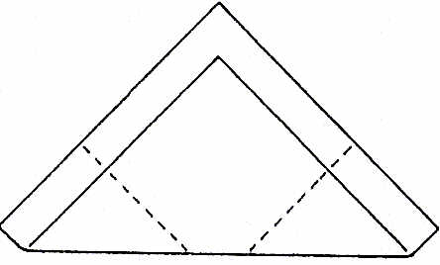
Two: Fold up the two corners nearest to you until the edges align.
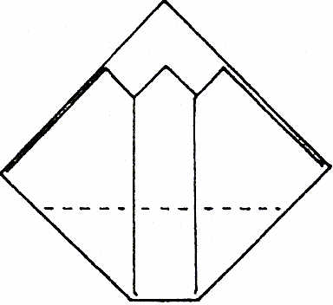
Three: Bring the newly formed bottom corner up And away from you so that its top edge sits just below the first corner when folded. Fold down the front edge.
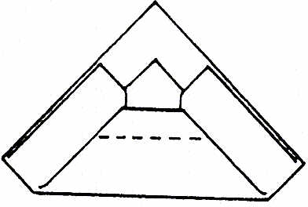
Four: Bend the left and right corners backwards and interlock one half into the other to form a tube that will not spring open. Stand the napkin up.
Foodservice Prep
Texas Restaurant Association
Education Foundation

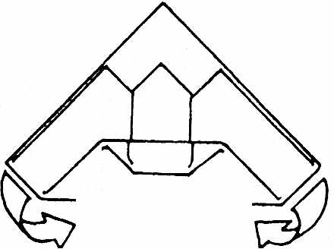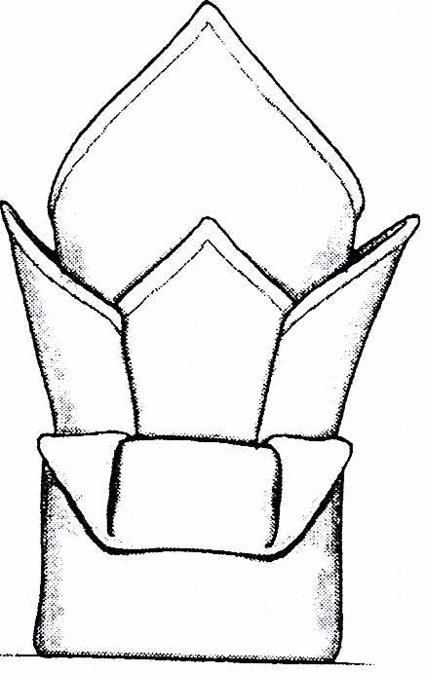

Water Lily
One of the best-known folds, the "water lily" is equally suitable for both formal and informal occasions. For a flat, open lily, use napkins made of soft, un-starched fabric; a crisper fabric will create sharper edges and a taller, bowl-like shape.
One: Fold each of the corners of the napkin in so they meet at the center to form a square. Fold the corners into the center again, to form a smaller square.
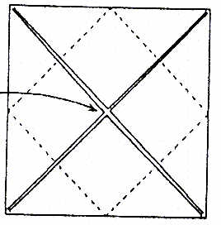
Two: Carefully turn the napkin over from left to right, keeping all of the folded corners tucked underneath.
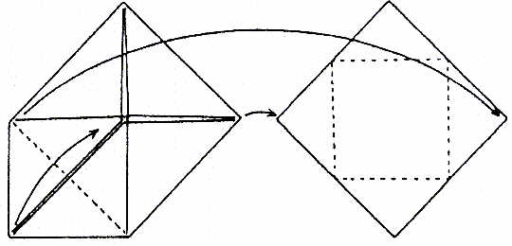
Three: Fold each of the other three corners into the center so that it forms a square.
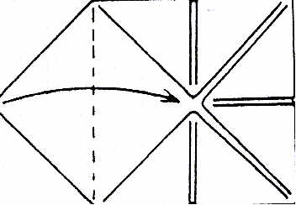
Foodservice Prep
Texas Restaurant Association
Education Foundation

Four: Holding the points at the center with your fingers, gently pull out the flap from under one of the corners.
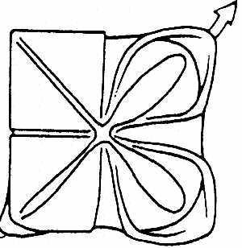
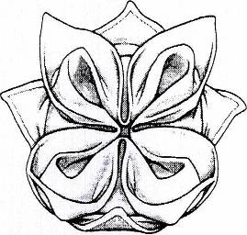
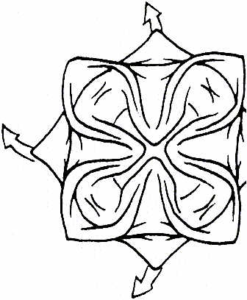
Five: Pull out each of the other corners to form the petals of the water lily.
Foodservice Prep
Texas Restaurant Association
Education Foundation

Exercises for Basic Table Etiquette
With the class seated at the set tables, have them demonstrate or discuss the following rules of basic etiquette. Optional: Have the class use "tong service" from platters to serve cheeses, salad, or appetizers, and have the class use the food in the activity.
- At your place setting, which bread plate, and set of glasses is yours?

- What is the rule that determines this?

- Explain the proper sequence of using the silverware set on the table, and for what course/dish it might be used.

- Demonstrate the proper timing and technique for using your napkin at the table.

- Demonstrate the proper technique for how to leave the table in the middle of the meal.

- Demonstrate how your place setting should look after you have finished eating the soup course.

- What should you do with silverware you do not need to use?

- Demonstrate how your place setting should look when you have finished eating the entree.

- Demonstrate the American Style of using silverware and cutting food.

- Demonstrate the European Style of using silverware and cutting food.

- Demonstrate how to sit at the table during the meal, and tell why this is so important.
Foodservice Prep
Texas Restaurant Association
Education Foundation

Exercises for Table Etiquette for Job Interviews and Business Dining
With the class seated at the set tables, have them demonstrate or discuss the following rules of business etiquette. Optional: Have the class use "tong service" from platters to serve cheeses, salad, or appetizers, and have the class use the food in the activity.
- Why are meals often part of job interviews? Why is etiquette important to business success?

- Have one member of the group act the part of the host, and have the host initiate seating the group, passing the bread basket, and starting the meal.

- Demonstrate the proper technique for eating bread and butter.

- Demonstrate the proper technique for eating large-leaf salad.

- Demonstrate the proper technique for excusing yourself from the table in the middle of the meal.

- Demonstrate the proper response if a large piece of food falls from your plate onto the table or onto the floor.

- Demonstrate the proper response if you drop a utensil on the floor during the meal.

- Demonstrate how your place setting should look after the meal is completed.

- Demonstrate the proper technique for making a toast to welcome the guests to a banquet.

- Discuss the proper technique for making a toast to a guest of honor.

- Demonstrate how to introduce yourself to a stranger when you are seated together at a business function.

- Demonstrate how to introduce your boss to a client.

- Demonstrate how to introduce your friend to the CEO of the company you work for.
Foodservice Prep
Texas Restaurant Association
Education Foundation

The Basic Table Setting
- The napkin may be placed in the center of the basic setting, approximately one-half inch from the edge of the table. The napkin may also be placed in a wine glass or water glass.

- The dinner knife is always placed to the right of the napkin (or, on the right side of the basic setting), with the blade facing in.

- The dinner fork is placed to the left of the center of the setting. The distance between the knife and the fork should be wide enough to fit a dinner plate between them.

- The water glass is placed about one-half inch above the tip of the knife. A second glass, for wine or iced tea, for instance, is set the right of the water glass, slightly closer to the table edge.

- Salt and pepper shakers should be on the table. All other condiments should be kept ready on the service table and are presented when appropriate.

- The bread plate, with a small knife, is placed left of the fork. The blade of the small knife should face left.

- If three glasses are set, they are as follows: the red wine glass is placed about one-half inch above the tip of the knife. The white wine glass is then placed below the red wine glass at a slight angle, and the water goblet is placed above the red-wine glass at the same angle. The same basic rule applies for any set of three glasses.

Foodservice Prep
Texas Restaurant Association
Education Foundation

Extending The Basic Table Setting
- The number of utensils on the table depends on the number of courses to be served, and the order in which they are placed is determined by the order in which the food is served. It is generally proper to preset no more than three glasses or three sets of flatware, except when there is dessert flatware. When dessert is planned, the silver for it can be placed above the center of the place setting. If more utensils than can be preset are needed, they should be brought during service, before the course arrives.

- A second knife, if it will be needed for the appetizer or salad course, should be placed to the right of the dinner knife.

- A second fork, for the salad or appetizer course, will be placed to the left of the dinner fork and slightly above it.

- A spoon goes to the right. Use a teaspoon for soups served in a cup, and a soup spoon for soups served in a soup plate or bowl.

- Since the sequence of courses determines the setup, the spoon can be placed differently. For example, when a soup is served after a cold appetizer, it is placed to the left of the knife for the appetizer.

- The dessert silver is placed above the napkin and is moved down by the service staff just before the dessert is served. For most desserts, a small fork and a small spoon are set. The fork is placed with its tines to the right; the spoon is placed with its bowl to the left.

- For crèmes, mousses, and ice creams, a coffee spoon is sufficient.

- For fresh fruit or cheese desserts, set a small knife and a small fork. The knife is placed with the handle to the right, blade facing down. The fork is placed below with the handle to the left.

