6th Grade Supply List

Science
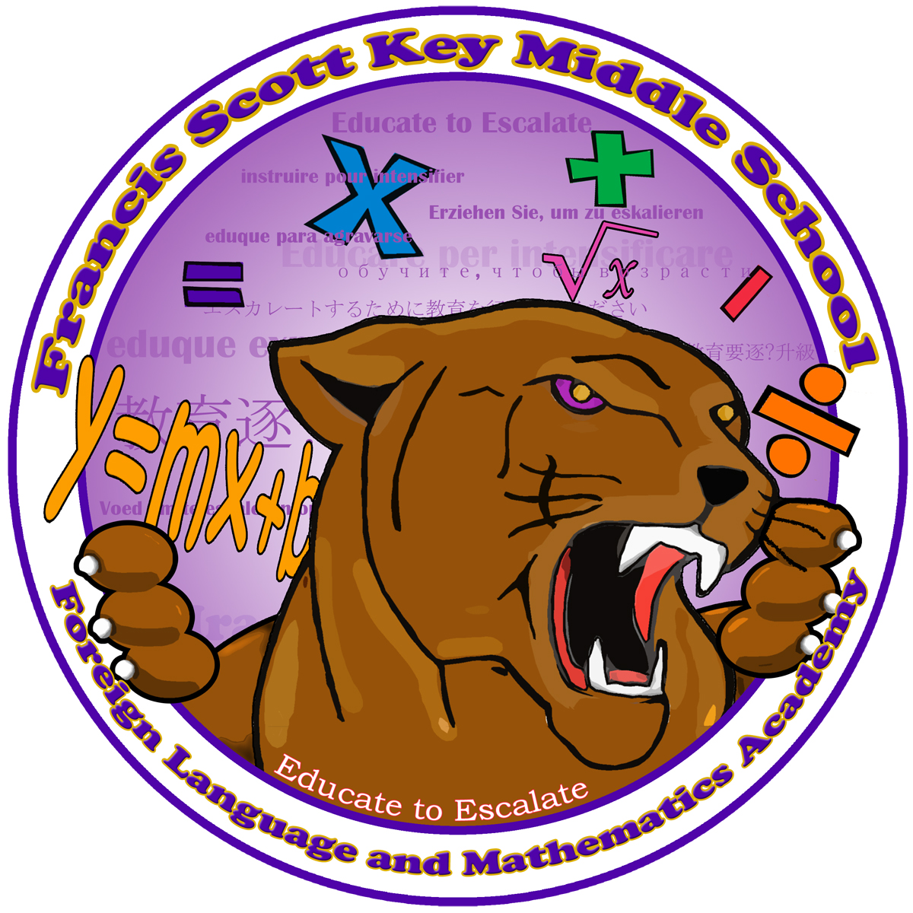
-Red/Green Pens 1 box (Continue to buy throughout the year)
-Pencils 1 box (Continue to buy throughout the year)
-2 boxes of tissue
-2 bottles of sanitizer
-2- 3 subject journals or composition notebooks (no spirals) or 2- single subject journals
-Pencil sharpener w/cover
-1 Flash drive

Social Studies
-2- 3 subject journals or composition notebooks (no spirals) or 2- single subject journals
-2 packets of loose leaf paper
-Blue/black pens (Continue to buy throughout the year)
-Pencil sharpener w/cover
-2 boxes of tissue
-map pencils and markers

Math
-6 glue sticks
- 2 Composition Notebooks (3 subject)
- 1 pack Graph Paper
- EXPO dry erase markers
- 2 reams of colored typing paper
- 2 packs of 12 pencils (Ticonderoga)
- 1 pair of scissors
- 5 pocket folders w/prongs (1 of each color - red, blue, green, yellow, orange)

Reading/ELA
-Composition Notebook-4
-Pens-2 boxes
-Pencils-1box & Pencil Sharpener
-Highlighters
-Notebook Paper
-Portfolio (provided)
-Flash Drive
8th Grade Supply List

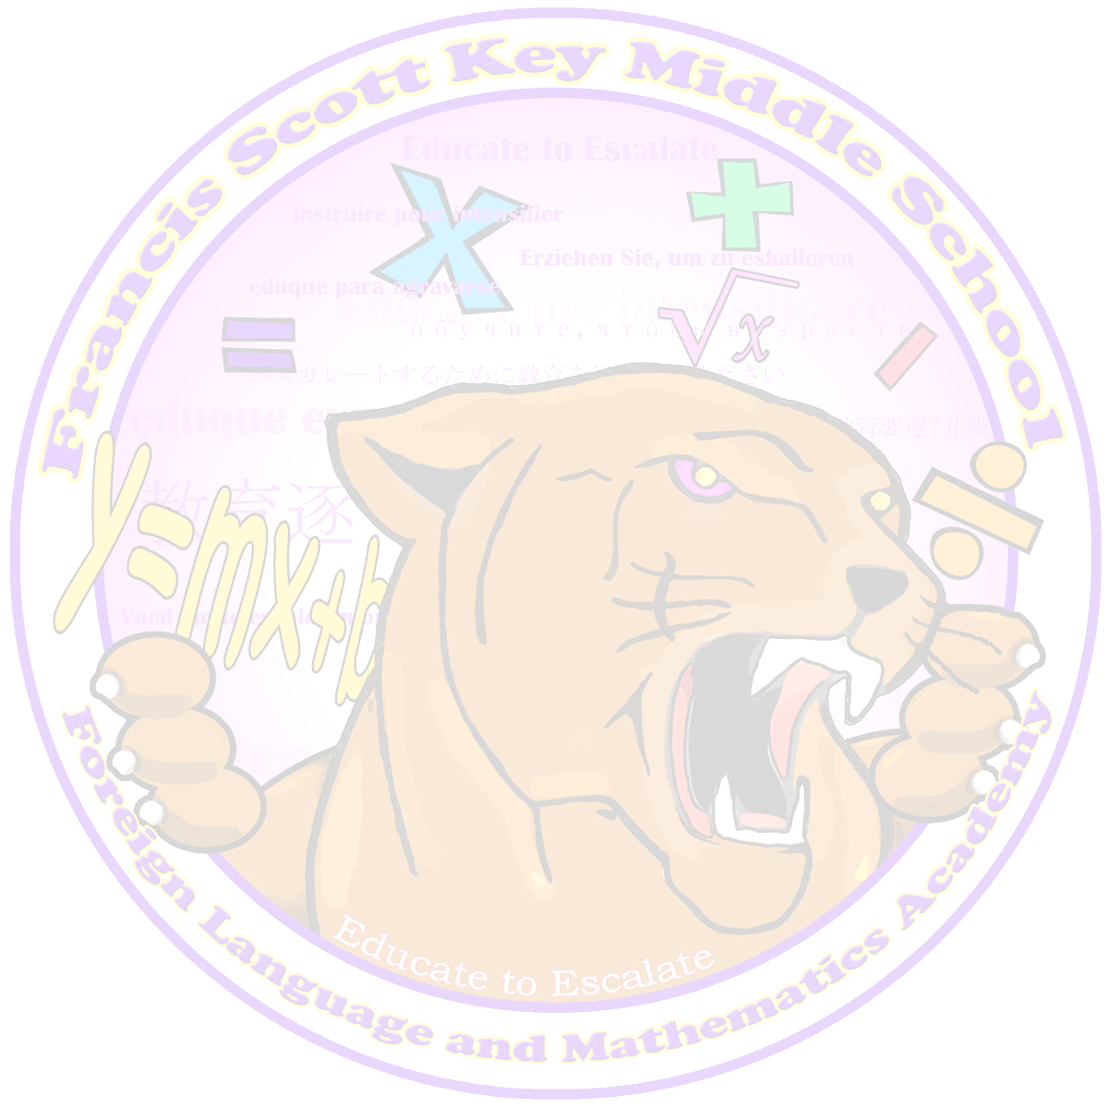
Dress Code
All 6th Grade students are required to wear a WHITE polo style shirt

Pants: Dark Blue, Khaki, or Black (uniform style) including Capri pants.

Skirts: Dark Blue, Khaki, or Black (no more than two (2) inches above the knee, no tennis skirts or skorts.

Shorts: Dark Blue, Khaki, or Black (uniform style, no more two (2) inches above the knee).

Sweatshirts: Any color (no gang, drug, alcohol, sexually related items, or blankets).

Jackets: Tennis shoes, closed toe shoes, and sandals with a back strap (no flip flops or house shoes).

Hats: (Baseball hats or bedtime head dressings are not allowed) Winter hats must be removed upon entering the building, continued non compliance with the rule will result in item being confiscated until parent conferences with administrator or the end of the school year.

Backpacks: All students are required to have a backpack with supplies daily

All students must dress out for Physical Education (P.E.) Key MS P.E. uniform not required, but must dress out in an appropriate t-shirt and shorts (Gray shirt/Gray shorts).

NO JEANS OF ANY TYPE WILL BE ALLOWED!

