**Lanier Vanguard Testing**

If you are interested in having your child tested for GT Identification either for Lanier Middle School or for an HISD High School for the 2018-2019 school year, you must complete a Vanguard application, and submit a completed HISD teacher recommendation form and a copy of your student’s final 2016-2017 report card to the Lanier Vanguard office by December 8, 2017. You will also need to register to take the Iowa and CogAT tests, both are required for GT identification in HISD.

**Required Documents**

***Vanguard Application -* To be completed by parent**

The Vanguard application needs to be filled out and submitted before ***December 8, 2017***. No late applications will be accepted.

***HISD Teacher Recommendation Form -* To be completed by current core teacher (Must be submitted by January 24, 2018) Please read directions on how to complete and submit.**

Each student is required to submit a completed HISD teacher recommendation form with their Vanguard application. Teacher recommendation forms must be completed by a core teacher (Math, Science, Social Studies or Reading) and must be completed on the provided HISD teacher recommendation form, we do not accept handwritten letters or other types of recommendation forms. You may submit only one teacher recommendation form with your application.

***2016-2017 Final Report Card* – Must be submitted by January 24, 2018**

Submitted report cards must be the ***FINAL 2016-2017*** ***report card***. We cannot accept progress reports, written statements, or report cards containing grades for only part of the school year.

**Vanguard Testing**

GT identification requires students to take both the Iowa and CogAT tests. All testing dates, times, and subsections are broken down below.   The dates and times listed below are the only dates and times we will offer test administration for GT Identification for the 2018-2019 school year. ***There will be no make-up exams.*** To register for testing dates, you will need to email Mrs. Garza Pender your selected dates for Iowa and CogAT at [jgarza8@houstonisd.org](mailto:jgarza8@houstonisd.org).

**Testing Dates and Times for GT Testing**

|  |  |  |  |  |
| --- | --- | --- | --- | --- |
| **Test** | **Date** | **Time** | **Grade** | **Location** |
| ***Iowa*** | Saturday,  December 2, 2017 | **Registration**  8:00AM-8:30AM  **Iowa Test**  8:30AM-2:00PM | ***Current 6th, 7th, and 8th grade students who are zoned Lanier*** | ***Hamilton Middle School***  ***139 E 20th St***  ***Houston TX 77008*** |
| ***\*Students should arrive at least 15 minutes prior to the testing start time to register for testing. The Iowa test is approximately 6 hours long, students will need a lunch, snacks, and water. Students will be given a lunch break during the test administration. Parents must be at Hamilton MS at 2:00PM to pick students up. This will be the only test date we offer for Iowa testing.*** | | | | |
| ***CogAT*** | Monday,  January 8, 2018 | 3:30PM-4:30PM | *Current* ***6th*** *grade students who are zoned to Lanier* | ***Lanier Middle School***  ***2600 Woodhead***  ***Houston TX 77098*** |
| ***CogAT*** | Tuesday,  January 9, 2018 | 3:30PM-4:30PM | *Current* ***7th and 8th*** *grade students who are zoned to Lanier* | ***Lanier Middle School***  ***2600 Woodhead***  ***Houston TX 77098*** |
| ***CogAT*** | Wednesday,  January 10, 2018 | 3:30PM-4:30PM | *Current* ***7th and 8th*** *grade students who are zoned to Lanier* | ***Lanier Middle School***  ***2600 Woodhead***  ***Houston TX 77098*** |
| ***CogAT*** | Thursday,  January 11, 2018 | 3:30PM-4:30PM | *Current* ***6th*** *grade students who are zoned to Lanier* | ***Lanier Middle School***  ***2600 Woodhead***  ***Houston TX 77098*** |

**Iowa subtests and administration times**

**(Paper and pencil test)**

**Testing time approximately 6 hours**

**\*Students will need a lunch, snacks, and water**

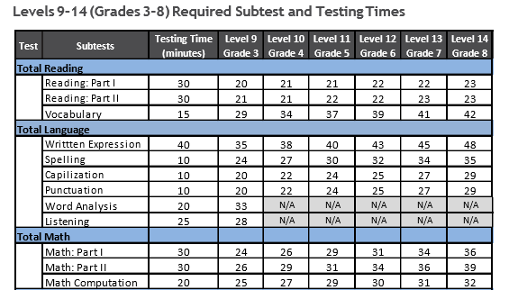

**CogAT Nonverbal subtests and administration times**

**(Completed online)**

**Testing time approximately 1 hour**

**\*Students do not need to bring any materials**

|  |  |  |  |  |
| --- | --- | --- | --- | --- |
| **CogAT** | **Level 12**  **Grade 6** | | **Level 13/14**  **Grade 7/8** | |
| **Nonverbal Subtest** | **Items** | **Time** | **Items** | **Time** |
| **Figure Matrices** | 22 | 10 | 22 | 10 |
| **Paper Folding** | 16 | 10 | 16 | 10 |
| **Figure Classification** | 22 | 10 | 22 | 10 |

Please email me at [jgarza8@houstonisd.org](mailto:jgarza8@houstonisd.org) and let me know which testing dates your child will be attending.

If you have any questions, please let me know.

Mrs. Garza Pender

Vanguard Magnet Coordinator

Lanier Middle School