Name_____________________________ Date__________ Period___

Fossils and Rock Layers
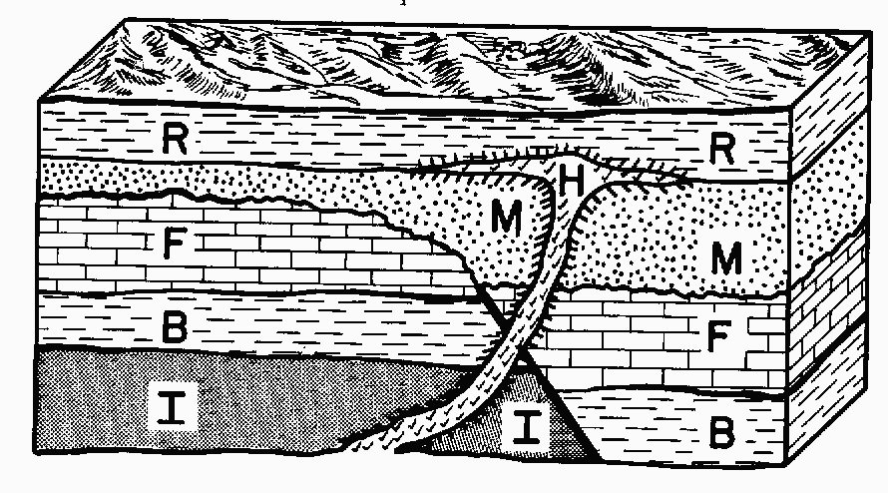

Use the rock layer diagram to the right to answer
Questions 1 – 5.

- Which layer is the oldest? _________

- Which layer is the youngest? _______

- What could have caused the formation of layer H? _________________________

- Would a fossil from layer F be older or younger than a fossil from layer B? ________

- How many different layers are shown in the diagram? _______

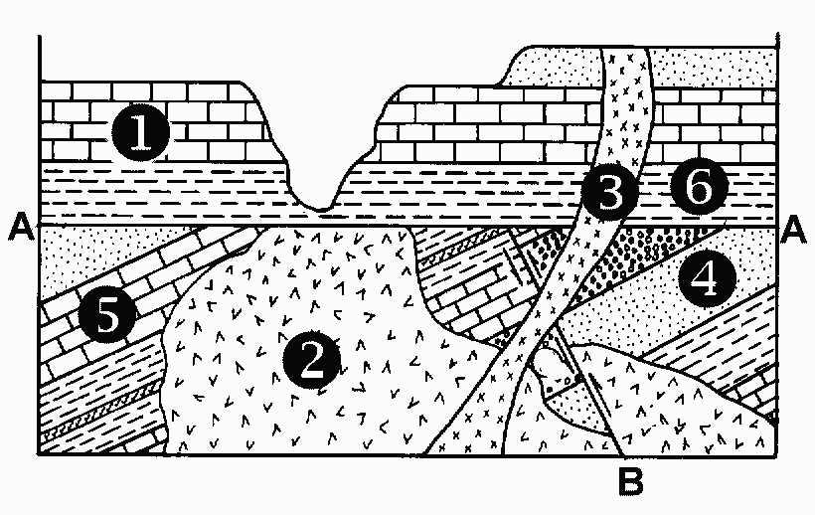
Use the rock layer diagram on the right to answer
Questions 6 – 10.

- In which layer would the youngest fossils
be found? ___________

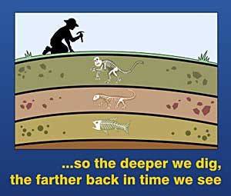
- In which layer would the oldest fossils
be found? ___________

- Which layer would be least likely to contain
a fossil (because it is not very old)? _____

- How does looking at rock layers and fossils help scientists to understand how organisms have changed over time? __________________________________

___________________________________________________________

- Where on Earth can you see the rock layers without drilling a hole into the ground? (think about geography and places you have heard of or seen on vacation)

___________________________________________________________

