

**Resource Guide**

**Food**

The Houston Parks and Recreation Department has Curbside Meal Program for Youth, ages 1 to 18, The Curbside Meal distribution of a snack and lunch will take place Mon-Fri from 1 pm-3 p.m. CHILDREN MUST BE PRESENT. Total of 50 meals will be available at each site. This may increase to up to 200 per site based on participation

**Internet**

**Internet Essential/Comcast –** 1-855-846-8376

**Spectrum** at 1-(866) 874-2389/855-243-8892

[www.att.com](http://www.att.com) (Access from AT & T)

**Computer**

**Compudopt.org** –

Go online to register for free computer lottery or call 713-426-2330

**Rental/Utilities/Food/**

Call 211

**Mental Health**

Appointments Available! New Patients Welcome! Call (832) 548 5000 to schedule an appointment or learn more at LegacyCommunityHealth.org

**Emotional Phone Support Help Line for COVID-19**

1-866-342-6892

**Texas Health and Human Services 24/7 hotline**

1-833-986-1919

**The Harris Center 24/7 hotline**

1-833-251-7544

**National Suicide Prevention Hotline 24/7**

1-800-273-8255

**The Salvation Army**

Emotional & Spiritual Support

1-844-458-HOPE (4673)

**Disaster Stress Helpline**

(Mental and Emotional distress)

1-800-985-5990 or text TALKWITHUS to 66746

**Lakewood Community Center**

8811 Feland

Houston, Tx 77028

**Moody Park**

3725 Fulton Street

Houston, Tx 77009

**Settegast Community Center**

3000 Garrow Street

Houston, Tx 77003

**School Meal Finder**

<https://schoolmealfinder.hoonuit.com/>

**Food Pantries**

Text the word FOOD to 855-308-2282

**Houston Food Bank**

**April 24, 2020**

Northside High School, 1101 Quitman St., 9 a.m.

North Forest School, 10726 Mesa Dr., 9 a.m.

Reynolds Elementary School, 9601 Rosehaven Dr., 11 a.m.

Bonham Elementary School, 8302 Braes River Dr., 3 p.m.

Chavez High School, 8501 Howard Dr. 3 p.m

**April 25, 2020**

**DRIVE-BY FOOD DISTRUBUTION**

NRG Stadium

Yellow Lot

4pm-7pm

**Free school activities**

[**https://hcp2.com/news/blog/13772-free-online-learning-resources-activities-for-children**](https://hcp2.com/news/blog/13772-free-online-learning-resources-activities-for-children)

**Disaster Unemployment**

<https://twc.texas.gov/jobseekers/disaster-unemployment-assistance>

**United Way Community Resources/School**

<http://referral.unitedwayhouston.org/>

**Carnegie Mellon University Computer Science Academy** - Interactive middle and high school computer science curriculum

**Codecademy** - Data science and coding lessons for high school and college students

**COVID-19 Resources**

<https://www.houstontexans.com/news/how-texans-community-partners-are-helping-during-covid-19-daily-brew>



**Hand Sanitizer**

Isopropyl or rubbing alcohol (99 percent alcohol volume, aloe vera gel, and an essential oil, such tea tree oil or lavender oil, or use lemon juice instead.

**Walgreens will operate two COVID-19 testing facilities in Harris County.**

One will be in Houston at the former Walgreens store site at 14531 Westheimer Road and the other in Pasadena at 101 West Southmore Avenue. (Note: The Westheimer location does not show up on most online map services because it is a closed location. Walgreens is re-opening that site to conduct testing.)

<https://www.walgreens.com/findcare/covid19/testing?ban=covid_testing>

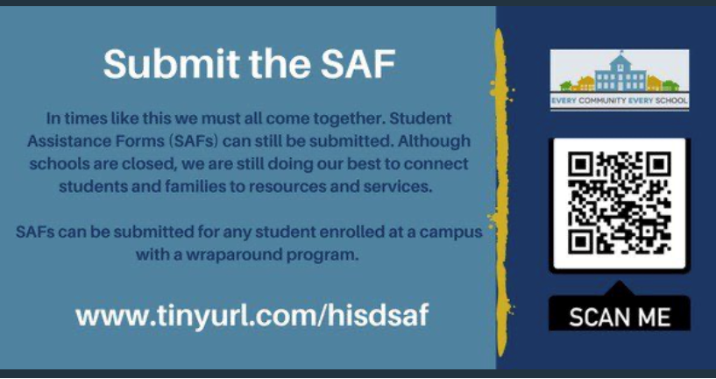

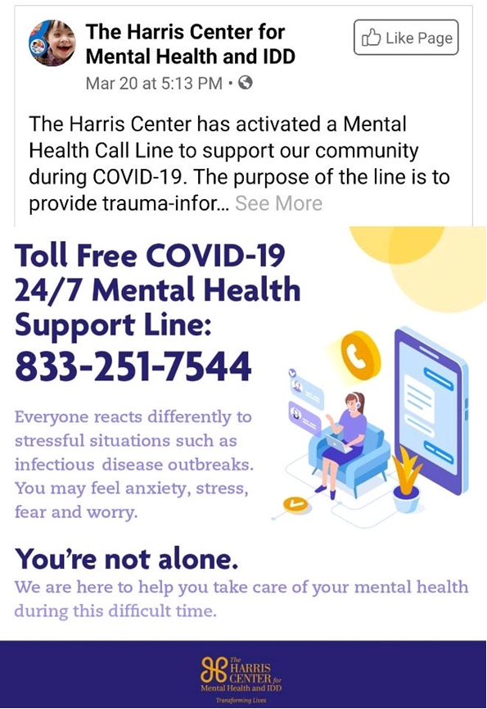

**Free school activities**

[**https://hcp2.com/news/blog/13772-free-online-learning-resources-activities-for-children**](https://hcp2.com/news/blog/13772-free-online-learning-resources-activities-for-children)

**Digital Resources by Content (including special education and GT)**

[https://sites.google.com/r4esc.net/covid19/digital-resources?authuser=0](https://sites.google.com/r4esc.net/covid19/digital-resources?authuser=0%0d)

**Digital Accessibility Tools/Resources**

<https://sites.google.com/r4esc.net/covid19/digital-accessibility-toolsresources?authuser=0>

**Virtual Field Trips**

<https://sites.google.com/r4esc.net/covid19/virtual-field-tripsmuseums?authuser=0>

**Enrichment**

<https://sites.google.com/r4esc.net/covid19/enrichment?authuser=0>

**Immigrants**

<https://immigrantsrising.org/>

Tangible Support for Undocumented Communities during COVID-19. WELL ORGANIZED

AND TONS OF RESOURCES. [Immigrants Rising] Tangible Support for Immigrant

**MANDATORY FACE COVERING STARTING MONDAY APRIL 27, 2020 FOR THOSE 10 YEARS AND OLDER**

**FREE DRIVE-THRU MASK/GLOVES DISTRUBUTIONS 12PM-2PM**

**April 25, 2020** **April 26,2020**  **April 28, 2020**

Mt. Sinai Missionary Baptist Church Cliffdale Baptist Church New Bethlehem Missionary

902 W. 8 Street 854 Enterprise Street 9126 Jensen Drive

Houston, Tx 77007 Houston, Tx 77088 Houston, Tx 77093

**April 30, 2020 May 2, 2020**

Sweet Home Missionary Baptist Church Mt. Pilgrim Missionary Baptist Church

7104 Homestead Road 908 E. 32 ½ Street

Houston, Tx 77028 Houston, Tx 77022

**SCHOOL ACTIVITIES**

**Listenwise -** Non-fiction audio stories covering ELA, social studies and science for grades 2-12

**CommonLit -** Reading and writing lessons for grades 3-12