

**2022-2023**

**Student HANDBOOK**

1910 Lamonte Lane

Houston, Texas 77018

**Follow Us!**

**TWITTER - @LStevensES**

**FACEBOOK – facebook.com/StevensElementary**

**WEBSITE – houstonisd.org/StevensES**

# A Message from the Principal

Dear Parents and Students,

Thank you for choosing Stevens Elementary! Our school community is dedicated to supporting each child that walks through our school doors or into our virtual classrooms.

This handbook was designed to create the best learning environment for our school community. Please read the handbook in its entirety. This operational manual is our guide for school policies and procedures. The goal is to ensure specific written procedures that are identifiable and understood.

In order for our school to run effectively, well-established routines and guidelines are necessary. If at any time, you have a question or further clarification is needed, please let me know.

I look forward to a successful year!

Best,

Erin R Trent

Principal

Stevens Elementary

**Stevens Elementary Handbook**

**Parent/Student Contract**

The Stevens Elementary Student Handbook has been written to help your son or daughter gain the greatest possible benefit from his or her school experience.

The Stevens faculty and staff are in need of your help and cooperation. It is important that every student and parent understand the handbook and be expected to follow the rules/guidelines set forth. Please read and discuss the handbook with your child. Afterwards, you and your child must sign this form and return to the school.

Thanks for your cooperation and support.

*Parent Signature & Date*: __________________________________

*Student Signature & Date*: _________________________________

*Grade & Homeroom*: _____________________________________

**Leadership Team**

Erin R Trent

**Principal**

Kenya Simpson

**Assistant Principal**

Julie Woods

**Instructional Specialist**

Shana Swain

**Teacher Specialist**

Julie Demeterio

**Reading Interventionist**

Sharde Davis-Thompson

**Math Interventionist**

Elsa Torres

**Special Education Department Chair**

Courtney Christten

**Counselor**

Kristin Bryant

**Wraparound Specialist**

**Campus Induction Coordinator**

Julie Demeterio

**Stevens Elementary Team**

**Office Personnel Social Emotional Team PK Team**

Sonia Hinojosa, Secretary Courtney Chrsitten, Counselor Hye Lee

Teresa Paz, SIR Bryant, Wraparound Gabriela Reyes-Flores

Patricia Cook, Nurse

Maria Rodriquez, LEP/Records

Isamar Lopez, Receptionist

**Kindergarten Team First Grade Team Second Grade Team**

Christina Martin Ryan Norton Dalia Rubio- Mendoza

Maria Delgado Aracely Morales Lauren Martin

Taylor Grigsby Alitza Walker Quiarre Stafford

Wendy Sprinkle Lakeisha White Julianah Botwe

**Third Grade Team Forth Grade Team Fifth Grade Team**

Anna Gutierrez Kimberly Saldivar Caleb White

Daniel Trujillo Claudia Hurd Diamond Barbosa

Christian Ramirez Michael White Louanna Reyna

Sheila Batson Claudia Delgado Natalie Brown

Dare Rodriquez

**SPED Team Ancillary Team Paraprofessional**

Elsa Torres Deirdre Ricketts Maria Verde

Keon Armstrong Lubna Musallam Karen Hunt

Krisna Young Jay Larson Leslie Lopez

John Tauser

Jessica Silva

**Clerks Hourly Staff SPED Paraprofessional**

Rickey Donatto Mary Baker Sherronda Tisdale

Deborah Pena Artistell Carter Chante Harrell Marcos Gonzalez Aurora Medina

Sheila Dixon



*Our mission will provide us with clarity, direction, establish clear boundaries and that will be used as the guiding statements that will influence our habits, decisions, and define why we exists as an educational organization.*

**Mission:**

The mission of Stevens Elementary is to create a positive and safe learning environment for students through strong leadership and excellence in instruction that ignites a passion for learning in our students.

**EXPECTATIONS**

**Student Expectations**

As a student participating exclusively in remote learning, I am aware that, in addition to the policies and requirements of my school/district, I am expected to comply with the following standards:

* Participate in remote learning for the remainder of the grading cycle.
* Adhere to the Houston ISD Student Code of Conduct and Acceptable Use Policy for Electronic Services for Students.
* Participate in each online course daily to maintain the pace including any required interventions.
* Attend mandatory meetings at school as required. Such as orientation, device pickup/drop-off, and testing.
* Complete classwork on time.
* Communicate with teachers and other classmates in a professional manner.
* Ask for help from the teacher as needed.

Students participating in virtual learning are expected to:

|  |  |  |  |  |
| --- | --- | --- | --- | --- |
| 1. **Be ready to learn.** | 1. **Don’t eat or drink near your technology device.** | 1. **Be respectful of others during live lessons.** | 1. **Check-in daily and turn in assignments on time.** | 1. **Don’t abuse the chat box.** |

**Parent Expectations**

As the parent and/or guardian of a student participating in only remote learning, I am aware that I am expected to support my student’s remote learning experience by adhering and complying to the following standards:

* Support my student in participating in remote learning for the remainder of the grading cycle.  
  Ensure my student has access to necessary resources, equipment, and internet connectivity to participate in all remote learning activities.
* Provide an adequate workspace for my student to work remotely.
* Complete required training.
* Become familiar with student resources and progress for course work.
* Encourage my student to seek assistance and support as needed.
* Communicate with course instructors as needed.
* Ensure student work is completed within the timeframes required by the course instructor.

**School/District Expectations**

The school and/or district will provide the following support for student and parents/guardians during the remote learning semester:

* Provide assigned academic coursework.
* Access to individualized meetings with a school counselor/administrator to discuss the alignment of the online coursework with student ‘s graduation requirements.
* Provide opportunities for training and technical support for parents and students.
* Provide access to essential digital platforms to support remote instruction, such as the district’s learning management system (the HUB), email, Microsoft Teams, and other productivity suites.
* Evaluate student’s 504 Plans or IEPs, to determine if the accommodations and support can be delivered virtually or would have to be modified.

**Important - Once students enroll in the remote instructional option, they will not be able to return to a face-to-face classroom for the remainder of the semester.**

**Helpful Tips for Parents**

Learning at home can be a balancing act. However, establishing a routine will help students be more successful in their learning. Please help your child/children by:

* Provide an appropriate learning space for the students when possible
* Communicate any instructional needs to the campus such as a lack of device or internet connection as defined in the campus communication plan
* Consistently monitor campus and district communication for continuous updates via callouts and websites.
* Maintain communication with teachers as needed
* Connect with your student every day at a time that works well for your household. This might be a quick check-in a few times a day or a longer check-in in the morning or evening.
* Monitor student time on task and encourage physical activity and/or exercise.

**Some questions that might help spark a conversation include:**

* Were you able to complete all the assigned activities?
* What did you learn/practice/read today?
* What was easy or challenging for you?
* Do you have any questions for your teacher?



**School Hours**

**1. HOURS: Monday – Friday 7:30 am – 3:00 pm**

**2**. **Front Office Hours:** During the 6 weeks of virtual learning the office will be open Monday – Friday from 7:30 a.m. – 2:30 p.m. To enter the building, you must wear and mask and adhere to all campus procedures to maintain your safety and the safety of others. You may also call the front office to handle any school business by phone and by email. Please call 713.613.2546.

For records, please email Teresa Paz, tpaz@houstonisd.org

For all other questions, please email Sonia Hinojosa [sonia.hinojosa@houstonisd.org](mailto:sonia.hinojosa@houstonisd.org).

**School Provided Technology**

Stevens Elementary will provide each family with at least one technology device.

* PK-2 Grade will receive an IPAD device.
* 3rd-5th Grade will receive a laptop.

A technology contract will be signed prior to receiving a device. The contract is a commitment by the student/parent to take care of the device and to adhere to the Houston ISD Student Code of Conduct and Acceptable Use Policy for Electronic Services for Students.

**Violations include, but are not limited to:**

* Sending or forwarding inappropriate electronic communications, including emails containing offensive language, untruthful statements, junk emails, chain letters, or jokes using HISD Information Technology resources or the HISD network and on personal devices/accounts.
* Viewing inappropriate sites or downloading non-educational resources for personal use.

**Technology Systems to Support Continuity of Learning**

During the remote operation of schools, teachers and students will use district adopted platforms to communicate and provide instruction. Microsoft Teams will be used to provide instructional support and host live class meetings with students. The district’s adopted learning management system (LMS), the HUB (itslearning), will be used to host, deliver, and manage content, instructional resources, and student assignments. The HUB will also be used to monitor student engagement and progress.

Teachers and students can use Microsoft Office 365 Suite and Google for Education Suite (G-Suite) to access a variety of productivity tools to enhance communication and support the creation of instructional content, resources and other essential elements for the learning process.

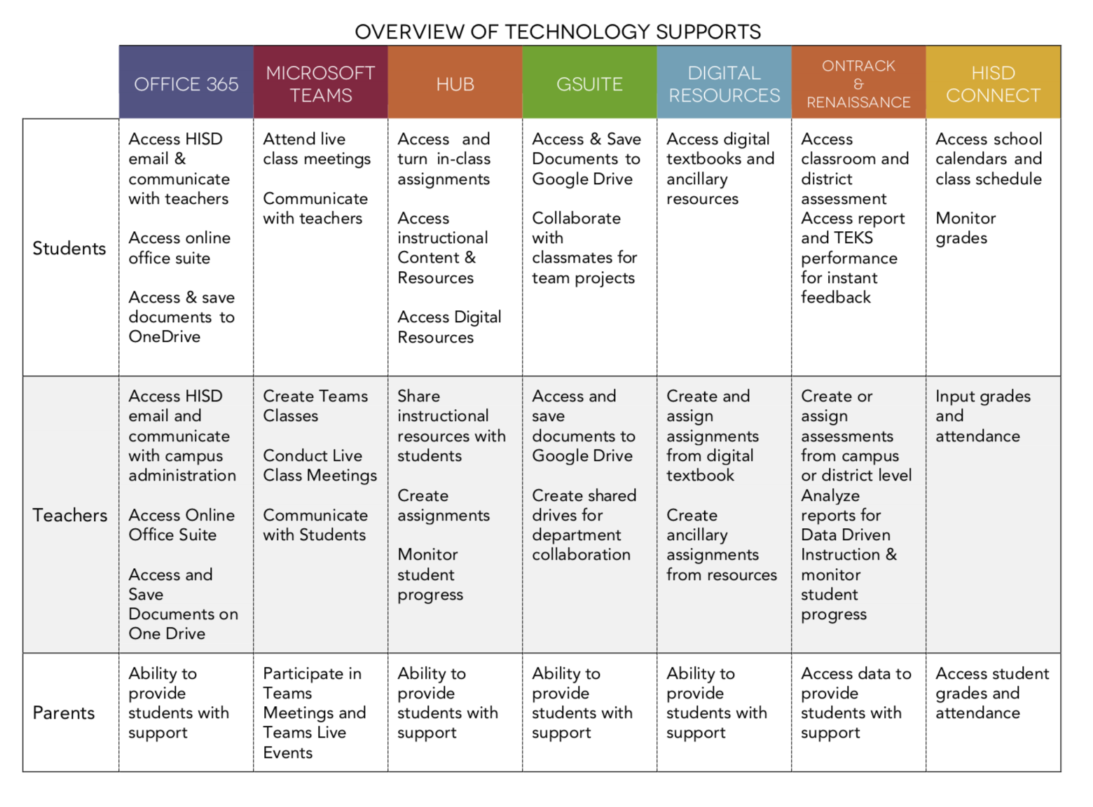

TECHNOLOGY PLATFORMS

Students and teachers will use two primary platforms for virtual learning.

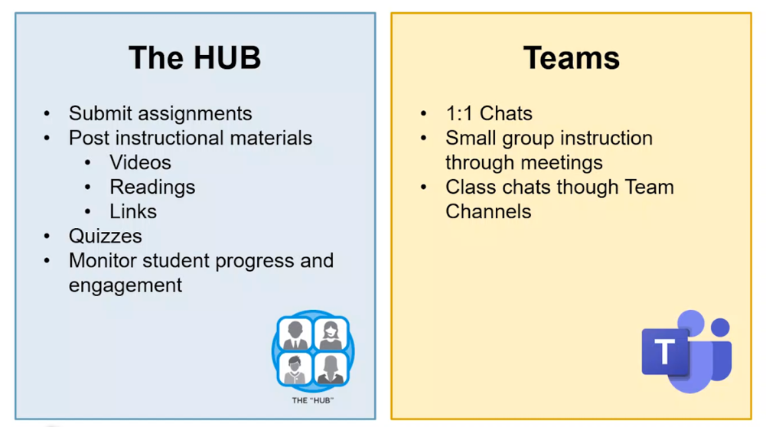

**Teachers will use the TEAMS platform for their instructional delivery of live lessons to students.**

|  |  |
| --- | --- |
|  | * Live Class Lessons * Small Group Intervention/Lessons * Communication with Teachers * Participate in Meetings and Live school events. * House all documents including PLC agenda, lesson plans, daily schedule, and communication log. |
| **Where to get support and more info on the platform**   * Academic Instructional Technology Training   <https://www.houstonisd.org/Page/181632>   * Microsoft Teams Support   <https://support.microsoft.com/en-us/teams?ui=en-us&rs=en-us&ad=us>   * Microsoft Training for Office 365   <https://support.microsoft.com/en-us/training?ui=en-us&rs=en-us&ad=us> | |

**Students will use the HUB platform to submit assignments and interact with digital tools.**

|  |  |
| --- | --- |
|  | * Submit Class Assignments * Monitor Student Progress and Engagement * Access and Post Instructional Content and Resources * Google Drive Links * Pear Deck Links * Access Digital Resources * Imaging Literacy, Español, and Math * Renaissance * My-On * Renzulli * Science Fusion * Social Studies Weekly |
| **Where to get support and more info on the platform**   * <https://www.houstonisd.org/Page/181615> * <https://support.itslearning.com/en/support/solutions/7000000470> | |

**Teachers, Students, and the campus will use Class Dojo for parent communication.**

|  |  |
| --- | --- |
|  | * Daily parent communication * Post master schedule * Parents will have access to school communication. |
| **Where to get support and more info on the platform**   * <https://www.classdojo.com/resources/> | |

**Virtual Learning Models**

|  |  |
| --- | --- |
| Asynchronous (HUB) | Synchronous (Microsoft Teams) |
|  |  |
| * Self-guided student learning with intermittent teacher interaction * Self-paced personalized activities via the HUB | * Teacher develops and executes direct and small group instruction via Microsoft Team |

Teachers will use both methods for student learning. Students will have access to the following:

|  |  |  |
| --- | --- | --- |
| Assignment | Discussion | Test |
| ● Open ended checks for understanding allow students to upload files of different types. Teachers can then access the file and check for understanding. Example: Teacher instructs students to search the internet and find and upload a picture to the assignment tool that accurately reflects an example of a fractal pattern in nature.  ● Requires a manual check for understanding.  ● Allows a grade to be assigned to individuals. | ● Allows students to engage in a dialogue usually responding to a guiding question.  ● Requires a manual check for understanding.  ● Provides a report for individual students on the number of threads and comments posted.  ● No grade can be assigned within the tool. | ● Allows many different question formats.  ● Allows for auto-graded check for understanding for non-open-ended questions.  ● Data is reflected for individual students only  ● Never anonymous  ● Immediate feedback |

Students will have the opportunity to complete the assigned work at their own pace within the daily learning schedule set by their campus. Teacher supports might take the form one-to-one. Microsoft Teams calls, pre- recorded lessons, supplemental materials, or small group instruction via Microsoft Teams

**Parent Access to Student Information**

|  |
| --- |
|  |

**HISD Connect Parent Portal**

HISD Connect Parent Portal is an online service that allows registered users (i.e., parents and students) to log in to access a variety of student information, see class assignments and school calendars, and even communicate electronically with teachers.

**Use:** Users can also choose to have an e-mail or text message sent if a child's grades drop below a selected average or is absent or tardy to class.

Information that PSC provides access to includes:

* Period and Daily Attendance
* Class Schedules and Assignments
* Progress Reports
* Report Cards
* Parent and Student Resources

**Where to get support:** HISD Technology Service Desk **Phone:** 713-892-7378

**Email:** servicedesk@houstonisd.org

**Grading Policy**

Teachers will use HISD Connect to input students’ grades by 3:15 p.m. every Friday. Please note that families are also provided access to student information. Modifications for students with special needs and for LEP students should also be noted. ***(Please note: New teachers will be provided training at the beginning of the school year.)***

**2 grades per week per subject (HISD Virtual Policy)**. Stevens will follow HISD guidelines for issuing grades:

**A = 90 – 100**

**B = 80 – 89**

**C = 75 – 79**

**D = 70 – 74**

**F = below 69**

**Stevens ES will adhere to a six - week cycle reporting period**. ***Students who earn a grade below 70 must receive a progress report during the 4th week of the grading period.*** Anytime a student is failing, parents need to be notified by teacher via telephone, progress reports, etc. and **documented in the parent communication log.** Documentation also includes re-teaching activities, independent work, or the re-test given. **NO homework will be given while virtual**.

The following grade distribution is a school wide policy:

**Grading Scale:**

Assessments 35%

Daily Work 40% Projects 15% Class Participation 10%

**Conduct Grading**

Marks in conduct are MANDATORY, teachers will also assign a grade for handwriting.

**Conduct Guide:**

**E** -- Excellent. Excellent conduct is expected from all Stevens ES students. Students who demonstrate excellent conduct consistently demonstrate and understanding and following of teacher’s expectations without little to know deviation from the rules.

**S** -- Good. The student’s behavior is generally satisfactory but not of the highest rank and needs improvement. Students rarely deviate from the rules.

**P** -- Probationary/Poor. Conduct is not satisfactory and needs improvement. Students consistently break the rules.

**U** -- Unacceptable. Students have little or no regard for rules. ***(Must have administrator approval and student must be referred to the counselor or wraparound specialist for support.***

The grades will reflect the components of the subject and content reflected in the curriculum. Teachers must document re-teaching if mastery is not met. ***(Documentation of re-teaching should be noted in HISD Connect and reflected in the lesson plans. Please note: This is a State requirement.***

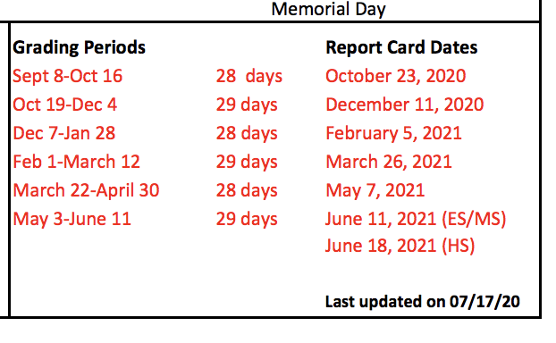

**Every DAY COUNTS!**

**Attendance**

Students who engage in learning activities via the HUB, participate in a Teams meeting with teachers, or submit assignments via the HUB are considered “present” and will not be marked absent. State law TEC §25.092 and Houston ISD Policy still require students to attend at least 90% of their classes to receive credit and be promoted. Remote attendance will count in the same manner as on-campus (face-to-face) attendance in satisfying this requirement.

**Students can engage with their teacher though the following:**

* Daily participation in the HUB, the HISD Learning Management System (LMS), completion of independent reading and work assignments, use of assigned digital tools, and/or group interactions.
* Interaction with teacher via Teams as part of live or small group instruction.
* Students assignment submission via the HUB for each scheduled class. When unable to submit via the HUB students can submit assignments via emails, photos, phone conferences or other forms of documentation.

**Students who have not logged in by the following times will be marked absent:**

* + Elementary schools - 2:30 p.m.
  + Middle & K-8 schools – 3:30 p.m.
  + High schools – 3:30 p.m.

This absence can be resolved if the student engages in daily learning assigned by their teachers via the HUB by 11:59 p.m. that same day. Parents and students will receive absence notifications via School Messenger after 6:00 p.m. each day and will be reminded of the opportunity to resolve that day’s absence if the student engages in learning before 11:59 p.m. of the same day via the HUB. Any absences recorded, but resolved by the student before 11:59 p.m. on the same day, will be reconciled based on login records of the HUB.

**PLEASE NOTE:** If a student is engaged in remote learning and completes the entire weeks’ worth of learning activities on Monday and does not log in for the remainder of the week, he/she will be marked “present” on Monday **only** and counted “absent” for Tuesday-Friday.

**MARK YOUR CALENDAR**

**Important Dates**

|  |  |
| --- | --- |
| **September** | **9/7/20 Labor Day**  **9/8/20 First Day of School**  **9/28/20 Fall Holiday (students only** |
| **October** |  |
| **November** | **11/23-11/27 Thanksgiving Holidays** |
| **December** | **12/21 – 1/1 Winter Break** |
| **January** | **1/18/21 MLK Day Holiday**  **1/29/21 Last Day of First Semester** |
| **February** | **2/1/21 First Day of Second Semester** |
| **March** | **3/15 – 3/19 Spring Break**  **3/29/21 Chavez-Huerta Day** |
| **April** | **4/2/21 Spring Holiday** |
| **May** | **5/31/21 Memorial Day Holiday** |
| **June** | **6/11/21 Last Day of School for Students** |

**Access the HISD Calendar by using the link below**

<https://www.houstonisd.org/academiccalendar>

Stevens will provide families with a monthly calendar that will be posted on Class DOJO. The calendar will note important dates and reminders for parents and students.

**SCHOOL PROGRAMS**

**Social and Emotional Learning**

Every learning day will be kicked off with a student check-in through circle time. The time will be dedicated on the master schedule.

**Other important components include:**

* Daily SEL focus provided by the counselor
* Virtual Calming Room will be available for students
* Trainings and supports for Integrating SEL into Academics
* Self-guided training library via the HUB
* Teachers will receive training on Cultural Sensitivity, De-escalation, Self-Regulation, Social Awareness, Problem Solving, Conflict Resolution, Cyberbullying, Relationship Building, and Trauma

If your child is in need of additional services for counseling, please contact Mrs. Courtney Christten [courtney.christten@houstonisd.org](mailto:courtney.christten@houstonisd.org).

**Wraparound Services**

Ms. Kristin Bryant is the campus’s Wraparound Specialist. Wraparound services support non-academic supports address critical issues such as mental health and physical health needs, food insecurity, lack of stable housing, violence, incarceration of a parent, and many other challenges that can have adverse effects on a student’s readiness and ability to learn. When wraparound services are provided in tandem with strong academics and high-quality teaching, schools can truly meet the needs of the whole child and graduate students who are college and career ready. If you or your child is in need of wraparound services, please contact Ms. Kristin Bryant at __________________.

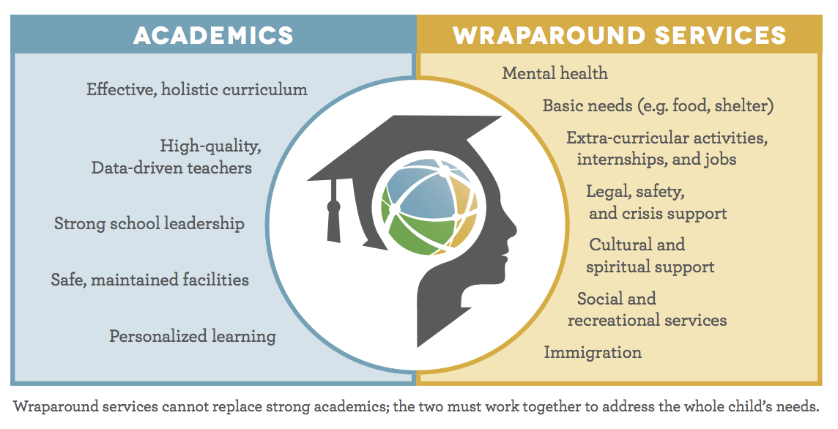

**Ancillary**

For the 2020-2021 school year Stevens students will be offered the following ancillary classes during virtual and face to face learning.

* ART – Lubna Musallam

[lmusalla@houstonisd.org](mailto:lmusalla@houstonisd.org)

* Physical Education – Jay Larson

[jlarson@houstonisd.org](mailto:jlarson@houstonisd.org)

* Science- Deirde Ricketts

[drickett@houstonisd.org](mailto:drickett@houstonisd.org)

If you have any questions regarding ancillary, please contact the ancillary team.

**Gifted and Talented Program**

The Neighborhood Gifted and Talented Program at Stevens Elementary School is a GT cluster self-contained program in grades 1-5.

Initial screening and placement begins in Kindergarten. However, students may be admitted to the program anytime if they meet criteria. All kindergarten students are screened in the fall each year using a District approved test of school abilities. A norm-referenced test is then given in the spring semester. Results are then transferred to a Profile Sheet along with report card grades and teacher rating scale. Folders are then reviewed in the spring and parents are notified of placement for the next school year.

One of two labels is applied: 1) District Qualified (meets all criteria) or 2) Not Qualified. All students that meet District Qualified criteria will be served in the program. Based on new guidelines approved by the Houston Independent School District during the 1997-98 school year, all decisions will be based on the information presented on the Profile Sheet regardless of race.

All students in Kindergarten and 5th grade will be given a District approved school abilities test in the fall of each year with a norm-referenced test during the spring semester. This information will be used by middle schools for placement in their gifted and talented programs.

Our program ensures that:

* G/T students are served by teachers who have completed the required G/T trainings.
* G/T students work together as a group, work with other students, and work independently during the school day throughout the entire school year.
* G/T students must be assured an array of learning opportunities that are commensurate with their abilities and that emphasize content in the four foundation curricular areas (Language Arts/ Reading, Math, Science and Social Studies)

For more information on the school’s program or G/T testing/results, please contact Mrs. Julie Woods [jwoods8@houstonisd.org](mailto:jwoods8@houstonisd.org)

**Special Education**

It is the responsibility of the classroom teacher and special education co-teacher to implement modifications to the regular curriculum for those students who have been identified as having a learning disability or cognitive impairment.

*Students falling under **Section 504** guidelines are also required to receive modifications according to their I.E.P.

|  |  |
| --- | --- |
| **Special Education Services**   * Deliver differentiated instruction in small groups * Attend, share data, and participate in the students’ ARD meeting * Participate in virtual campus/department PLCs and professional development offered by the OSES, IAT, SEL, Academic Instructional Technology and Curriculum department * Monitor student growth and progress using the appropriate data sources. * Access Social Emotional Learning and Intensive Intervention Teams (IITs) for psycho-social and behavioral support. * Implement Social Emotional learning behavior strategies within the lessons. | **Dyslexia Services**   * Access Nessy.com and/or Neuhaus Academy with support of the dyslexia teacher * Access and use accommodated instructional materials/supplemental aids, and strategies, assistive technologies which can be found on the dyslexia home page at[Houstonisd.org/dyslexia](http://houstonisd.org/dyslexia) * Attend virtual interventions with the dyslexia teacher via MS Teams |

For more information on the school’s SPED program, please contact Mrs. Elsa Torres [etorres3@houstonisd.org](mailto:etorres3@houstonisd.org).

**Bilingual/ESL/Program**

The **Multilingual Department** is committed to providing supplemental support to campuses to address English learners' instructional needs as we operate via an asynchronous instructional model. Multilingual area office teams offer additional support to students, parents, teachers, and campus leadership teams to ensure learning continues and is uninterrupted. **For ESL student accommodations or modifications, teachers should contact Mrs. Simpson** [**kenya.simpson@houstonisd.org**](mailto:kenya.simpson@houstonisd.org) **and Mrs. Gutierrez** [**ana.gutierrez2@houstonisd.org**](mailto:ana.gutierrez2@houstonisd.org)**.**

**Intervention Program**

Stevens is committed to supporting all learners. Teachers will ensure that the needs of struggling students are met by using research driven best practices and behavioral/academic data.

**Teachers will support students struggling students by:**

* Creating assignments and monitor student growth and progress in the HUB Provide lessons and assignments.
* Monitoring student online interventions usage on the digital platforms
* Attending, sharing data, and participating in IAT meetings.
* Providing small group tiered instruction
* Keepings parents informed on student’s progress.
* Documenting interventions used and student progress.

For more information on the school’s Interventions program, please contact Ms. Jennifer Demeterio [jdemeter@houstonisd.org](mailto:jdemeter@houstonisd.org).

**Student Placement**

Students must be four years old on or before September 1st to be enrolled in prekindergarten and five years old on or before September 1st to be enrolled in kindergarten. Students must be six years old on or before September 1st to be enrolled in first grade. No child becoming five years old after September 1st will be admitted to kindergarten during the year. This rule also applies to those who have attended school elsewhere.

Students who will be five years of age as of September 1st , who have satisfactorily completed one year in a kindergarten instructional program and who apply for assignment to first grade, may be admitted in accordance with the following requirements:

* Space availability
* Successful completion of a year of instruction in kindergarten and a written recommendation from the kindergarten program director
* Records and portfolio of class work showing the pupil's classroom performance, both social and academic.
* The final decision rests with the principal, who must adhere to Board Policy and these guidelines.

**LEGAL CUSTODY**

Should there be a change in normal custodial arrangements for your child/children, it is imperative the Principal be informed as soon as possible. A letter specifying such from the adult with custodial rights and a copy of the corresponding legal documentation are required to be sent to the Principal for adherence. A copy will be placed on file, and associated personnel will be informed of the change.

The same procedure is required should there be a restraining order in effect relative to the child. Each time there is an extension or alteration to such order, the legal documentation verifying such must be provided to the Principal for adherence to it. The latest orders from the courts are the one that will be followed.

**Shared Decision Committee (SDMC)**

The SDMC is a required committee that is responsible for reviewing educational campus goals, objectives, and major district-wide classroom instructional programs as per TEC section 11.251 and district board policy (SPM 2652.B). It is composed of professional and non-professional staff, parents, community members and business representatives. School-based staff members are elected.

The committee is an advisory group to the school principal. The principal shall consult the SDMC in matters relating to the school educational program, but the principal has the final authority in fiduciary and financial decisions. Meetings are required monthly and may occur during early dismissal schedule or after school. SDMC minutes will be distributed by principal to staff members via email. Agenda items for meetings should be submitted on “SDMC Input Form” at least 24 hours prior to the scheduled meeting. SDMC will meet virtually.

**SMDC MEMBERS**

**2020-2021**

|  |  |
| --- | --- |
| **Committee Representation** | **Name** |
| Erin R Trent | Chairperson |
| Amanda Barringer | Parent |
| Chris Harrison | Business Representative |
| Coree Laabs | Community Member |
| Keon Armstrong | Professional Staff -SPED Teacher |
| Gabriela Reyes Flores | Professional Staff-Teacher |
| Treasa Paz | Non-Instructional Staff |

**Parent Teacher Organization (PTO)**

Stevens’s PTO is a wonderful way to get involved with the school. We are always looking for parents who are willing to help our teachers and students. Please contact Coree Laabs at [stevenspto.hou@gmail.com](mailto:stevenspto.hou@gmail.com).

**PTO COMMITTEE**

|  |  |
| --- | --- |
| President |  |
| Vice President |  |
| Secretary |  |
| Treasure |  |

**Child Protective Services (CPS)**

Report any physical abuse that warrants an incident report to the Nurse, Principal and/or Assistant Principal. However, by law, you are required within 48 hours to file a CPS report. After you file the CPS report, you must provide the principal with the CPS incident case number. (by email) The person(s) witnessing and/or suspecting the abuse is the person(s) required by law to make the initial CPS report. Merely notifying school administration and the nurse does not relieve you of your legal obligation to report the suspected abuse to CPS. Failure to comply with this policy may result in disciplinary and/or legal action.

(Noted from the CPS website) -The law requires any person who believes that a child, or person 65 years or older, or an adult with disabilities is being abused, neglected, or exploited to report the circumstances to the Texas Department of Family and Protective Services (DFPS). A person making a report is immune from civil or criminal liability provided they make the report in good faith, and the name of the person making the report is kept confidential. Any person suspecting abuse and not reporting it can be held liable for a Class B misdemeanor. Time frames for investigating reports are based on severity of allegations. Reporting suspected child abuse makes it possible for a family to get help.

**Two Ways to Report Abuse**

**1-800-252-5400  
Call our Abuse Hotline toll-free 24 hours a day, 7 days a week, nationwide.**

<https://www.dfps.state.tx.us/child_protection/>

Make your report through our secure web site and you will receive a response within 24 hours.

We cannot accept e-mail reports of suspected abuse or neglect.

Any and all parties knowing any type of abuse must report it to the 800 #, It is the law.

**To report suspected child abuse/neglect:**

* Each individual must create an account with a new login and password.
* Use your school address and phone number and not your personal phone or address information.
* Use of the web site should not be a substitute for reporting life- threatening/emergency situations. If you feel that immediate intervention is needed to protect a child, please call the CPS hotline at 1-800-252-5400.
* Questions or concerns regarding recognition of signs/symptoms of abuse or neglect should be directed to the school nurse and administration.

**STAFF DIRECTORY**

|  |  |  |
| --- | --- | --- |
| Principal | Erin R Trent | Etrent2@houstonisd.org |
| Assistant Principal | Kenya Simpson | Kenya.Simpson@houstonisd.org |
| Instructional Specialist | Julie Woods | JWoods8@houstonisd.org |
|  | Teacher Specialist |  |
| **Counselor** | | |
| Counselor | Courtney Christten | Courtney.Christten@houstonisd.org |
| **Staff** | | |
|  | 2nd grade bilingual |  |
| Armstrong, Keon | BSC | Keon.Armstrong@houstonisd.org |
| Baker, Mary | Hourly Interventionist | MBAKER@houstonisd.org |
| Barbosa, Diamond | 5th grade Reading/LA/SS | Diamond.Barbosa@houstonisd.org |
| Batson, Shelia | 4th grade ESL Reading/LA/SS | SBATSON@houstonisd.org |
| Botwe, Julianah | 2nd grade ESL | Julianah.Botwe@houstonisd.org |
| Brown, Natalie | 5th grade Reading/LA/SS |  |
| Carter, Artistell | Hourly Interventionist |  |
| Cook, Patricia | Nurse | PCOOK@houstonisd.org |
| Davis-Thompson, Sharde | Interventionist Math | SDAVIS33@houstonisd.org |
| Delgado, Claudia | 4th grade ESL Math/SS | Claudia.Delgado@houstonisd.org |
| Demeterio, Julie | Interventionist ELA | JDEMETER@houstonisd.org |
| Dixon, Shelia | PALS TA | Sheila.Dixon@houstonisd.org |
| Donato, Rickey | Clerk | RDONATO@houstonisd.org |
| Gonzalez Rivero, Marcos | Hourly Interventionist | Marcos.GonzalezRivero@houstonisd.org |
| Grigsby, Taylor | Kinder ESL | Taylor.Grigsby@houstonisd.org |
| Gutierrez, Ana | 3rd grade BIL Reading/SLA/SS | Ana.Gutierrez2@houstonisd.org |
| Harrell, Chante | BSC TA | Chante.Harrell@houstonisd.org |
| Hinojosa, Sonia | Secretary | Sonia.Hinojosa@houstonisd.org |
| Hunt, Karen | TA | KHUNT1@houstonisd.org |
| Hurd, Claudia | 4th grade ESL Reading/Writing | Claudia.Hurd@houstonisd.org |
| Jones, Terry | 21st Century Coordinator | Terry.Jones@houstonisd.org |
| Larson, Jay | P.E. | JLARSON@houstonisd.org |
| Lee, Hye | Pre-K ESL | HLEE5@houstonisd.org |
| Lopez, Isamar | Receptionist | ILOPEZ6@houstonisd.org |
| Lopez, Leslie | Bilingual TA | Leslie.Lopez@houstonisd.org |
| McLain, Emily | Speech Pathologist | Emily.McLain@houstonisd.org |
| Mantilla, Maria | Kinder Bilingual | MDELGA12@houstonisd.org |
| Martin, Cristina | Kinder Bilingual | SMARTI37@houstonisd.org |
| Martin, Lauren | 2nd grade ESL | Lauren.Martin@houstonisd.org |
| Medina, Aurora | PALS TA | Aurora.Medina@houstonisd.org |
| Morales, Aracely | 1st grade Bilingual |  |
| Musallam, Lubna | Art | LMUSALLA@houstonisd.org |
| Norton, Ryan | 1st grade ESL | Ryan.Norton@houstonisd.org |
| Paz, Teresa | Registrar | TPAZ@houstonisd.org |
| Pena, Debora | Clerk | DPENA@houstonisd.org |
| Ramirez, Christian | 3rd grade Math/SCI | Christian.Ramirez@houstonisd.org |
| Reyes-Flores, Gabriela | Pre-K Bilingual | GREYESFL@houstonisd.org |
| Reyna-Smith, Louanna | 5th grade Math/ Science | Louanna.Smith@houstonisd.org |
| Ricketts, Deirdre | Science Lab | DRICKETT@houstonisd.org |
| Rodriguez, Dare | 3rd grade ESL Writing/SS/SCI | Dare.Rodriguez@houstonisd.org |
| Rodriguez, Maria | Records Clerk/LEP | Maria.Rodriguez9@houstonisd.org |
| Rubio-Mendoza, Dalia | 2nd grade Bilingual | DRUBIOME@houstonisd.org |
| Saldivar, Kimberly | 4th grade Reading/Writing | Kimberly.Saldivar@houstonisd.org |
| Silva, Jessica | Reader’s Theatre | Jessica.Silva@houstonisd.org |
| Sprinkle, Wendy | Kinder ESL | Wendy.Sprinkle@houstonisd.org |
| Stafford, Quiarre | 2nd grade ESL | Quiarre.Stafford@houstonisd.org |
| Tisdale, Sherronda | BSC TA | Sherronda.Tisdale@houstonisd.org |
| Torres, Elsa | SP. ED. Resource | ETORRES3@houstonisd.org |
| Trujillo, Daniel | 3rd grade BIL Math/SCI | DTRUJILL@houstonisd.org |
| Verde, Maria | Bilingual TA | MVERDE@houstonisd.org |
| Walker, Alitza | 1st grade Bilingual | AWALKE15@houstonisd.org |
| White, Caleb | 5th grade Math/SCI | Caleb.White@houstonisd.org |
| White, Lakeisha | 1st grade ESL | LWHITE21@houstonisd.org |
| White, Michael | 4th grade Math/SS | Michael.White@houstonisd.org |
| Young, Krisna | PALS | KYOUNG5@houstonisd.org |
| **Technology** | | |
| Tauser, John | Technology | JTAUSER@houstonisd.org |