Upcoming Events/Reminders
General Election November 6
SDMC Meeting – November 7
Faculty Meeting – November 12
Early Release on November 14th. Topic: Discipline, Data, Attendance, and Committee Meetings.
Connie Reza, guest author, will read to our students – November 20 (morning)

Please take some time to reflect on the efforts to increase our daily attendance and our results. We still have lots of work to do.

I have goals, data charts and formative assessments…NOW WHAT?

Please use these guiding questions to help in the planning process.
The Fall Picture fundraiser raised a profit of $621. WOW! This will help Kindergarten with their efforts of raising money for a spring field trip. Our next fundraiser in December will be pre-sale pictures with Santa. The funds will help continue our Attendance Initiatives.

Halpin Early Childhood Center
Faculty and Staff Newsletter
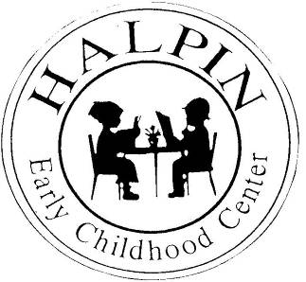
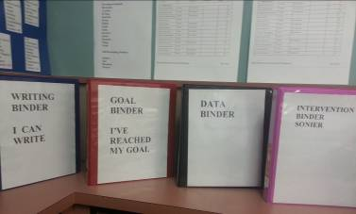
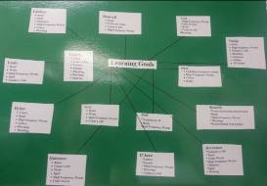
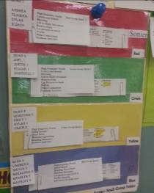
Attendance Goal

95%

Weekly
Attendance %

8/27 | 96.9%
9/4 | 94.4%
9/10 | 94.31%
9/17 | 92.79%
9/24 | 92.87%
10/1 | 95.6%
10/8 | 94.8%
10/15 | 94.6%
10/22 | 93.8%
10/29 | 94.4%

November 5, 2012
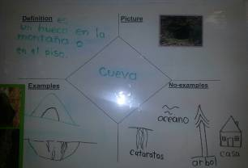
Community Helpers
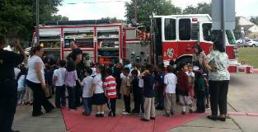

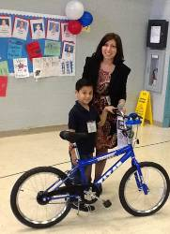
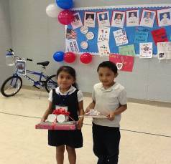

Don’t forget to vote!
Our Halpin students already voted.
“Scare Away Drugs” Parade
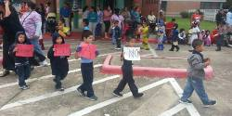
Guest speaker, Connie Reza, shares with PTO the harmful effects of drugs and alcohol on the brain. Our PTO president, Patrina Johnson, assisted her during the presentation.

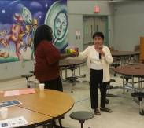
Professional Learning Community – Team Planning

Approximately 30% of the year has passed.

Where are the students in relation to the end-of-year goals?
What TEKS has each student mastered? What TEKS lie ahead?
How does my re teach look like?
How do I know the students have mastered the goals?
What are my tiered groups? What interventions do I have in place for my struggling students?
Have I started using my intervention monitor as an additional support for my students?
What am I doing to ensure that EVERY child has at least one year’s academic growth?
How do my student journals look? Am I reviewing the student entries?
How do I collaborate with the ancillary teachers to improve student academic vocabulary?

The PLC room is ready for planning!
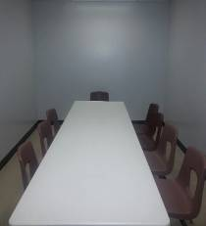
PLC room next to Ms. Sonier’s classroom
Critical Thinking
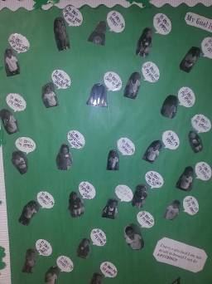
Red Ribbon Week
Meet our 2012 President and Vice President!

