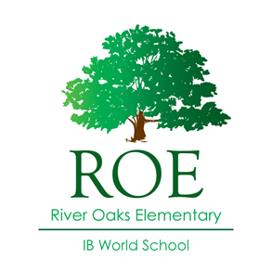**River Oaks Elementary**

**2008 Kirby Dr. Houston TX 77019**

Principal: Brett Gallini

**SDMC Final Meeting**

Tuesday, May 23, 2023

Minutes

Start: 3:15 p.m.

* Mr. Gallini welcomed SDMC attendees for the final session of the year. He acknowledged the committee and its work.
* The following highlights of the year were addressed with the committee:
  1. Post-Covid “back to normal” with many opportunities for families to engage in campus life.
  2. Enrollment Increase
  3. Curricular Step-Back and Recalibrate
     1. Vision for Excellence in ELA and Math
* Teachers have collaborated and selected high-quality instructional materials (HQIM) to support their coursework for the 23-24 school-year
* Mr. Gallini discussed summer professional development for the campus, including:
  + TIBS training for new staff and those who need additional IB training.
  + Pre-Service Professional Development
    1. ELA and Math focused.
* Mr. Gallini shared that an additional enrichment teacher will be added to the 23-24 schedule. Science Lab. All students will engage in laboratory science with a specialist. This is in addition to science, which is taught by classroom teachers.
* 23-24 Enrichment Specialists:
  + Physical Education, Music, Art, Library, Spanish, and Laboratory Science

Meeting Ended at 4:00 p.m.