

llll

MISSION STATEMENT

Albert Thomas Middle School

1. The Uniform in Uniformity

Educators and experts who are pro school uniforms believe that uniforms contribute positively to students' behavior. They believe that hen students wear uniforms, they feel more professional and behave accordingly. Many educators believe that students can become distracted by fashion trends and status symbol clothing. Therefore, when all students are dressed in regulation uniforms, there is less focus on fashion in the classroom and more focus on learning.

2. Simple Economics

Buying a few school uniforms instead of a new school wardrobe every fall is much more economical. School uniforms are designed to stand up to everyday wear and repeated washing so most parents find that they can get away with buying a few sets.

3. An Even Playing Field

One of the most obvious argument for school uniforms is that by having all children dressed the same, there is a decrease in bullying and teasing. In this era of status brands and high-fashion trends, clothing has become the definitive status symbol for children and teens. By evening the playing field with uniforms, there is less opportunity for children to be picked on or shunned for their clothes.

4. Easier Mornings for Parents

When there's no debate on what a student is allowed wear to school, then that makes mornings easier for parents and for kids. Everyone knows exactly what the kids need to wear, their regulated school uniform. This can lead to a decrease in morning arguments.

To provide a world class education to every student that crosses the threshold of Albert Thomas Middle School so that they may become global citizens able to compete worldwide or locally while making a positive impact on society and having the capacity to sustain themselves as young men and women of integrity as they go beyond the walls of Albert Thomas Middle School.

The Pros of school uniforms

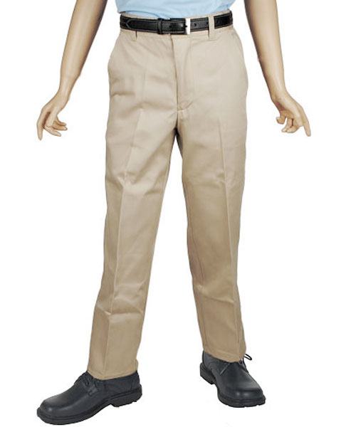
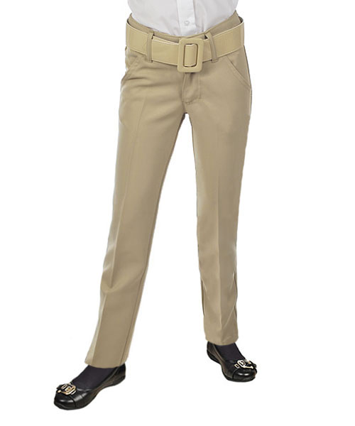

6th Grade Female Uniform Polo Blouse-

RED

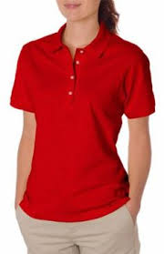

7th Grade Female Uniform Polo Blouse- BLUE

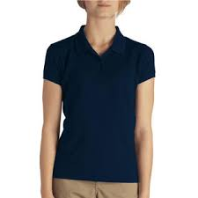

8th Grade Female Uniform Polo Blouse-

BLACK

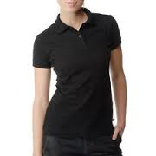

Females may wear Only Khaki pants, knee-length shorts and skirts

We Build Dreams. We Discover Strengths. We Maximize Talents.

6th Grade Male Uniform Polo Shirt-

RED

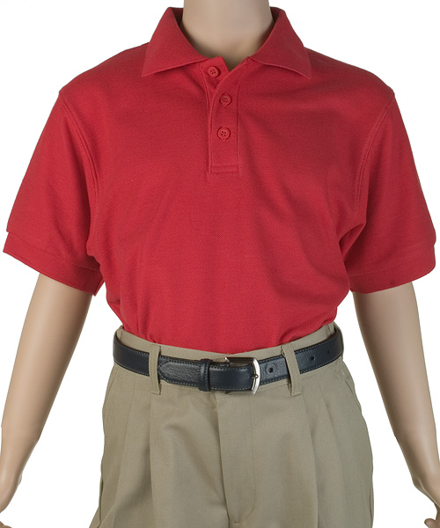

7th Grade Male Uniform Polo Shirt-BLUE

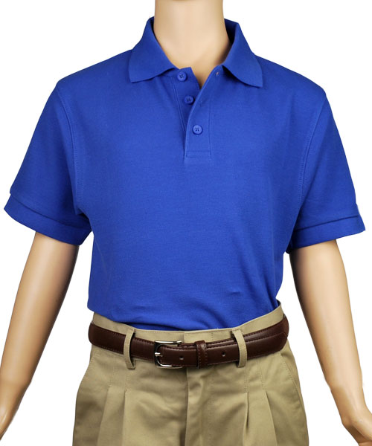

8th Grade Male Uniform Polo Shirt -BLACK

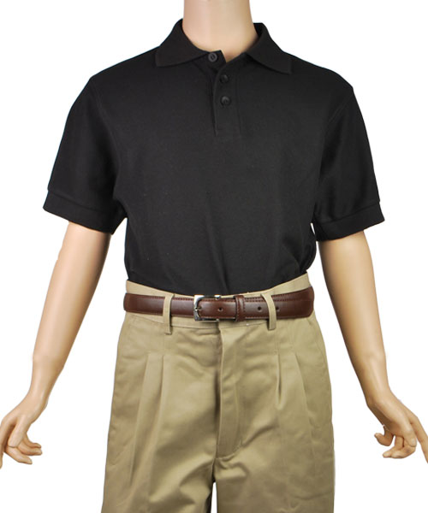

Males may wear Only Khaki pants or knee length shorts with a belt

A.T.M.S School Uniform Policy

2016-2017

The young men and women of Albert Thomas Middle School must abide by the school uniform at all times. Blouses and polo shirts MUST be tucked in, with a belt, and proper shoes. Only khaki pants, knee-length shorts or skirts are acceptable. Uniforms can be purchased at your local Uniform Superstore.
Absolutely no hoodies will be allowed on campus. Please make sure jackets have a zipper or buttons.
Boys may not wear earrings. NO EXCEPTIONS!

