Kindergarten teachers and I attended Think Literacy training at Tinsley Elementary. We learned the importance of high quality literature during Read Aloud time. The team actively participated and completed all assigned homework. Ms. Abu, Tinsley’s principal, was impressed with the collaboration. We will be using PLC meetings the rest of this school year to start developing the main idea and plans for books to be read to our students.
We have had successfully pre-registered 110 students for the upcoming school year!
This was the book we practiced with Tinsley students last week. What is the main idea???
Scholastic Book Fair – We sold over $4,000!

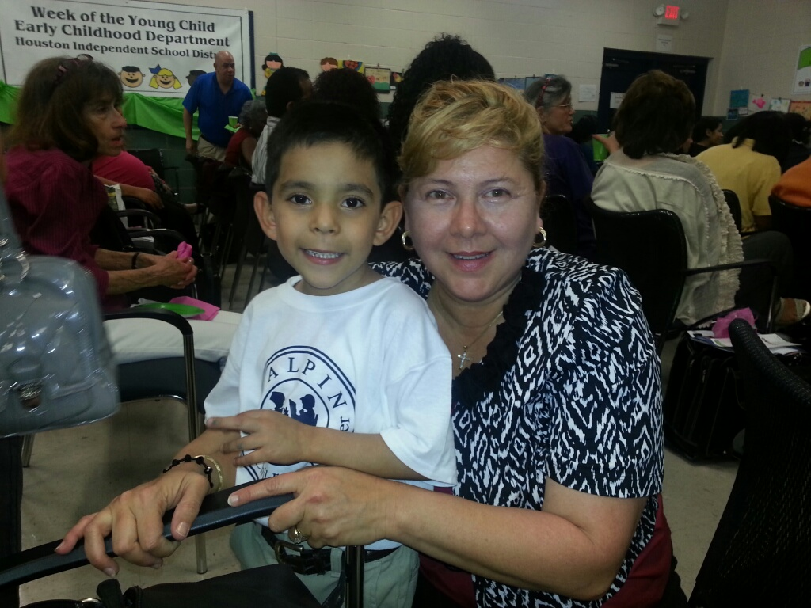
Halpin Early Childhood Center
Faculty and Staff Newsletter
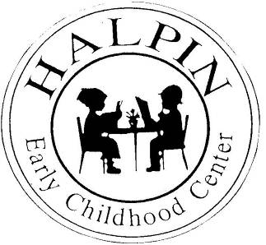
Attendance Goal
95%

Weekly
Attendance %
3/18 | 95.3%
3/25 | 95.1%
4/01 | 95.2%
4/08 | 95.9%
4/15 | 96%

April 22, 2013
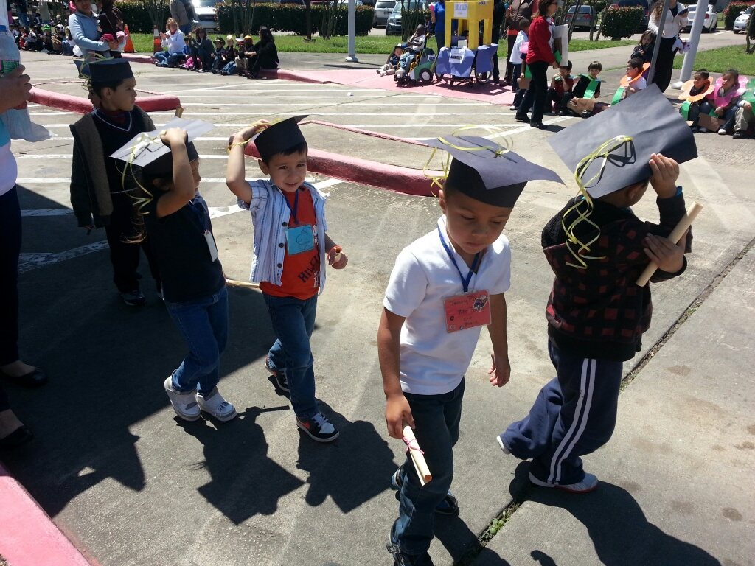
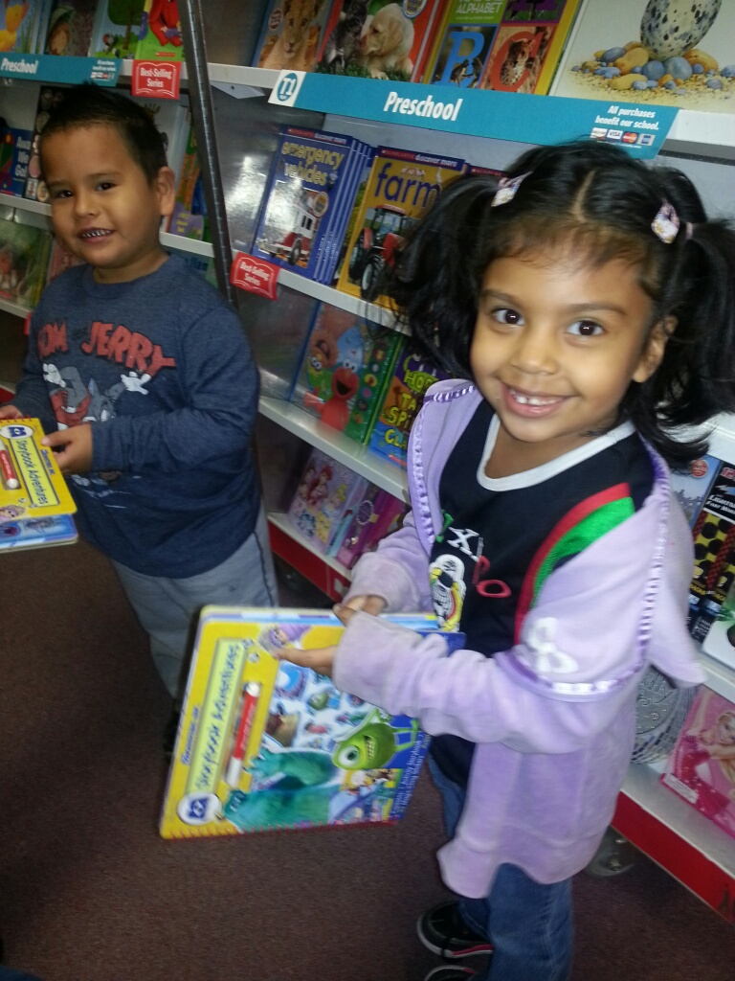

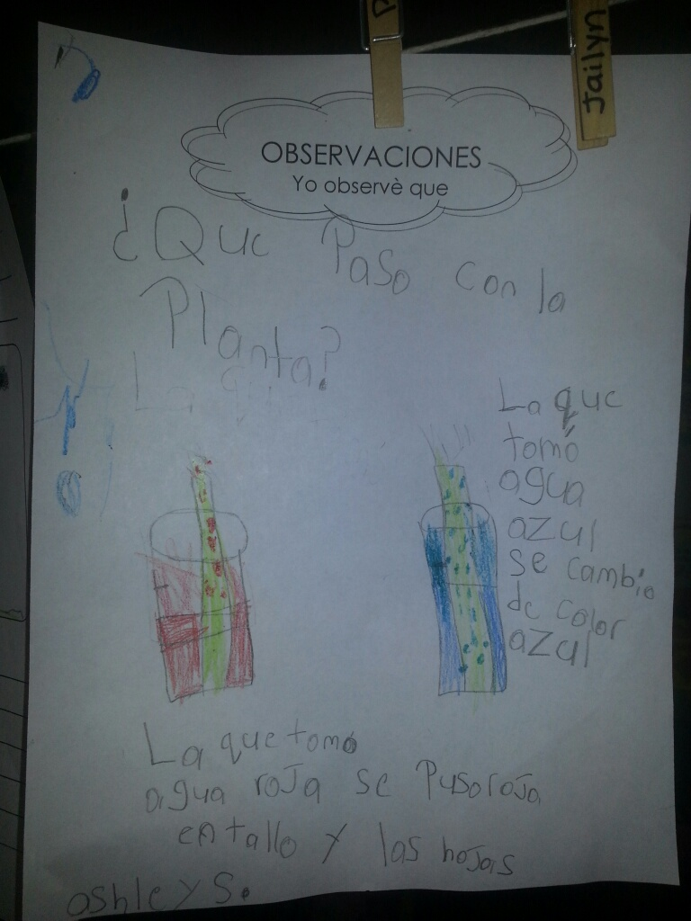
Upcoming events

Book Study Presentations – Monday, April 22 and Tuesday, April 23 at 3:35
Week of Young Child Pictures – Wednesday, April 24 and Thursday, April 25
SDMC Meeting – Wednesday, April 24 at 3:40
Support Staff Appreciation Breakfast – Wednesday, April 24 8:00 – 8:30
Children’s Museum Night (Parent/Child Field trip) – April 25
Halpin ECC will be at the School Choice Fair – Saturday, April 27 9:00 – 12:00

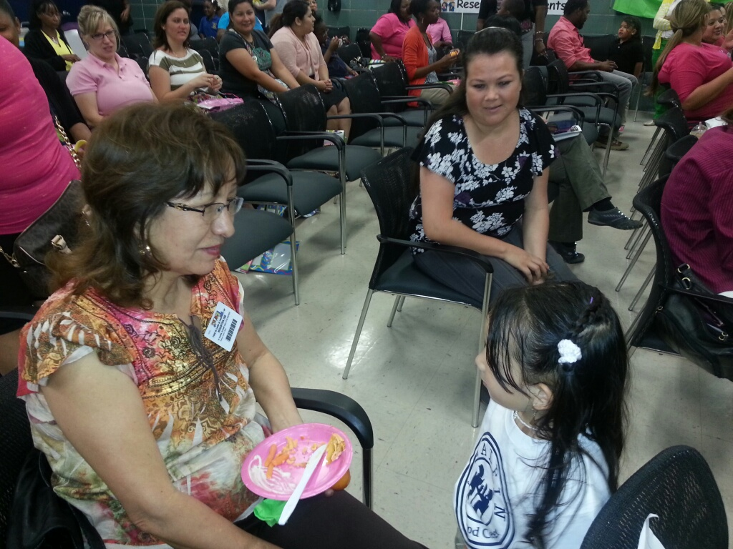
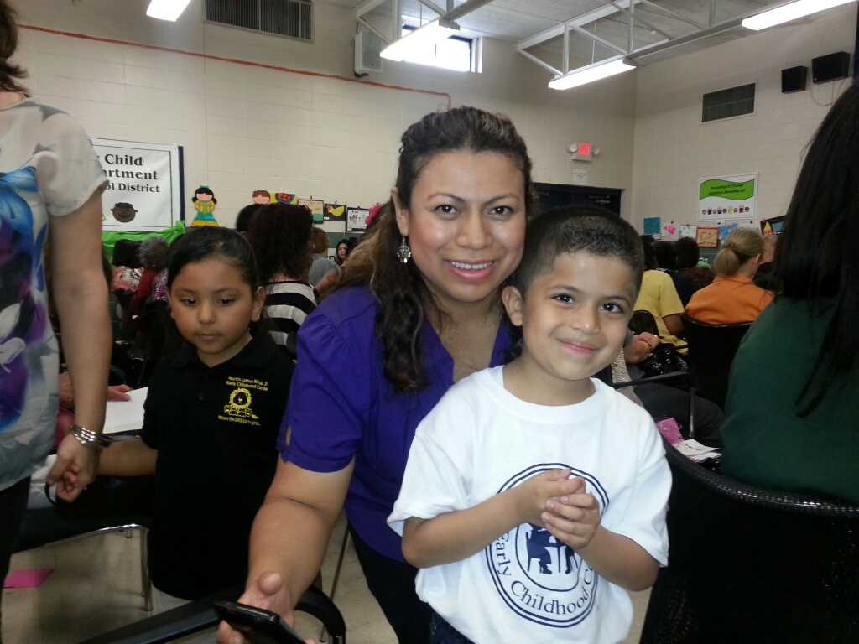
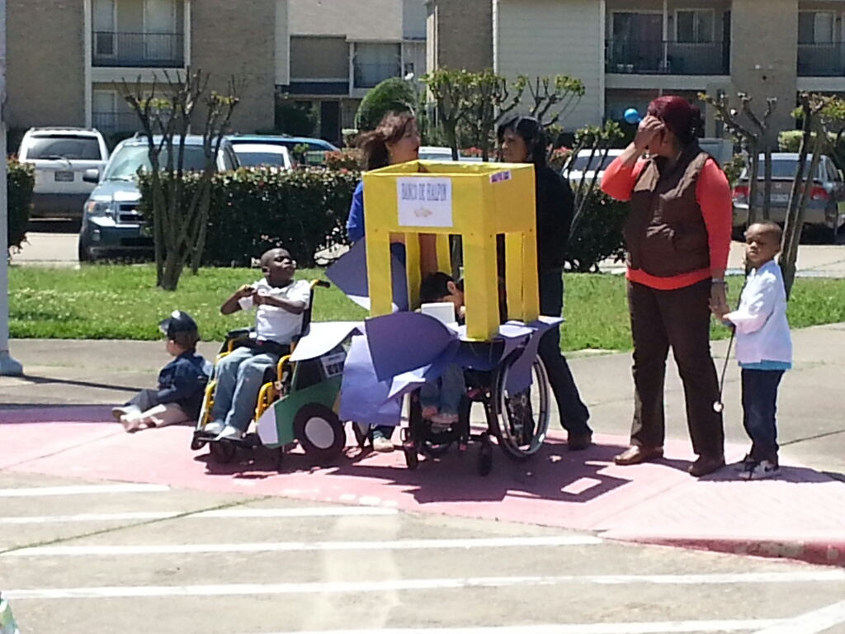
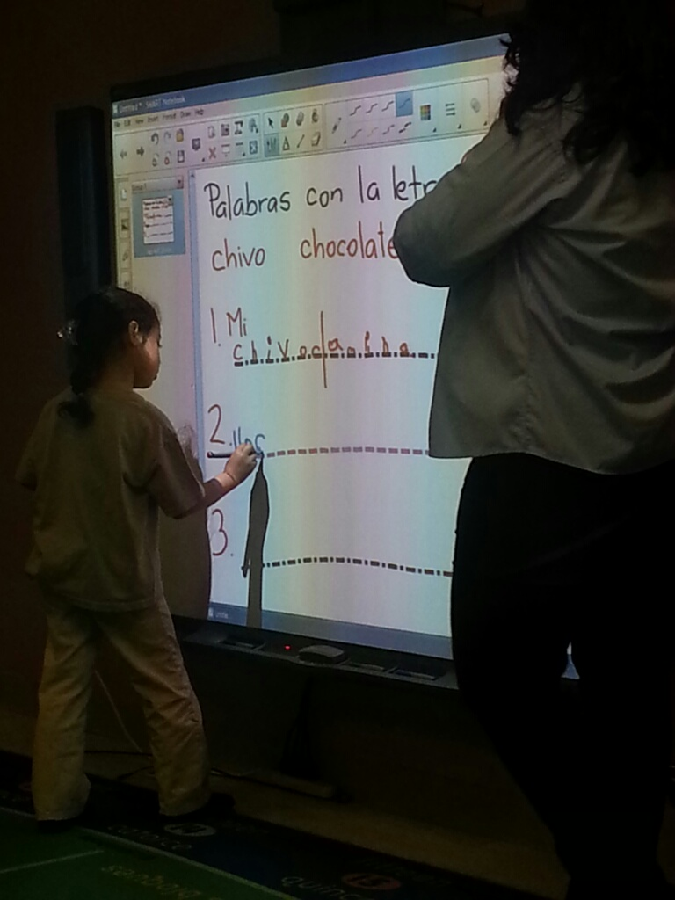
Week of the Young Child
Thank you to all the teachers that attended the event. It was amazing to hear our students tell all that they have learned this year in PK.

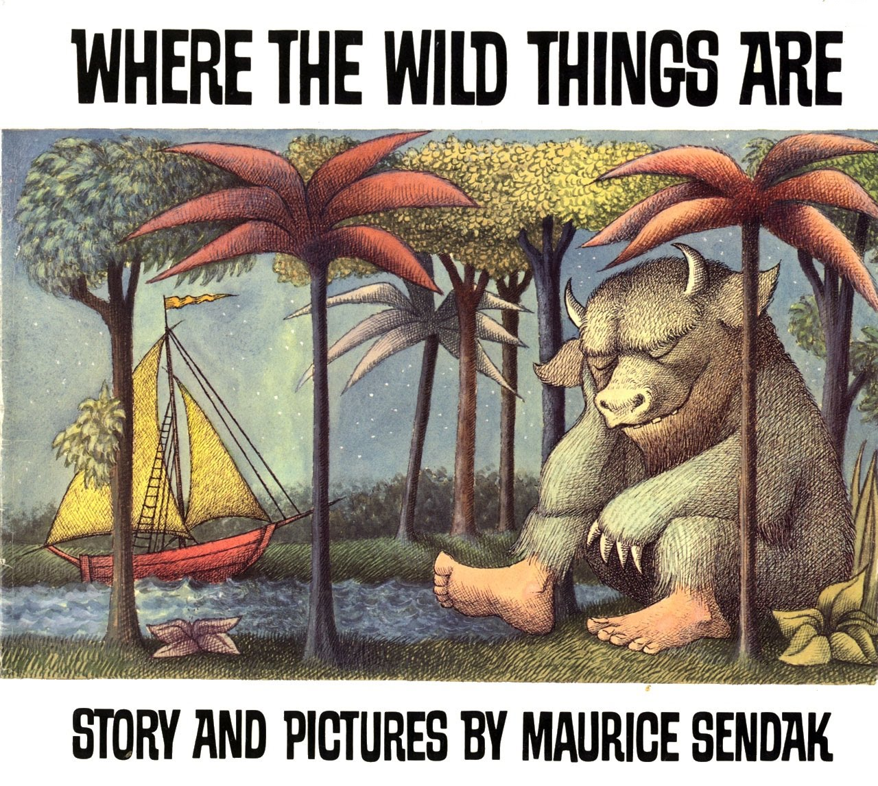
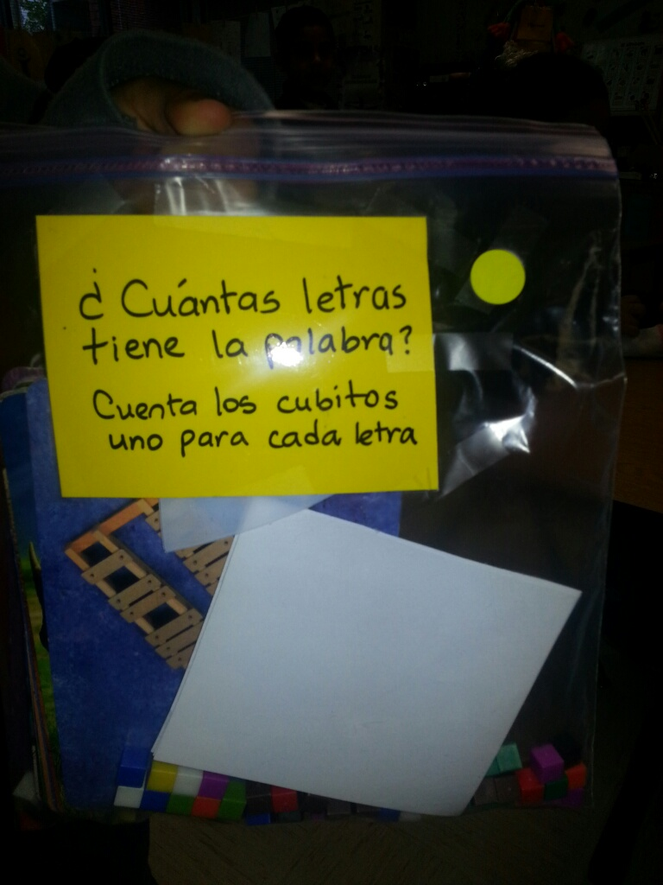
Week of Young Child Parade
New Kindergarten Smart Boards in action!!!
Science/Writing Work Product
Think Literacy
We want to thank you for all you do because we can't spell SUCCESS without "U"!
Support Staff Appreciation Breakfast
April 24, 2013
8:00 - 8:30

