In need of hands-on activities…just visit a colleague for great ideas!
We have seen lots of progress as we look at our Istation reports and DRA/EDL levels. Continue utilizing your data to strategically intervene with students and help them achieve their individual student goals.

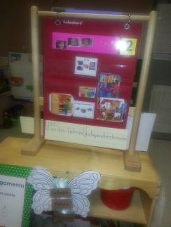
Halpin Early Childhood Center
Faculty and Staff Newsletter
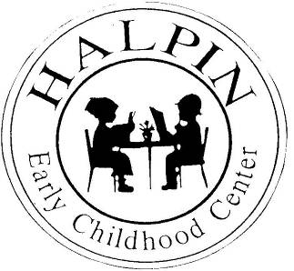

April 8, 2013
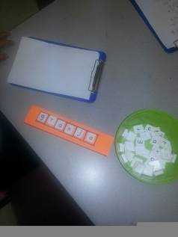
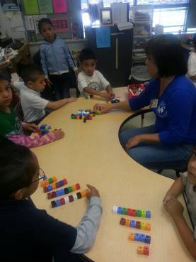
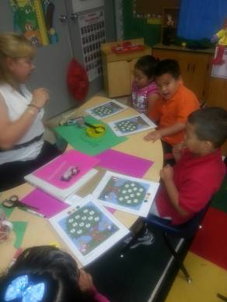
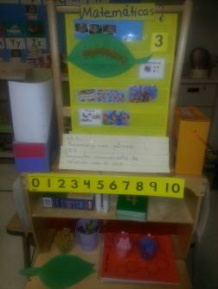
Attendance Goal
95%

Weekly
Attendance %
3/18 | 94.7%
3/25 | 95%
4/01 | 95%

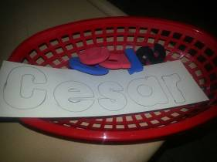
Upcoming events

HeadStart/HISD Teacher Collaborative Meeting – Tuesday, April 9th 3:30
Kindergarten Think Learning training – April 17 and 18 at Tinsley Elementary
Children’s Museum Night (Parent/Child Field trip) – April 25
Halpin ECC will be at the School Choice Fair – Saturday, April 27

Kindergarten TPRI/Tejas Lee testing starts today!
Please continue to update your DRA/EDL levels to adjust your reading groups.

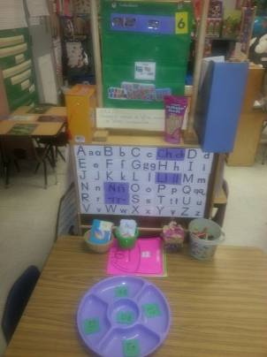
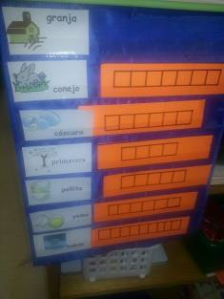
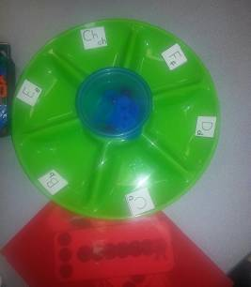
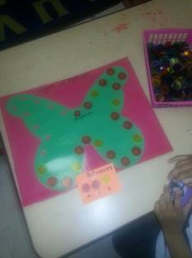
Week of the Young Child
Event will be held on Monday, April 15 – Sign up on E-Train
We will have some students attend and share what they have learned in PK.
We will also celebrate with a picture fundraising opportunity. Ms. Briseno is sending out information to parents. Students will have the opportunity on April 24 and 25 to select an outfit that highlights their future career.
We have had a successful first week of PK roundup.
Last week 80 students were preregistered!
Small Group Instruction

