Upcoming Events/Reminders
Stanford/Aprenda Testing - December 3 - 14
Discipline Committee – December 3
SDMC – December 12
Faculty Holiday Meeting – December 17
Winter Pictures Fundraiser – December 18 and 19
December AttenDANCE and teacher drawing – December 21
Thank you Ms. Blessinger, the Attendance Committee and supporters for a fabulous November AttenDANCE celebration! We will continue to promote to parents the positive effects being at school has with students reaching their academic goals.

Congratulations to Ms. Hearn for being the lucky winner of the November teacher drawing and winning the AMC gift card! Teachers don’t forget the more you help in getting your students here the more chances you have to win. Each day your class is in the 100% club, place the ticket with your name in the container for December’s drawing.

Please remind parents: December Attendance Incentive

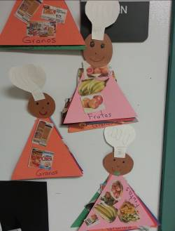
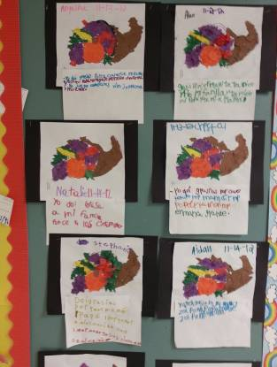
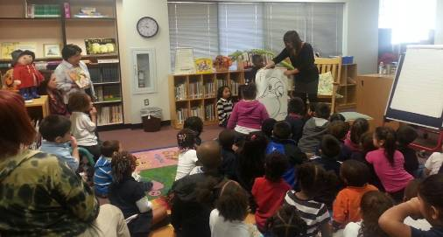
Halpin Early Childhood Center
Faculty and Staff Newsletter
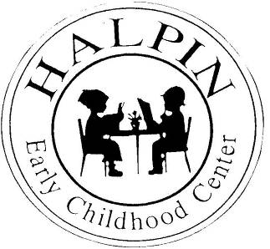
Attendance Goal

95%

Weekly
Attendance %

8/27 | 96.9%
9/4 | 94.4%
9/10 | 94.31%
9/17 | 92.79%
9/24 | 92.87%
10/1 | 95.6%
10/8 | 94.8%
10/15 | 94.6%
10/22 | 93.8%
10/29 | 94.4%
11/5 | 94.07%
11/12 | 93.6%
11/19 | 90.7%
11/26 | 94.4%

December 3, 2012
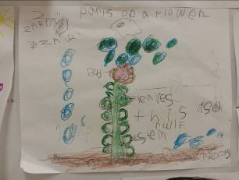
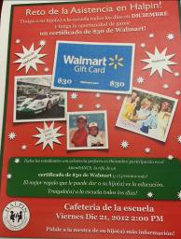
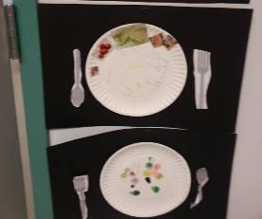
A variety of ways to express what we gives thanks for.
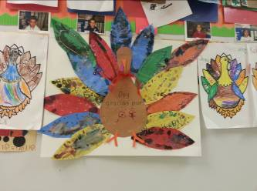
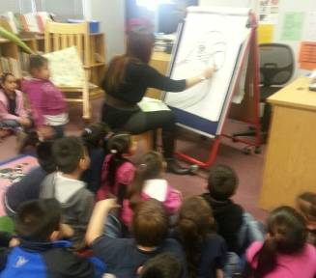
After today’s health screening, we all would benefit from learning some tips from Pre-Kindergarten on nutrition.
Ms. Tankersley’s class is studying how plants grow.
Connie Reza, author of “Leah Ann adopta un perico”, and illustrator, Mei Chang, graciously read for our students on Tuesday, November 20th. This was an amazing experience used to promote College and Career Readiness at our campus.
