G r a n d

Ma r s h a ll

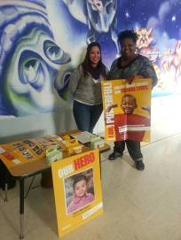
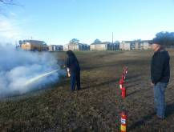

Halpin Early Childhood Center
Faculty and Staff Newsletter

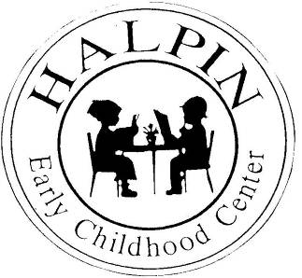
Attendance Goal
95%

Weekly
Attendance %
1/08 | 94.8%
1/14 | 91.1%
1/21 | 91.7%
1/28 | 95.4%
2/04 | 96%

February 11, 2013
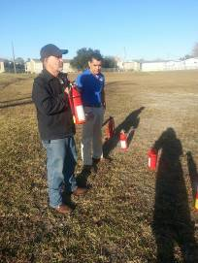
Professional Learning Communities at Work
Kindergarten teachers are learning how to effectively use the reports and monitor interventions using Istation. We thank Team HISD for sending us the “COW” computers on wheels. We have 232 students in our Istation system and last week 212 students logged in and used Istation.

Way to go Team HALPIN!!!
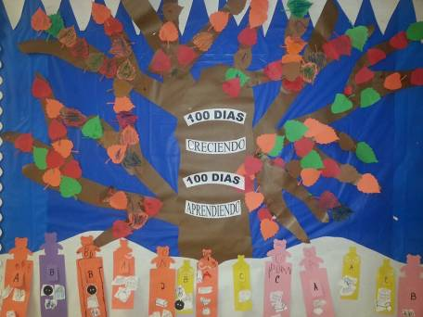
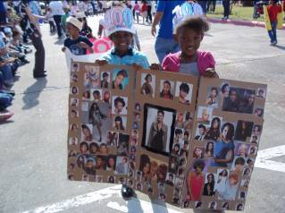

Our Nurse Mrs. Luckett is Amazing!!!
She coordinated our hand-washing classes for students, nutrition classes for parents, organizing fundraisers Pennies for Patients, fire extinguisher class, and much more.
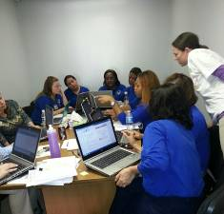
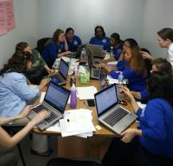
Upcoming events
Parent Workshop “Loving Limits” Collaboration with Children’s Museum – Tuesday, February 12 at 2:00 (Halpin’s Cafeteria)

Early Release (Faculty Data Meeting and Committee Meetings) – Wednesday, February 20

Tinsley’s Reading Ambassadors – February 21st (selected classrooms)

Don’t forget about our Black History Daily Celebrations during announcements.
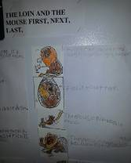
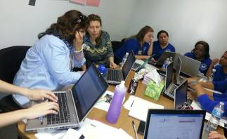
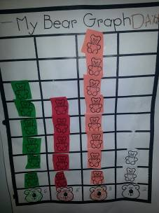
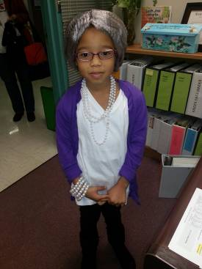
Wow! Team Halpin is getting our attendance back up. Continue informing parents of our attendance policies and the importance of being at school every day.
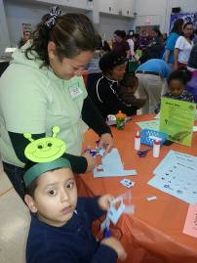
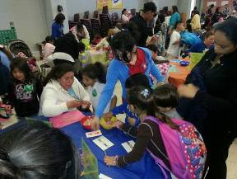

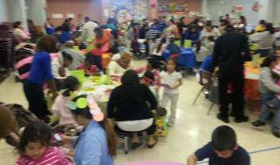
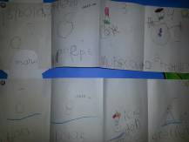
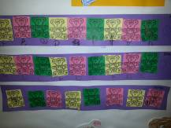
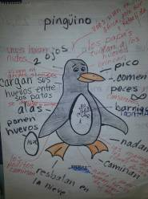
Thank you, to Mr. Najera and his team. Our floors look so shiny and clean after this weekend’s re-waxing. He sure takes care of our building.
Family Math Event

