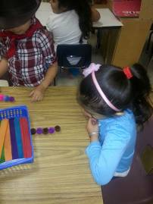
Halpin Early Childhood Center
Faculty and Staff Newsletter
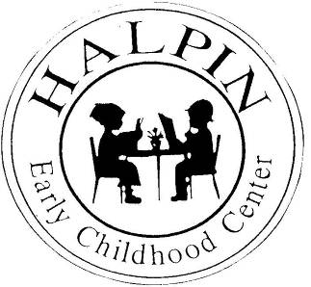

February 25, 2013
Attendance Goal
95%

Weekly
Attendance %
1/08 | 94.8%
1/14 | 91.1%
1/21 | 91.7%
1/28 | 95.4%
2/04 | 96%
2/11 | 95.9%
2/18 | 92.8%


As I visited classrooms last week I saw evidence of Data Charts, Attendance Tracking Charts, Some Differentiation, Small Group instruction, DRA Leveled Readers, Istation Implementation, Positive Interactions Between Teachers and Students.
Upcoming events

AttenDANCE – Friday, March 1
PreKindergarten Report Cards due – Friday, March 1
Spring Break – March 11 – 15
Thank you to the PK and Kindergarten team members for conducting such a professional Vertical Alignment meeting on our early release. It proved to be worthwhile for everyone in attendance. Kindergarten teachers also gave the PK teachers praise because they can tell the difference between a student coming from our PK program and an outside or no PK experience.
Thank you to our in-house presenters: Ms. Blessinger (Attendance Update); Ms. Duran-Reyes and Ms. Turner (Discipline); and Nurse Luckett (Safety).

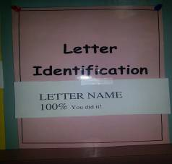
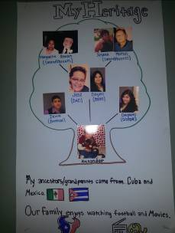
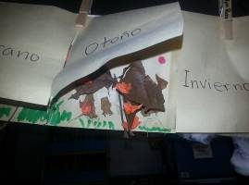

Teachers, continue informing parents of our attendance policies and the importance of being at school every day. Remember, you have an Attendance Committee and our school registrar, Ms. Dela Rosa, to go to for additional assistance in contacting and meeting with parents.

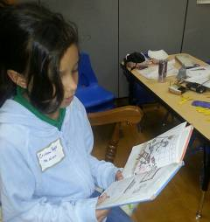
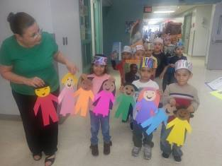
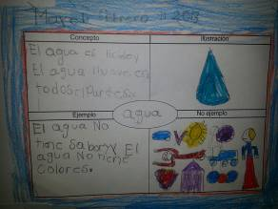
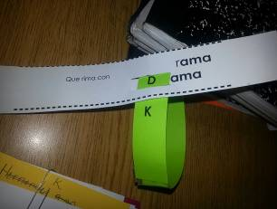
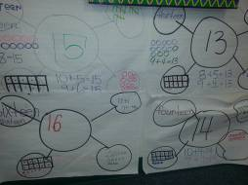
Check out our pictures on HISD’s Facebook page!
We look forward to reading some of their compositions.

Black History Parade
Go Texan Day!

