We are looking forward to our book presentations on
Wednesday, January 23rd (Kinder and Special Education Teams) and
Monday, January 28th (PK and Ancillary Teams).

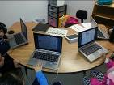

Wow! We are off to a great start of the year. Our Kindergarten students have all been tested on the new Istation software program. We will discuss results, other data points, resources available and much more during our extended Kindergarten PLC meeting tomorrow from 1:00 – 3:00.
Please bring your data binder.

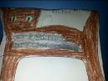
Halpin Early Childhood Center
Faculty and Staff Newsletter
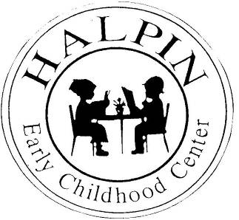
Lots of student writing evident in our hallways!!!
Attendance Goal
95%

Weekly
Attendance %
1/08 | 94.8%

January 14, 2013
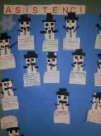
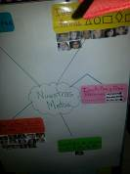
Istation
Our kindergarten students have already started their intervention sessions this week. Thank you, Ms. Warner for spending precious weekend hours working on our charts and groups.


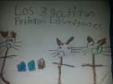
WORKSTATIONS
Workstations allow you the opportunity to differentiate and meet with a small group of students. Ms. Hearn provides her students with a 1st and 2nd choice activity.
Upcoming events

SDMC Meeting – Wednesday, January 16
Faculty Meeting – Wednesday, January 23rd (“Shouting Won’t Grow Dendrites” book presentation)
Muffins for Mom – Thursday, January 24 at 8:30 AM
Professional Development – Monday, January 28th (book presentation)
Math Family Event – Children’s Museum Partnership (Early Release) – Wednesday, January 30th at 1:30
January AttenDANCE – Friday, February 1
Don’t forget to continue to track your student data and celebrate their progress.

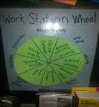
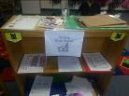
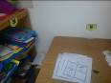
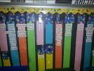
Happy New Year!!!

