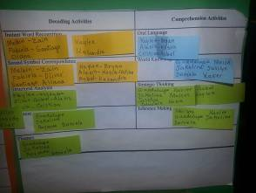


Halpin Early Childhood Center
Faculty and Staff Newsletter
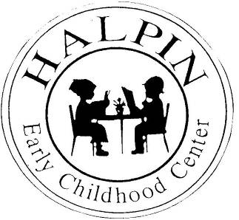
Attendance Goal
95%

Weekly
Attendance %
1/08 | 94.8%
1/14 | 91.1%
1/21 | 91.7%

January 28, 2013

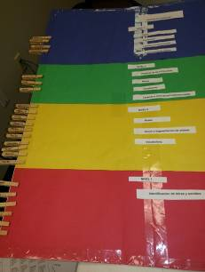
Book Study “Shouting Won’t Grow Dendrites”
Amazing PD given by our very own teachers during the two sessions of the book study. We not only reviewed the content of the chapters but were able to see some real life examples.

Way to go HALPIN!!!
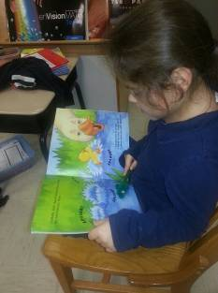
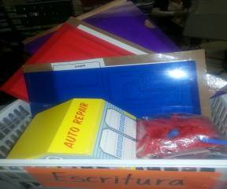
DIFFERENTIATION
As I visit classrooms I see students reading at their own level, teachers taking a risk and providing at least 3 levels of the same activity in a workstation, a variety of instructional strategies that help engage the brain, small group instruction and Istation implementation.
Upcoming events
Early Release (Family Math Event) – Wednesday, January 30
Discipline Committee Meeting – Wednesday, January 30 at 3:00
January AttenDANCE – Friday, February 1
“Muffins for Mom” was a huge success with over 100 attendees. Way to go Mrs. Lorence!!!
We have seen a decline in attendance the week of January 14 and 21. It has been reported that a large amount of students have gotten sick (6 in a classroom). We still need to inform parents to bring students if they are not sick (fever). We have sent personalized letters home through the mail and will start meeting with parents with high number of absences.
Need an idea on how to track student progress or small group instruction, then don’t hesitate and visit another classroom. Here are a few of many great ideas.

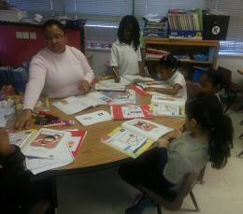
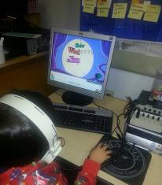

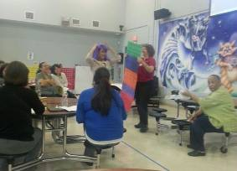
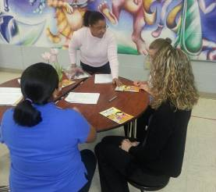


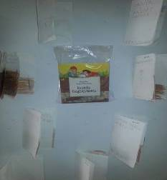

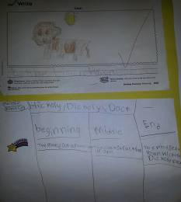
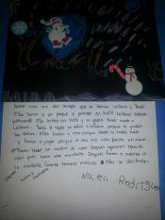
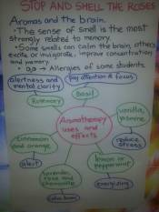
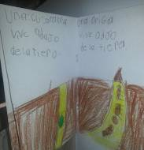
Don’t forget to call parents by 8:45 if the student is not at school.
The daily reminders will send the message that we need their child here each and every day.

