Upcoming events

Book Fair – March 25 - 28
Donuts with Dad – Tuesday, March 26
AttenDANCE – Thursday, March 28
Spring Holiday – March 29

Halpin Early Childhood Center
Faculty and Staff Newsletter

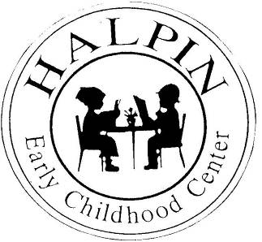
Attendance Goal
95%

Weekly
Attendance %
3/18 | 94.7%

March 25, 2013
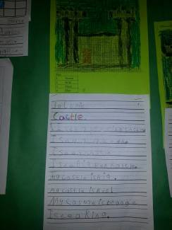
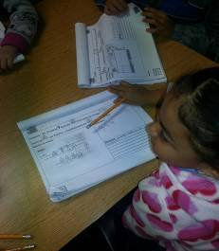
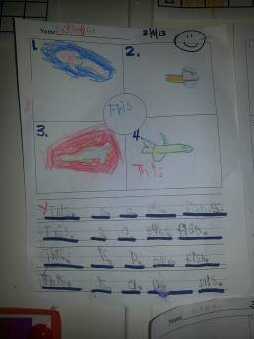


Let’s keep our focus on attendance strong! Look at the chart below. In April last year we dropped to 91%. Keep talking to parents and remind students that we have two whole months of critical instruction in order to prepare our students for the next school year.
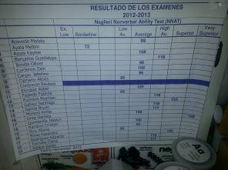
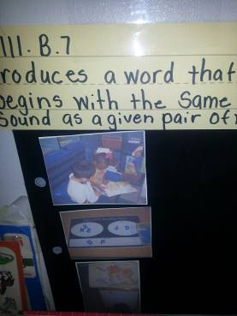
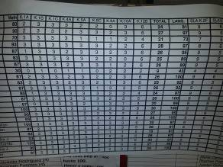


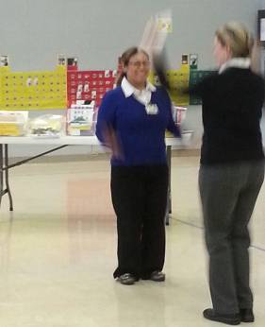
ATTENDANCE
YTD Aug. Sept. Oct. Nov. Dec. Jan. Feb. Mar. 8 April May
'12-'13 | 96.0% | 97.7% | 95.6% | 96.4% | 95.3% | 95.9% | 95.4% | 96.6% | 96.6%
'11-'12 | 93.0% | 96.9% | 95.3% | 93.9% | 92.9% | 93.5% | 92.7% | 92.0% | 92.1% | 91.0% | 92.1%

Thank you to everyone for participating in our Faculty Meeting. I know everyone was able to learn at least one new idea to implement hands-on activities in their classroom.
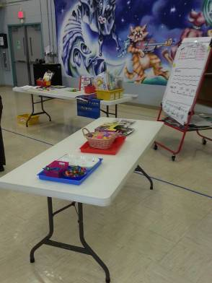
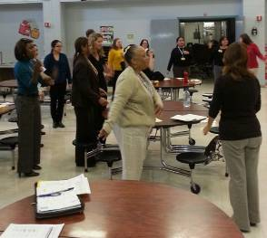
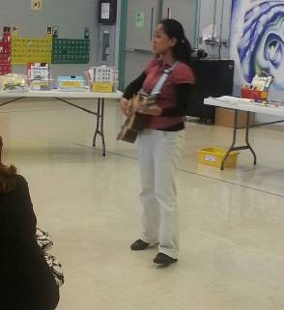
Writing
Workstation Activities
TEKS/Data

