Technology Quiz
_______________________________________________________________________________________________________________


1. This icon takes you to the __________ .

Internet Desktop Window


- What does open on the computer ?

menu window folder

3. This key helps you make corrections when you are
typing.

Tab Shift Backspace

4. Our computer lab has _______ computers.

laptop desktop tablet

- Which of the following is an input device:

printer speakers keyboard

- When you type, place your fingers on the:

home row numbers upper row

- There are ______ parts to a computer

2 3 4

X
- Use the to _____ a program.

continue start close

9. You can use the scroll wheel on the mouse to

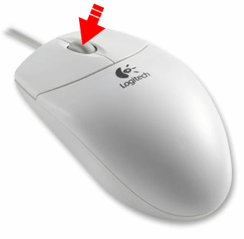
move up and down in a window
move left and right in a window

start a program

10. This program is for 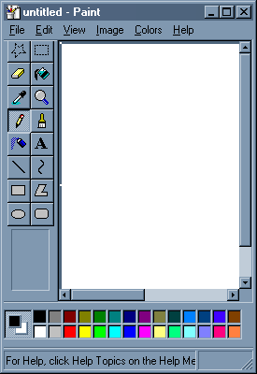

drawing and painting writing testing

11. To open an icon you have to ________.

scroll click double-click

12. When you type a Password, it will look like the following:

# # # # @ @ @ @

