Dear Families,

Our school is challenging students to read at least 100,000 minutes by October 27. If every student reads 15 minutes each day for the next 9 days, we would easily have more than 100,000 minutes. Let’s see how many we can really read! If students read 100,000 minutes by October 27, I have agreed to let them dress up as their favorite book character on Monday, October 31!

I am hoping that when the student body sees that I am willing to do something wacky, just to get them to read more, it tells them that I consider reading to be very important.

Good reading skills provide all children with a valuable educational advantage. Allowing kids to choose their own books by connecting them with books they want to read will motivate them to practice more. I hope that letting the students dress as their favorite character will rally our entire school community around a reading goal and get everyone more focused on the importance of reading.

You can count time you spend reading aloud to your child. Reading together also strengthens the connection between you and your child – here are a few ways you can promote reading in your own home:

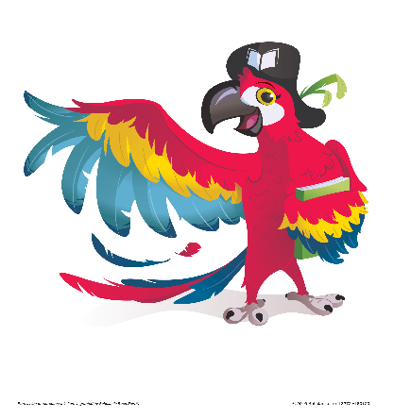• Encourage your child to choose the books they want to read.

• Share the books that you loved as a kid with your own child.

• Start a Family Book Club and enjoy the same book together.

• Visit the Book Fair with your child.

• Encourage reading every day with library visits, story-time at home, and conversations about books. Let your child see you reading.

We hope your family makes reading a big part of your family fun.

Sincerely,

Lori Frodine