Frog Dissection
Pictures: Modern Biology, Holt
Modified from: http://sps.k12.ar.us/massengale/frog_dissection.htm
Background:
As members of the class Amphibia, frogs may live some of their adult lives on land, but they must return to water to reproduce. Eggs are laid and fertilized in water. On the outside of the frog’s head are two external nares, or nostrils; two tympani, or eardrums; and two eyes, each of which has three lids. The third lid, called the nictitating membrane, is transparent. Inside the mouth are two internal nares, or openings into the nostrils; two vomerine teeth in the middle of the roof of the mouth; and two maxillary teeth at the sides of the mouth. Also inside the mouth behind the tongue is the pharynx, or throat.
In the pharynx, there are several openings: one into the esophagus, the tube into which food is swallowed; one into the glottis, through which air enters the larynx, or voice box; and two into the Eustachian tubes, which connect the pharynx to the ear. The digestive system consists of the organs of the digestive tract, or food tube, and the digestive glands. From the esophagus, swallowed food moves into the stomach and then into the small intestine. Bile is a digestive juice made by the liver and stored in the gallbladder. Bile flows into a tube called the common bile duct, into which pancreatic juice, a digestive juice from the pancreas, also flows. The contents of the common bile duct flow into the small intestine, where most of the digestion and absorption of food into the bloodstream takes place.
Indigestible materials pass through the large intestine and then into the cloaca, the common exit chamber of the digestive, excretory, and reproductive systems. The respiratory system consists of the nostrils and the larynx, which opens into two lungs, hollow sacs with thin walls. The walls of the lungs are filled with capillaries, which are microscopic blood vessels through which materials pass into and out of the blood. The circulatory system consists of the heart, blood vessels, and blood. The heart has two receiving chambers, or atria, and one sending chamber, or ventricle. Blood is carried to the heart in vessels called veins. Veins from different parts of the body enter the right and left atria. Blood from both atria goes into the ventricle and then is pumped into the arteries, which are blood vessels that carry blood away from the heart.
The urinary system consists of the frog’s kidneys, ureters, bladder, and cloaca. The kidneys are organs that excrete urine. Connected to each kidney is a ureter, a tube through which urine passes into the urinary bladder, a sac that stores urine until it passes out of the body through the cloaca. The organs of the male reproductive system are the testes, sperm ducts, and cloaca. Those of the female system are the ovaries, oviducts, uteri, and cloaca. The testes produce sperm, or male sex cells, which move through sperm ducts, tubes that carry sperm into the cloaca, from which the sperm move outside the body. The ovaries produce eggs, or female sex cells, which move through oviducts into the uteri, then through the cloaca outside the body.
The central nervous system of the frog consists of the brain, which is enclosed in the skull, and the spinal cord, which is enclosed in the backbone. Nerves branch out from the spinal cord. The frog’s skeletal and muscular systems consist of its framework of bones and joints, to which nearly all the voluntary muscles of the body are attached. Voluntary muscles, which are those over which the frog has control, occur in pairs of flexors and extensors. When a flexor of a leg or other body part contracts, that part is bent. When the extensor of that body part contracts, the part straightens.
Objectives:
• Describe the appearance of various organs found in the frog.
• Name the organs that make up various systems of the frog.
Purpose:
In this lab, you will dissect a frog in order to observe the external and internal structures of frog anatomy.
Materials:
• safety goggles, gloves, and a lab apron
• forceps
• preserved frog
• dissecting pins (6–10)
• dissecting tray and paper towels
• plastic storage bag and twist tie
• scissors
• marking pen
• dissecting needle

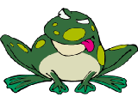
Frog External Anatomy

1. Observe the dorsal and ventral sides of the frog.
How do they differ in color?
- Dorsal side color ___________
- Ventral side color ____________

2. Examine the hind legs.
How many toes are present on one foot? ________ Are the toes webbed? ______

3. Examine the forelegs.
How many toes are present on one foot? _________Are the toes webbed? _______

4. Use a ruler to measure your frog, measure from the tip of the head to the end of the frog’s backbone (do not include the legs in your measurement). Compare the length of your frog to other frogs.

Your Frog  (length in cm) | Frog 1 | Frog 2 | Frog 3 | Frog 4 | Average Length of Grass Frogs

5. Locate the frog’s eyes, the nictitating membrane is a clear membrane that attached to the bottom of the eye and is used for protection of the eye. Use tweezers to carefully remove the nictitating membrane. You may also remove the eyeball.
- What color is the nictitating membrane? _______
- What color is the eyeball? _________

6. Just behind the eyes on the frog’s head is a circular structure called the tympanic membrane. The tympanic membrane is used for hearing. Measure the diameter (distance across the circle) of the tympanic membrane.

Diameter of tympanic membrane _______cm

7. Feel the frog’s skin. Is it scaly or is it slimy? ____________

Anatomy of the Frog’s Mouth

Procedure: Pry the frog’s mouth open and use scissors to cut the angles of the frog’s jaws open. Cut deeply enough so that the frog’s mouth opens wide enough to view the structures inside.

1. Locate the tongue. Play with the tongue. Does it attach to the front or the back of the mouth? __________ (You may remove the tongue)

2. In the center of the mouth, toward the back is a single round opening. This is the esophagus. This tube leads to the stomach. Use a probe to poke into the esophagus.

3. Close to the angles of the jaw are two openings, one on each side. These are the Eustachian tubes. They are used to equalize pressure in the inner ear while the frog is swimming.

Insert a probe into the Eustachian tube. To what structure does the Eustachian tube attach? ____________________

4. Just behind the tongue, and before you reach the esophagus is a slit like opening. (You may need to use your probe to get it to open up). This slit is the glottis, and it is the opening to the lungs. The frog breathes and vocalizes with the glottis.

5. The frog has two sets of teeth. The vomerine teeth are found on the roof of the mouth. The maxillary teeth are found around the edge of the mouth. Both are used for holding prey, frogs swallow their meals whole and do NOT chew.

6. On the roof of the mouth, you will find two tiny openings, if you put your probe into those openings, you will find they exit on the outside of the frog. These are the nostrils.

7. Label each of the structures underlined above on the frog’s mouth and complete the table.

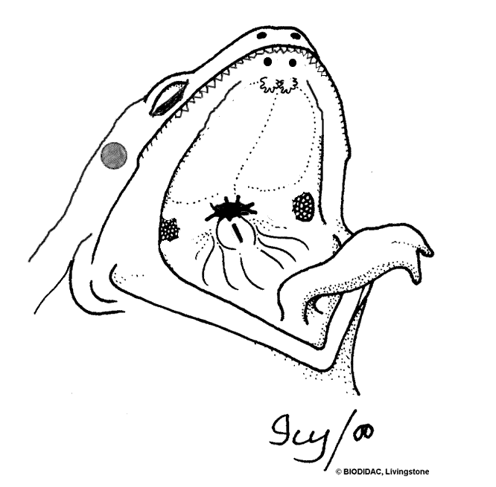

Dissection Instructions
1. Place the frog in the dissecting pan ventral side up.
2. Use scissors to lift the abdominal muscles away from the body cavity. Cut along the midline of the body from the pelvic to the pectoral girdle.
3. Make transverse (horizontal) cuts near the arms and legs.
4. Lift the flaps of the body wall and pin back.
*If your specimen is a female, the body may be filled with eggs and an enlarged ovary. You may need to remove these eggs to view the organs.
Locate each of the organs. Check the box to indicate that you found the organs.
Digestive, Circulatory and Respiratory Systems

Fat Bodies --Spaghetti shaped structures that have a bright orange or yellow color, if you have a particularly fat frog, these fat bodies may need to be removed to see the other structures.
Peritoneum A spider web like membrane that covers many of the organs, you may have to carefully pick it off to get a clear view
Liver--The largest structure of the body cavity. This brown colored organ is composed of three parts, or lobes. The right lobe, the left anterior lobe, and the left posterior lobe. The liver is not primarily an organ of digestion; it does secrete a digestive juice called bile. Bile is needed for the proper digestion of fats. Bile is emptied into the gall bladder which then empties into the duodenum.
Heart - at the top of the liver, the heart is a triangular structure. The left and right atrium can be found at the top of the heart. A single ventricle located at the bottom of the heart. The large vessel that extends out from the heart is the conus arteriosis which supplies blood to the body.
Lungs - Locate the lungs by looking underneath and behind the heart and liver. They are two spongy organs. Lungs attach to the trachea via tubes called bronchi.
Gall bladder--Lift the lobes of the liver, there will be a small green sac under the liver. This is the gall bladder, which stores bile. (Hint: it kind of looks like a booger.) The gall bladder stores bile and then releases it into the duodenum via the bile duct. The bile duct may be too small to see.
Stomach--Curving from underneath the liver is the stomach. The stomach is the first major site of chemical digestion. Frogs swallow their meals whole. Follow the stomach to where it turns into the small intestine. The pyloric sphincter valve regulates the exit of food from the stomach
Pancreas – This glandular organ is located within the curve of the stomach. On preserved frogs it may not be easy to find, as the gland breaks down. It secretes insulin, which is needed for the proper breakdown of sugar.
Small Intestine--Leading from the stomach. The first straight portion of the small intestine is called the duodenum, the curled portion is the ileum. A membrane called the mesentery holds the ileum together. Note the blood vessels running through the mesentery; they will carry absorbed nutrients away from the intestine. Absorption of digested nutrients occurs in the small intestine.
Large Intestine--As you follow the small intestine down, it will widen into the large intestine. The large intestine is also known as the cloaca in the frog. The cloaca is the last stop before wastes, sperm, or urine exit the frog's body. (The word "cloaca" means sewer.) Locate the anus.
Spleen--Return to the folds of the mesentery, this dark red spherical object serves as a holding area for blood, where harmful particles can be filtered out for the immune system.
Esophagus--Return to the stomach and follow it upward, where it gets smaller is the beginning of the esophagus. The esophagus is the tube that leads from the frog’s mouth to the stomach. Open the frog’s mouth and find the esophagus, poke your probe into it and see where it leads.
STOP! If you have not located each of the organs above, do not continue!
Removal of the Stomach & Intestine
Cut the stomach out of the frog and open it up. You may find what remains of the frog's last meal in there. Look at the texture of the stomach on the inside. Note the ridges on the walls of the stomach called rugae. Rugae help to break down food. What did you find in the stomach? _________________________________
Measuring the Small intestine: Remove the small intestine and stretch it out and measure it. Now measure your frog. Record the measurements below in centimeters.
Frog length: ______ cm Intestine length ______ cm Which is longer? _____
Removal of the Heart
Carefully cut out the heart from its position above the liver. The vessel on the front of the heart is the conus arteriosis, which sends blood to the body. On the back you can find the openings for the anterior and posterior vena cava, which return blood to the heart. How many chambers does the frog heart have? ___
Urogenital System-
The frog’s reproductive and excretory system is combined into one system called the urogenital system. You will need to know the structures for both the male and female frog,
Kidneys – flattened bean shaped organs located at the lower back of the frog, near the spine. They are often a dark color. The kidneys filter wastes from the blood. Often fat bodies are attached to the kidney.
Testes – in male frogs, these organs are located at the top of the kidneys, they are pale colored and round.
Oviducts – females do not have testes, though you may see a curly-q type structure around the outside of the kidney, these are the oviducts. Oviducts are where eggs are produced. Males can have structures that look similar, but serve no actual purpose. In males, they are called vestigial oviducts.
Bladder – An empty sac located at the lowest part of the body cavity. The bladder stores urine. Cloaca – mentioned again as part of the urogenital system – urine, sperm and eggs exit here.
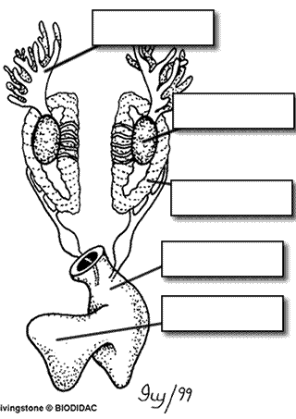
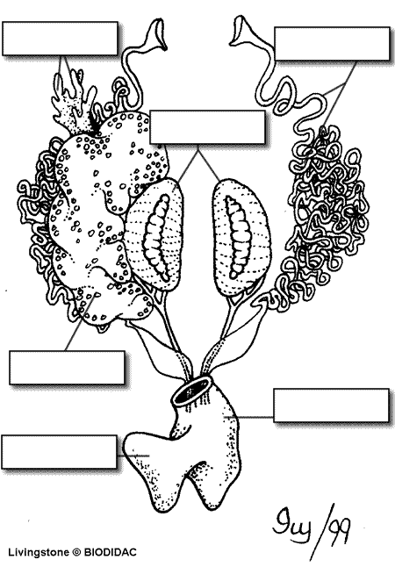

Label the Diagram
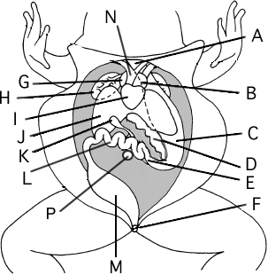
A. __________________________________
B. __________________________________
C. __________________________________
D. __________________________________
E. __________________________________
F. __________________________________
G. __________________________________
H. __________________________________
I. __________________________________
J. __________________________________
K. __________________________________
L. __________________________________
M. __________________________________
N. __________________________________
P. __________________________________

