**Science Interactive Notebook Policies and Organization**

**An Interactive Notebook…**

* is like a personalized textbook that you create.
* helps you keep your notes organized and easy to use.
* is a portfolio to showcase what you've learned in Biology class.

**You are responsible for…**

* making sure your notebook has all items (even when you are absent);
  + assignments
  + class work
  + notes
  + etc.
* keeping Table of Contents up to date;
* numbering all pages;
* keeping notebook neat and organized; and
* bringing your notebook to class EVERY DAY.

**Notebook Checks**

* Usually one per unit; follows grading rubric provided & posted on my webpage

***NOTEBOOK ORGANIZATION***  
Use the following guidelines when setting up your interactive notebook:

**Notebook Cover**

Write the following on the outside of the composition notebook:

* Name
* Teacher name
* Class Period

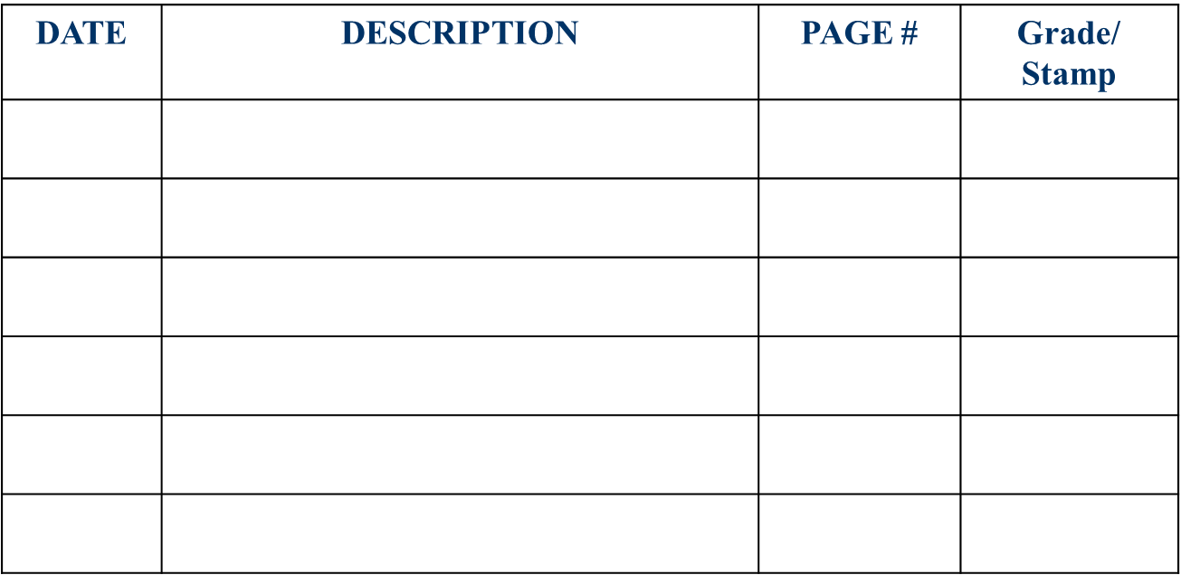**Table of Contents:**  
The first 5-6 pages should be reserved for your Table of Contents. Include the following for each entry:

* Date
* Title/Description of activity or chapter
* Page number

**Organizational features**   
The features itemized below will help you to organize your work so that you are able to more efficiently access learning from prior activities or lessons.

* Page numbers
* Date of activity or discussion
* Topic of discussion or title of activity
* Diagrams or drawings
* Textbook and lecture notes and glossary or key terms
* Summary statement of topic/unit in your own words

**What Happens If I Am Absent?**

* Check your folder for any handouts, etc.
* Check your teacher’s webpage for notes
* See a trusted friend to copy notes

**What If I Lose My Interactive Notebook?**

* Tell your teacher as soon as possible!
* Do not quit working on assignments
* Begin rebuilding your notebook

**Simply copying from the textbook or slides only earn you a score of 70!**

**Go beyond!**

|  |  |  |
| --- | --- | --- |
| 100% | Notebook contents are neatly completed, all pages are numbered, titled and dated.  Topics are correct and contents are organized according to class guidelines.  Table of Contents reflects ALL entries to date.  Notes go BEYOND basic requirements; shows IMPRESSIVE, IN-DEPTH scientific thought and effort.  Summary statement in student’s own words provided at the end of each unit |  |
| 90% | Notebook contents are neatly completed, all pages are numbered, titled and dated.  Topics are correct and contents are organized according to class guidelines.  Table of Contents reflects all entries to date.  Notes meet requirements and some go beyond; shows IN-DEPTH thought and effort.  Summary statement in student’s own words provided at the end of each unit |  |
| 80% | Notebook contents are MOSTLY NEAT and complete (at least 90%), pages numbered, titled and dated.  Topics are correct and organized with no more than 2 assignments incorrectly placed.  Table of Contents reflects 90% or more of all entries up to date.  Notes meet requirements: Shows a basic understanding of content topics, shows some thought and effort, e.g. concept maps, diagrams, etc.  Summary statement in student’s own words provided at the end of each unit |  |
| 70% | Notebook contents are legible, complete (at least 80%), pages numbered, titled and dated.  Topics are correct and organized with no more than 4 assignments incorrectly placed.  Table of contents reflects at least 80% of all entries to date.  Notes nearly meet minimum requirements: Information was simply transferred from textbook to notebook, which shows a limited understanding of content topics; limited thought and effort.  No summary statement provided for unit. |  |
| 60% | Notebook contents are sloppy or incomplete (50%), many pages are not numbered, titled or dated.  Organization inconsistent and contents are unorganized with more than 5 assignments incorrectly placed.  Table of contents shows limited attempts at keeping entries up to date.  Notes incomplete; shows only a superficial understanding and/or some inaccuracies, little thought or effort.  No summary statement provided for unit. |  |
| 50% | Notebook turned in but too incomplete to score well.  Majority of pages are missing or incomplete.  Dating and labeling of pages is inconsistent.  Notes incomplete and missing; shows minimal understanding, not neatly written, minimal effort.  No summary statement provided for unit. |  |
| 0% | Notebook not turned in. No evidence of work done.  AND/OR Notebook has inappropriate content or words written on the cover or pages. |  |

**MLA Header**: Use the “Score” column to check off the grade that you think your notes deserve.

**Interactive Notebook Check Grading Rubric**

Score

**Reason why I deserve a grade of _________:**