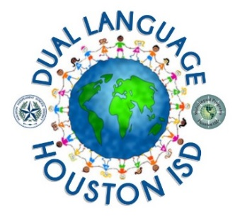
School Name_______________________ ____________________________
Target Language: Principal
Spanish
Mandarin
School Address
Houston, Texas ZIP
School Phone I School Fax
Arabic

Houston ISD Dual Language Program
Parent Commitment Form
I would like to enroll my child in the Dual Language Program. I understand that I will receive a confirmation letter from the school indicating the status of my child’s enrollment.
The goals for Dual Language students are:
- Development of fluency and literacy in English and in an additional language. (Bilingualism)
- Demonstration of mastery in all academic areas in English and the target language. (Biliteracy)
- Promotion and development of cross-cultural sensitivity.
Child’s Name |  |  |  |  |  |  |  | Entering Grade
Birthdate |  |  |  |  | Previous School
Address |  |  |  |  | City/State/Zip
Home Phone
Parent’s Name |  |  | Wk Phone |  |  |  |  |  | Cell Phone
Parent’s Name |  |  | Wk Phone |  |  |  |  |  | Cell Phone
Email:
Zoned to ___________ |  | yes |  | no |  | If not, school name: _________________
Dual Language Transfer requested |  | yes |  | no |  | School name: ________________
Sibling attending _________ |  | yes |  | no |  | Sibling’s name:
According to dual language research, I understand that long-term participation of 5 to7 years is required for the benefits of the program to be fully realized. With my signature below, I agree to the following requirements for enrollment and continuation in the program:
- I agree to continue enrollment of my child in the Dual Language program for the next 5 to 7 years.
- I agree that the following students may only enter in Kindergarten and no later than 1st grade provided that there is availability:
- Native English speakers
- Students who speak a language other than the target language
- I agree to provide parental support/volunteerism for a minimum of 5 hours per semester.
- I agree to provide encouragement and support for biliteracy and bilingualism for my child.
Signature |  |  |  |  |  |  | Date

Required Documents for Enrollment
- Proof of Residence (lease agreement, recent utility bill, or proof of mortgage)
- Birth Certificate
- Parent’s ID (State driver’s license, state identification card, or passport)
- Student’s Immunization Records
- Non-ELL students Grades 2-5 must show documentation of previous Bilingual/Dual Language program enrollment

NOTE: The only official notification of enrollment will be on a school letter signed by the principal. Submission of this form
does not ensure enrollment to the program.
Office Use only Date received: Time received: Received by:

