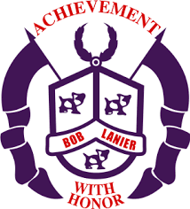**Bob Lanier Middle School**

**Shared Decision-Making Committee**

**September 27, 2019**

**Agenda**

* **School Safety**
* Physical
* Fire Drills
* Lockdown Drill
* Shelter in Place
* Arrival
* Dismissal
* Access
* Transitions
* Lunch
* Election Day
* Emotional
* No Place for Hate
* Social Worker
* Second Chance
* PLC #1: What do we want our children to know and be able to do?
* Team collaboration
* Curriculum
* Lesson Plans
* IB MYP Units
* PLC #2: How will we know if our children have learned what we want them to learn?
* CFU/Daily/Weekly Assessments
* Common Formative Assessments
* Renaissance 360
* STAAR/TELPAS
* Iowa
* PLC #3: How will we respond when, in spite of our best efforts, we discover that some of our children have not learned what we want them to learn?
* Tier 1 (regular classroom instruction)
* Tier 2 (in-class intervention by teacher; small flexible groups; one-on-one)
* Tier 3 (student(s) pulled out by interventions specialist(s)); tutorials)
* PLC#4: How will we respond when we discover that some of our children already know what we want them to learn and be able to do?
* Operational Issues
* Parents as partners
* Business partner
* Community Partner
* Old Business
* New Business
* SDMC Role and Processes
* Approval of 2019 – 2020 School Improvement Plan
* Common Cluster Planning Time
* Dress Up Day (student initiated)
* Attendance Incentives
* Common Communication Platform
* Homework/Exam Schedule

Meeting Adjourned

Faculty Advisory Committee

Next Meeting: November 8, 2019