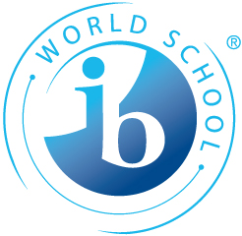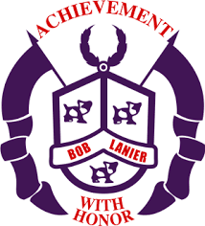**Bob Lanier Middle School**

**Shared Decision-Making Committee**

**November 8, 2019**

**Agenda**

* **School Safety**
* Physical
* Fire Drills
* Lockdown Drill
* Shelter in Place, 10/11/19
* Arrival
* Dismissal
* Access
* Transitions
* Lunch
* **Sandy Hook Promise**
* **Election Day**
* Emotional
* No Place for Hate
* Social Workers
* Second Chance
* Sandy Hook
* PLC #1: What do we want our children to know and be able to do?
* Team collaboration
* Curriculum
* Lesson Plans
* IB MYP Units
* PLC #2: How will we know if our children have learned what we want them to learn?
* CFU/Daily/Weekly Assessments
* Common Formative Assessments
* Renaissance 360
* STAAR/TELPAS
* Iowa (for G/T)
* PSAT
* AP Spanish Language/AP Mandarin Chinese Language
* PLC #3: How will we respond when, in spite of our best efforts, we discover that some of our children have not learned what we want them to learn?
* Tier 1 (regular classroom instruction)
* Tier 2 (in-class intervention by teacher; small flexible groups; one-on-one)
* Tier 3 (student(s) pulled out by interventions specialist(s)); tutorials)
* PLC#4: How will we respond when we discover that some of our children already know what we want them to learn and be able to do?
* **Operational Issues**
* **Parents as partners**
* **Business partner**
* **Community Partner**
* **Old Business**
* **Attendance Incentives**
* **New Business**
* **TEA Takeover**
* **6 week versus 9 week grading periods**
* **Practice versus play participation policy**
* **Dance: dismissal procedure, play list**
* **Study lab procedure: send or receive students**
* **Open House**
* **Tutorials**
* **Bus lane being used for student drop off**

Meeting Adjourned

Faculty Advisory Committee

**Next Meeting: January 17, 2020**