Dear Parents and Guardians,

Thank you for taking the time to complete the 2021–2022, HISD Title I, Part A Parent and Family Engagement Survey. The purpose of this annual survey is to see how well your child’s school partners with you and encourages your family’s engagement in your child’s education. The survey should take approximately 10 minutes to complete. Your feedback is anonymous. For your voice to be heard, you must complete this survey on or before May 20, 2022 for your child’s school. If you have more than one child, please complete a survey for each school your children currently attend. If you have more than one child at a specific school, you need only complete one survey for that school. If you need assistance in completing this survey, please reach out to the Title I campus contact person at your child's school.
To complete the survey, you can access it online at
English Version:
https://houstonisd.research.net/r/PFE2022_English
OR
Take a picture with your smartphone or tablet of the following QR Code and you will be directed to the online survey:
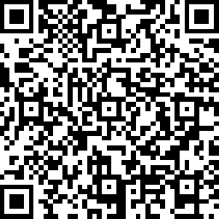

Spanish Version:
https://houstonisd.research.net/r/PFE2022_Spanish
OR
Take a picture with your smartphone or tablet of the following QR Code and you will be directed to the online survey:
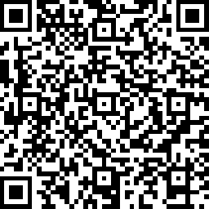
Vietnamese version:
https://houstonisd.research.net/r/PFE2022_Vietnamese
OR
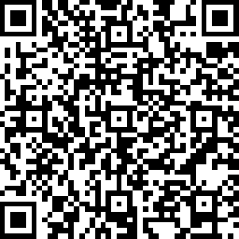
Take a picture with your smartphone or tablet of the following QR Code and you will be directed to the online survey:

