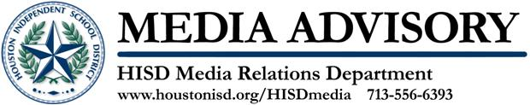

HISD Superintendent Recognizes Eastwood Academy for National Blue Ribbon School Award

February 6, 2012 – HISD Superintendent Terry Grier on Tuesday will visit Eastwood Academy staff and parents to celebrate the campus’ designation as a 2011 National Blue Ribbon School. This award honors public and private schools whose students achieve at very high levels or have made significant progress toward closing gaps in achievement, especially among disadvantaged and minority students. Challenge Early College and Lyons Elementary School are also on the list of HISD’s 2011 National Blue Ribbon Schools. This event was rescheduled following a postponement due to inclement weather on January 25, 2012.

Who: HISD Superintendent Terry Grier and Eastwood Academy Principal Paula Fendley

What: Dr. Grier Recognizes Eastwood Academy Students, Parents, Faculty and Staff for 2011 National Blue Ribbon School Award

When: Tuesday, February 7, 2012, 3:45 p.m. to 5p.m.

Where: 1315 Dumble, Houston, 77023

The Houston Independent School District is the largest school district in Texas and the seventh-largest in the United States with 281 schools and more than 200,000 students. The 301-square-mile district is one of the largest employers in the Houston metropolitan area with nearly 30,000 employees.
For more information, visit the HISD Web site at www.houstonisd.org.

