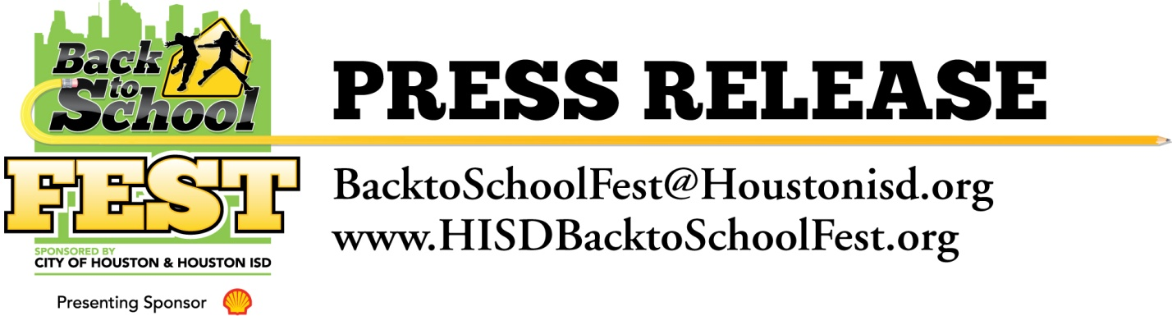

Houston ISD, the City of Houston, Shell and Motiva Host Mega Back to School Fest

August 6, 2011 – The Houston Independent School District (HISD), the City of Houston, Shell Oil Company and Motiva Enterprises LLC today pulled off one of the largest back to school events in the city’s history at the George R. Brown Convention Center. Tens of thousands of HISD students and their families are better prepared for the new school year after receiving backpacks, schools supplies, uniforms, vaccinations and other services.
The event was officially opened by Houston Mayor Annise Parker, HISD Superintendent Terry Grier, and Shell Oil Company Foundation Vice President Dr. Frazier Wilson.
HISD Superintendent Terry Grier said, “It would not be possible to stage an event of this magnitude without a small army of volunteers. I want to personally thank all the volunteers as well as the citizens of Houston and our business partners for helping our students get the best possible start for the upcoming school year.”
In addition to backpacks, school supplies and school uniforms, the Houston Food Bank donated 25,000 three-pound bags of food for families; Texas Barber Colleges and Hairstyling Schools donated 25,000 free haircut vouchers and the City of Houston provided 20,000 box lunches for children from its summer feeding program and 3,000 immunizations.
“The first day of school sets the tone for the entire school year, said Houston Mayor Annise Parker. “When students have all the necessary school supplies and are prepared for the first day of school, it helps to build self-confidence and provides a boost of enthusiasm that is more likely to result in a successful school year.”
The event also featured dental and health checks; information on HISD schools and programs; HISD resource and service information; City and community resource information; as well as a host of fun, educational activities for children, and live entertainment featuring Houston rap artist Baby J.
Shell Oil Company Vice President Dr. Frazier Wilson said, "Shell and Motiva are proud to be a partner for this important event. Through initiatives like this, Shell demonstrates a long-standing commitment to supporting our schools, teachers and students. Together with our community partners, we are improving education, expanding knowledge and helping to build a brighter future by enhancing the education experience.”
Shell and Motiva were the Presenting Sponsor of the event. Title Sponsors included the Blue Cross Blue Shield Care Van Program, Kroger, Reliant Energy, Texas Barber Colleges and Hairstyling Schools and UnitedHealthcare. Metro was a Platinum Sponsor.

Gold Sponsors were Amerigroup and KelseyCare powered by CIGNA and TAM International. St. Luke’s Hospital, Target and Yellow Cab were Silver Sponsors. Capital One Bank, C.A.R.E. Foundation, Citgo, Comcast, Fiesta, Stand For Children, and Union Pacific were Bronze Sponsors. Additionally, numerous corporations and non-profit organizations hosted school supply drives to support the 2011Back to School Fest. For more information, please visit www.HISDBacktoSchoolFest.org

