

State Releases 2011-2012 STAAR Exam Results for Grades 3-8
New exams measure whether students are on track for
college and career readiness

January 29, 2013 – Most Houston ISD students who took the new State of Texas Assessments of Academic Readiness (STAAR) in grades 3-8 for the first time in 2011-2012 met the tougher academic challenge.
The Texas Education Agency released the STAAR passing rates by grade level and subject nearly a year after students took the tests during the 2011-2012 school year. Because this was the first time students were tested under the new STAAR system, the state will not use these scores to rate schools and they were not used for student grade-level promotion decisions last summer.
At least 70 percent of HISD students in grades 3, 4, 5, 7, and 8 met the passing standard in reading. In the sixth-grade, 67 percent met the reading standard. In math, the percent of students meeting the passing standard ranged from 75 percent in the fifth grade to 53 percent in grade 7. The passing standards are scheduled to increase in the coming years.
“These results show us that many of Houston’s students are progressing at a pace that will have them prepared to succeed in college and in the workplace when they graduate,” said HISD Superintendent Terry Grier. “But we also see that too many students are trailing academically. We must continue acting with a sense of urgency to help our principals and teachers raise the level of rigor in every classroom.”

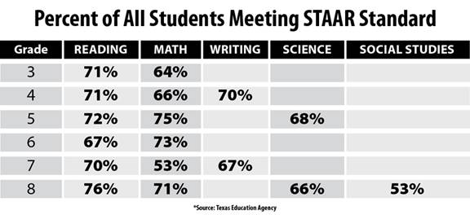

HISD has undertaken several initiatives to raise the level of achievement for all students. This school year, the district implemented a revamped new reading curriculum that has an intensive focus on students in the sixth and ninth grades. HISD is also partnering with local universities to train teachers, giving them the skills and resources they need to help students meet the tougher standards required by STAAR.

The Houston Independent School District is the largest school district in Texas and the seventh-largest in the United States with 276 schools and more than 203,000 students. The 301-square-mile district is one of the largest employers in the Houston metropolitan area with nearly 30,000 employees.
For more information, visit the HISD Web site at www.houstonisd.org.

