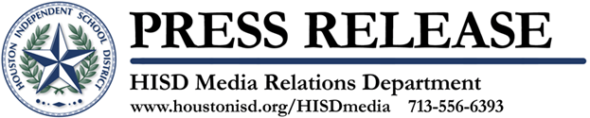

Blue Bell Ice Cream Rewards Project Chrysalis Middle School for Earning National Blue Ribbon Honor

October 10, 2012 – Blue Bell Creameries will honor Project Chrysalis Middle School (4528 Leeland), one of two HISD schools named 2012 National Blue Ribbon Schools, with a school-wide ice cream party on Thursday, Oct. 11. A Blue Bell truck filled with ice cream will arrive at the school at noon to treat all of the students, teachers, and staff members.
The U.S. Department of Education’s Blue Ribbon Schools program has honored more than 7,000 of America’s most successful schools for the past 30 years. This year 269 public and private schools across the country, including HISD’s East Early College High School, received the coveted award. Blue Bell Creameries rewarded East Early College High School at a previous party.
Blue Ribbon Schools are selected based on two primary criteria. They must be among the highest-performing schools in their state, or they are schools with at least 40 percent of students from disadvantaged backgrounds that have improved student performance to high levels.
This year’s winning schools will also be honored at an awards ceremony in Washington D.C. on Nov. 12-13, 2012.

The Houston Independent School District is the largest school district in Texas and the seventh-largest in the United States with 279 schools and more than 203,000 students. The 301-square-mile district is one of the largest employers in the Houston metropolitan area with nearly 30,000 employees.
For more information, visit the HISD Web site at www.houstonisd.org.


Click here to Tweet this

