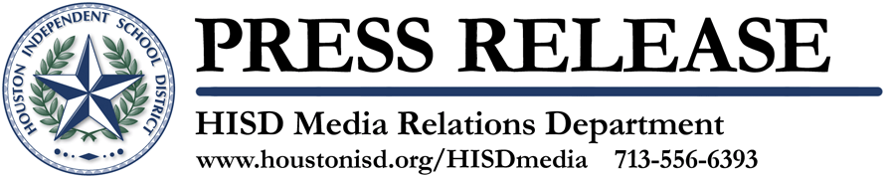

Asian American College and Career Day Highlights Experience and Success in Houston’s Asian Communities

October 27, 2011 -- It’s been said that experience is one of life’s best teachers. That’s the idea behind the Houston Independent School District’s sixth annual Asian American College and Career Day, when Asian American middle and high school students in the Houston area learn about career options from young Asian professionals who relate their experiences leading to success.
“We have seen that as students have a chance to interact with successful Asian role models, they are often inspired to seek career opportunities that had not previously been considered,” said Gordon Quan, chair of the HISD Asian Advisory Committee,
“An engaged community opens doors for our students,” said HISD Superintendent Dr. Terry Grier. “Opportunity is what Houston is about.”
Keynote speaker Miya Shay, reporter for KTRK Channel 13 news, will kick off this free, four-hour event, which starts at 8 a.m. on Saturday, November 19 at Bellaire High School, 5100 Maple Street in Bellaire.
With “Marketing Yourself” as this year’s event theme, students will be encouraged to hone skills and practices (leadership, good interpersonal relationships, teamwork, promoting their capabilities, and good grooming habits) that enhance academic excellence.
And as in years past, Houston-area Asian American professionals serve as role models, providing students and parents with advice and information in the following areas: business, counseling and social work, creative arts, culinary arts, education, energy and engineering, entrepreneurship, health care, information technology, law enforcement/public service, legal, media, and medical. This year, speakers will be available to meet with students informally during breakfast, prior to the opening assembly.
Throughout the morning, students also will have access to local and regional college and university representatives who share information about financial aid, admissions requirements, and college life.
Special workshops will be available for parents to help them understand college and financial aid requirements and the emotional issues surrounding the transition to college. The workshops will be available in Cantonese, Mandarin, Vietnamese, Bhutanese and English.
Middle school students and their parents will also be welcomed at a one-hour session presenting information on how to prepare for high school, college, and careers.
The college and career day for students in Houston’s Asian and Pacific Islander communities is a signature activity of the HISD Asian Advisory Committee, which was established in the fall of 2005 by the Superintendent of Schools.
Event partners are the University of Houston, Houston Community College, and ARAMARK.

The Houston Independent School District is the largest school district in Texas and the seventh-largest in the United States with 281 schools and more than 200,000 students. The 301-square-mile district is one of the largest employers in the Houston metropolitan area with nearly 30,000 employees. For more information, visit the HISD website at www.houstonisd.org

