All the graphs (and some other stuff) you need to know for Macro

Correctly drawing and labeling graphs is critical in answering the free response questions (FRQs). For an interactive lessons in the graphs go to http://www.reffonomics.com/1.html . There is a step by step review of several of the important graphs.

Graph: | Things to remember:
Production Possibilities:  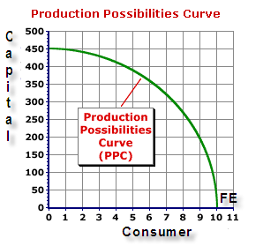  Unattainable  Inefficient | - The curve represents full employment  - Points inside the curve are inefficient  - Points outside the curve are unattainable at this time  - The curve can move to the right when there are more or better resources  - Trade-offs and opportunity costs can be determined from quantity changes on the axes.  - Shifters:  - Increases in Resource Supplies (CELL)  - Advances in Technology  - Present choices and future possibilities
Demand and Supply (Basic)  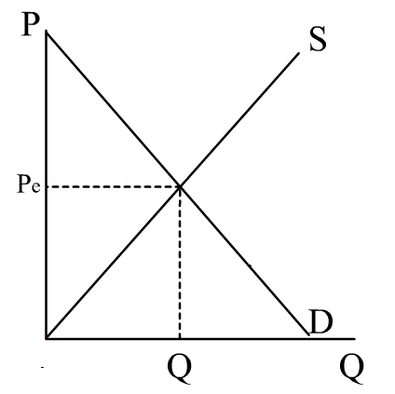 | 1. Movement on the curve happens from a change in price.  2. When anything other than price changes, you draw a new curve.  3. Demand shifters  - Change in buyer taste  - Change in number of buyers  - Change in income (normal or inferior goods)  - Change in prices of related goods (substitutes and complements)  - Change in buyer expectations  4. Supply shifters:  - Change in resource prices  - Change in technology  - Change in taxes or subsidies  - Change in expectations  - Change in the number of suppliers
Business Cycle  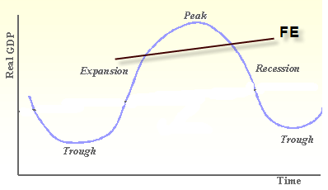 | 1. You always move left to right on the graph – you can’t go backward.  2. At the peak the economy has the lowest levels of unemployment and the highest levels of inflation  3. In the trough, the economy has the highest levels of unemployment. Inflation is not a problem.  4. An extended severe recession of 6 or more months can become a depression.  **Some test writers call the recession a contraction and the recovery an expansion.

Short Run AD/AS  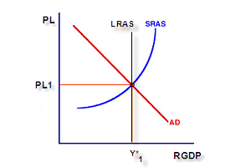 | 1. Labels on the axes change to PL and RGDP (or RDO)  2. Curves are now AD and SRAS (AS)  3. Price is identified as PL at each equilibrium level. On the X axis, use the letter Y to indicate the quantity amount.  4. Aggregate Demand Shifters (changes in CIGXn):  - Changes in Consumer spending caused by wealth, expectations, indebtedness, or personal taxes  - Changes in investment spending caused by a change in interest rates, profit expectations, business taxes, or excess capacity  - Changes in government spending  - Changes in net export spending caused by a change in national income abroad or exchange rates.  5. Aggregate Supply Shifters  - Changes in input prices (changes in CELL)  - Changes in productivity  - Changes in government policies such as business taxes, subsidies, regulations
Money Market  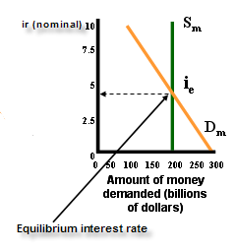 | - Increasing the money supply lowers interest rates as surplus money moves into the bond market, increasing bond prices (increased demand for bonds).  - Decreasing the money supply increases interest rates as the shortage of money creates a sell-off of bonds, decreaseing bond prices.  - Sell bonds = smaller money supply / buy bonds = bigger money supply.  - Supply of money is always vertical because the fed and does not increase or decrease due to changes in the IR  - Total demand for money is downsloping and responds to the interest rate. At lower rates, people HOLD more money. At higher interest rates, there is a greater incentive to move cash into forms of savings.  - Transaction demand for money (also a vertical line) is a fraction of GDP.  - The Demand for money curve SHIFTS when there are changes in GDP.  - The Supply of money SHIFTS due to actions of the fed.
Loanable Funds  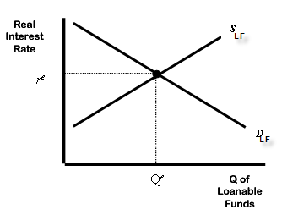 | - The supply of loanable funds is from savings  - The demand of loanable funds comes from investment.  - Equilibrium is at the real interest rate where dollars saved equals dollars invested.  - Shifters / Policies that influence the loanable funds market:  - Taxes and Saving (Taxes on savings reduce the incentive to save. A tax decrease would alter the incentive for households to save at any given interest rate and would affect the supply of loanable funds )  - Taxes and Investment (A tax Break on investment would increase the incentive to borrow if an investment tax credit were given.)  - Government Budget Deficits/Surpluses (When the government borrows to finance its budget deficit, it reduces the demand for loanable funds available to finance investment by households and firms. This deficit borrowing “crowds out” the private borrowers who are trying to finance investments.)

Investment Demand  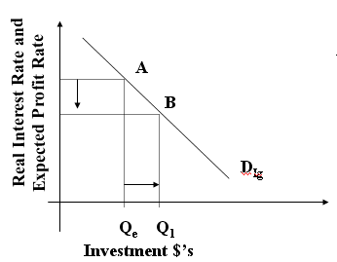  Shifters:  a. Acquisition, maintenance and operating costs  b. Business taxes  c. technological change  d. stock of capital goods on hand  e. expectations | - A firm will invest so long as the real profit is greater than or equal to the real rate of interest.  - As interest rates fall the amount of (quantity) of investments rise.  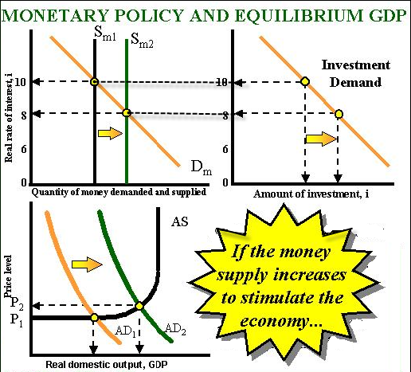
Long Range Aggregate Supply  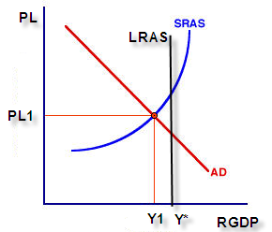 | - Changes (shifters) in the long run supply are not caused by changes in the price level. LRAS moves due to the same reason as SRAS --- this time it’s a more permanent situation.  - The long run is generally a year or greater time wise.  - A change in LRAS is the same as a rightward move of the PPC curve.  - Points below the LRAS indicate that the economy is not at full employment and growth is still possible for RGDP.  - Points above full employment (LRAS) indicate an overheated economy with inflationary problems.  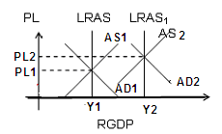  **In a more complicated graph, “drag” the new curves along with the new LRAS for reading ease.
Market for Foreign Currency (Exchange Rates)  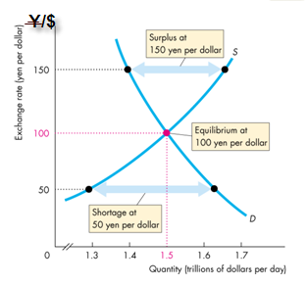 | - Other countries want U. S. goods when:  - Ours are cheaper  - Our inflation is less that theirs  - Our interest rate is higher  - The other country is growing faster  - All of the above increase the demand for the dollar  - These cause the dollar to APPRECIATE  - The $ depreciates when the opposite events occur.  - Think of dollars as a commodity with a simple supply/demand curve.  Remember—Set the Y axis up like a fraction. The currency that is the denominator is the currency on the X axis. The exchange rate is the cost of the other country’s currency to one for the country in the graph. The quantity is the number that will be demanded and supplied in the world market at that “price”.

Phillips Curve (SRPC)  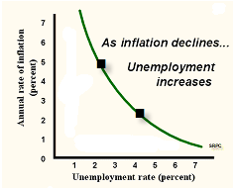  Phillips Curve (LRPC)  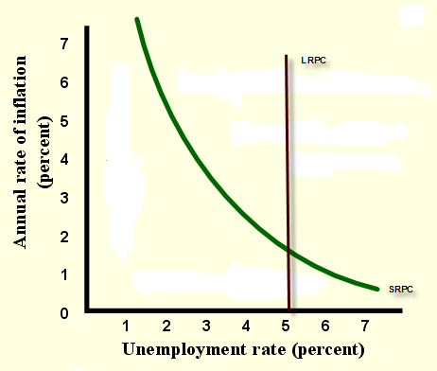 | - Under normal circumstances, there is a short-run tradeoff between the rate of inflation and the rate of unemployment.  - Aggregate supply shocks can cause both higher rates of unemployment (a rightward shift of the curve)  - There is no significant tradeoff between inflation and unemployment over long periods of time.  - Stagflation is simultaneous high inflation and high unemployment.  - After all nominal wage adjustments to increases and decreases in the rate of inflation have occurred, the economy ends up back at its full-employment level of output and its natural rate of unemployment.  - The long-run Phillips Curve therefore is vertical at the natural rate of unemployment.  - Other Shifters:  a. Changes in the labor force characteristics. Age, sex, number of married both employed couples, number of new workers entering the labor force, structural changes in demand for labor skills, educational attainment level of the workers or requirements of the jobs.  b. Changes of government policies. Minimum wage, unemployment compensation, job training programs, employment subsidies to workers or the employers.  c. Changes in Productivity. Increases in productivity w/o wage increases makes workers more desirable, and slowing of productivity w/o a corresponding slowing of wage increases makes workers less desirable.  d. Changes in Labor Market Institutions. Power of labor unions to negotiate wages above equilibrium level, number of and efficiency of temporary employment agencies, the efficacy of the internet for job searches.
Laffer Curve  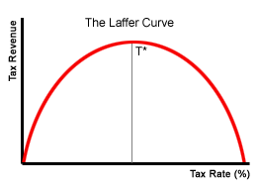  OR  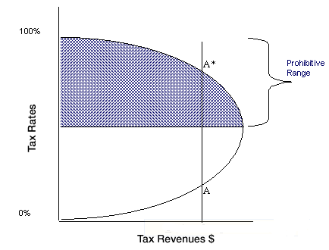 | - This graph can be drawn with the labels on either axis.  - t* represents the rate of taxation at which maximal revenue is generated. Note: This diagram is not to scale; t* could theoretically be anywhere, not necessarily in the vicinity of 50% as shown here.  - The theory is based on the notion that government collects zero revenue if the tax rate is 0% and if the tax rate is 100%. At a 100% tax rate no one has the incentive to work, produce, and earn income, so there is no income to tax. As such, the optimum tax rate, in which government revenue is maximized, lies somewhere between 0% and 100%.  - If the economy is operating to the right of the peak, then government revenue can be increased by decreasing the tax rate. This was used to justify supply-side economic policies during the Reagan Administration, especially the Economic Recovery Tax Act of 1981 (Kemp-Roth Act).

Other Reminders!
Monetary Policy  If the problem is . . .  Unemployment Inflation  ↓ ↓  Then the Federal Reserve uses . . .  OMO (Open Market Operations) is the #1 tool of the Federal Reserve! | Fiscal Policy (– affects short run Aggregate Demand) )  If the problem is . . .  Unemployment Inflation  ↓ ↓  Then Congress uses . . . .  Supply Side Fiscal Policy is general a tax reduction targeted to increase AS so that real GDP increases with very little inflation. An increase is AS is the best of all possible macroeconomic situations.
  Tools | Expansion | Contraction
  OMO | Buys bonds | Sells bonds
  Reserve Requirement | Decrease | Increase
  Discount Rate | Decrease | Increase
  Tools | Expansion | Contraction
  Taxes=T | Decrease | Increase
  Subsidies | Increase | Decrease
  Spending=G | Increase | Decrease

Formulas

GDP = Consumption + Investment + Government Spending + Net Exports

MPC = ∆C/∆DI = slope of consumption function
MPS= ∆S/∆DI= slope of saving function
MPC + MPS = 1

Spending Multipliers:
1/1-MPC = 1/MPS= (∆GDP)/( ∆ Spending)

Tax Multiplier
MPC/MPS

Balanced Budget Multiplier (equal changes in taxes and government spending) = 1

Simple Money Multiplier:
1/RR

Money Expansion = Money multiplier X Excess Reserves

