

HISD’s Furr High School Receives 2011 Inspiration Award from the College Board
Honor Includes a $25,000 Check

May 11, 2011 – Today, HISD’s Furr High School (520 Mercury, 77013) was presented with a 2011 College Board Inspiration Award and a $25,000 check. Furr is one of only three high schools in the country to win the award for helping underserved students achieve equitable access to higher education.
College Board President Gaston Caperton, HISD Board Member Juliet Stipeche, and Superintendent Terry Grier and visited the school today to congratulate Principal Bertie Simmons and the Furr community during a school assembly.
Just five years ago, less than 8 percent of the students at Furr were taking the more rigorous Advanced Placement (AP) classes. Now, 62 percent of the 735 students at Furr take Advanced Placement (AP) courses and an additional 16 percent are taking Pre-AP courses for a total of 78 percent.
HISD Superintendent Terry Grier said, “We’ve made it our goal to become the best school district in the country. The way to get there is to increase the number of student taking more rigorous college-level courses, to have an effective teacher in every classroom and an outstanding principal leading every school. Furr is a good example of the type of turnaround that can happen when you bring all of those factors together. I congratulate Dr. Simmons and the entire Furr family for this prestigious College Board recognition.” Bertie Simmons, 77, was recruited out of retirement in 2000 to lead the turnaround of Furr High School.
Districtwide, the growth in the number of students taking AP courses and tests has been dramatic. In the 2009-2010 school year, more HISD students than ever attempted college-level AP courses and exams and a record number of students performed well enough to earn college credit. In fact, it was the largest one-year increase in the history of HISD with 46 percent more students taking AP exams. More than 6,000 of those exams were scored high enough to earn college credit – a 27 percent increase over the year before. Since 1999, the district’s growth in AP tests taken and scores high enough to earn college credit has been on the rise.
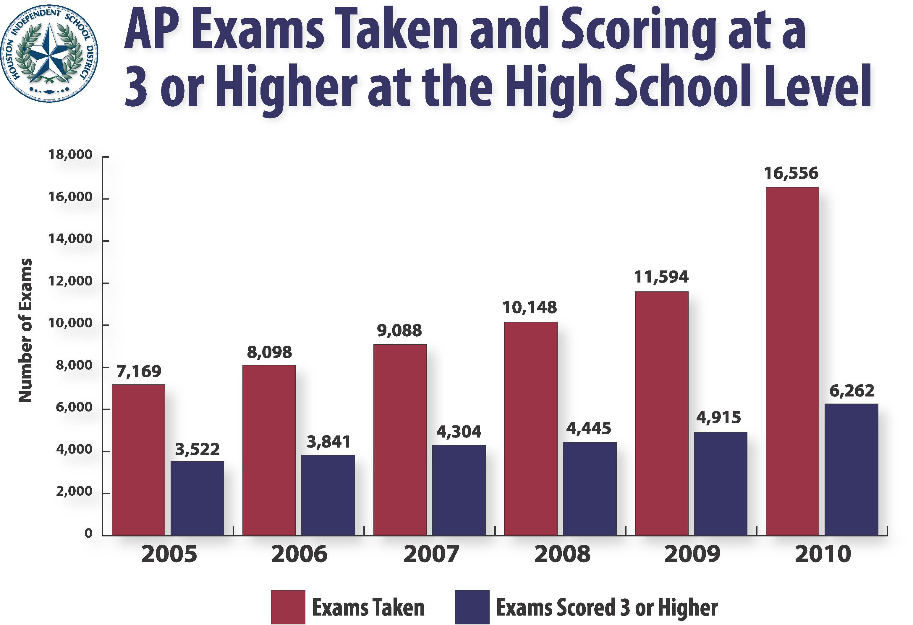

This year HISD high schools were required to provide at least 10 AP courses. Next year, the minimum requirement rises to 15 AP courses. Additional AP courses are available online. The district is also requiring AP students to take AP tests. This year the district began picking up the cost of AP tests and provided free SAT college entrance exam testing during the school day at its high schools for the first time. Pre-AP courses are also being expanded in HISD middle schools and the district is the first in the country to offer AP and Pre-AP designations to high schools and middle schools that meet specific criteria.
Just last week, HISD became the first district in the country to partner with the College Board to launch a college awareness campaign called Five Ways Education Pays, which includes advertisements on 50 HISD buses . The campaign will go nationwide this fall.

About The College Board
The College Board is a mission-driven not-for-profit organization that connects students to college success and opportunity. Founded in 1900, the College Board was created to expand access to higher education. Today, the membership association is made up of more than 5,900 of the world’s leading educational institutions and is dedicated to promoting excellence and equity in education. Each year, the College Board helps more than seven million students prepare for a successful transition to college through programs and services in college readiness and college success — including the SAT® and the Advanced Placement Program®. The organization also serves the education community through research and advocacy on behalf of students, educators and schools. For more information visit www.collegeboard.org

The Houston Independent School District is the largest school district in Texas and the seventh-largest in the United States with 298 schools and more than 200,000 students. The 301-square-mile district is one of the largest employers in the Houston metropolitan area with nearly 30,000 employees. For more information, visit the HISD Web site at www.houstonisd.org.

