

HISD Sets Another Record in National School Rankings

May 20, 2011 – The increased focus on academic rigor at Houston ISD is yielding benefits in national school rankings. HISD has set a new record for the number of schools on the list of America’s Best High Schools, now known as The High School Challenge. A total of 25 HISD high schools made the list, up from 16 in 2010 and 7 in 2009.
Three HISD schools made the Top 100. Carnegie Vanguard High School is number 13, up from 29 in 2010. DeBakey High School for Health Profession came in at number 61, up from 70 last year. Eastwood Academy, which is new to the list, is number 37.
This year the list moved from Newsweek to the Washington Post. All 16 of the HISD schools that made last year’s list are back on the 2011 list and are underlined below.

2011 Rank School Name

13 Carnegie Vanguard
37 Eastwood Academy
61 Debakey High School for Health Professions
127 Bellaire
168 High School for the Performing and Visual Arts
178 High School for Law Enforcement and Criminal Justice
236 Westside
283 Lee
375 Furr
478 Challenge Early College
565 Westbury
627 Chavez
769 Sharpstown
916 Lamar
1008 Austin
1193 Waltrip
1224 Empowerment College Prep
1231 Houston Academy of International Studies
1239 Milby
1253 Reagan
1278 Davis
1360 Mt Carmel Academy
1367 Sam Houston Math, Science and Technology Center
1444 East Early College
1654 Scarborough

Only 1,905 of the approximately 27,000 public high schools in the country met the standards to be included on The High School Challenge list, which also breaks down the best schools by state. Only 149 Texas high schools made the list. Nearly 6 percent are HISD schools.
HISD Superintendent Terry Grier said, “These national rankings indicate that we are heading in the right direction by increasing academic rigor and access to college-level courses and exams. Five of the top 25 Texas schools are HISD schools. No other Houston-area public or charter school is represented in the top 25.”
The rankings are based on data from the 2009-2010 school year. That year saw more HISD students than ever attempting college-level Advance Placement (AP) courses and exams and a record number of students performing at high enough levels to earn college credit. It was the largest one-year increase in the history of HISD with 46 percent more students taking AP exams. More than 6,000 of those exams scored high enough to earn college credit – a 27 percent increase over the year before. Since 1999, the district’s growth in AP tests taken and scores high enough to earn college credit increased dramatically.

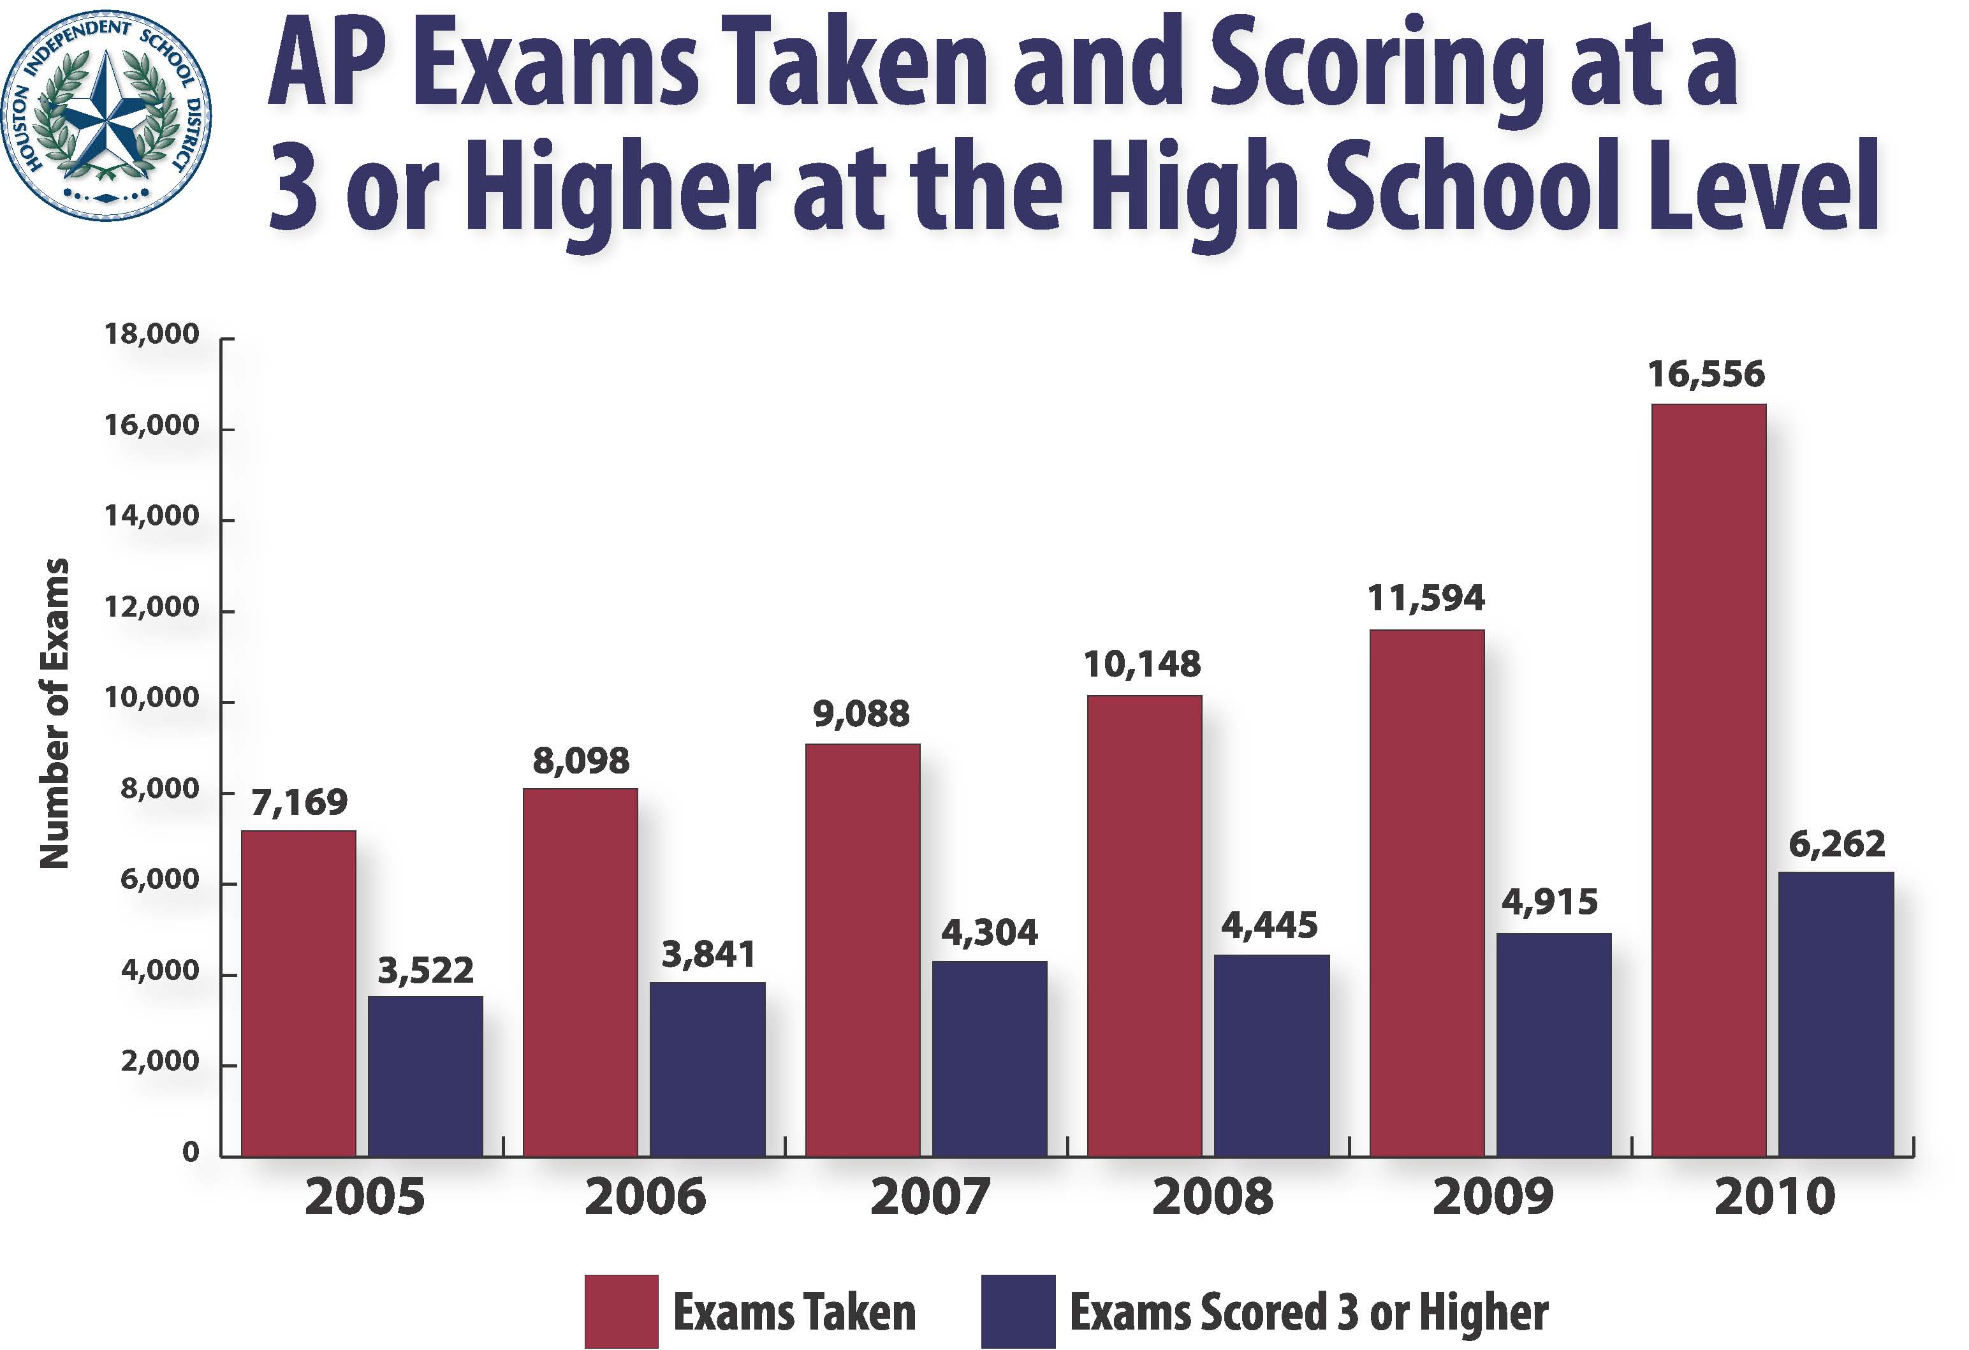

This year HISD high schools were required to provide at least 10 AP courses. Next year, the minimum requirement rises to 15 AP courses. The district is also requiring AP students to take AP tests. This year the district began picking up the cost of AP tests.
The High School Challenge is compiled by taking the total number of AP tests, International Baccalaureate tests, and Cambridge tests taken by all students at a school and dividing by the number of graduating seniors. Click here to see the entire list.

The Houston Independent School District is the largest school district in Texas and the seventh-largest in the United States with 298 schools and more than 200,000 students. The 301-square-mile district is one of the largest employers in the Houston metropolitan area with nearly 30,000 employees.
For more information, visit the HISD Web site at www.houstonisd.org.

