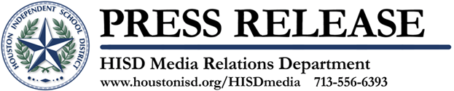

Two More HISD Campuses Offering International Baccalaureate Programs
Hogg Middle and Reagan High schools celebrate IB authorization

July 18, 2013 – Reagan High School and Hogg Middle School are the two latest HISD campuses to receive official authorization to operate as International Baccalaureate World Schools bringing the district’s total to 12campuses.
The addition of IB programs at Hogg and Reagan creates the first continuous IB feeder pattern in the historic Heights neighborhood. Students now can begin the IB Primary Years Programme (PYP) at Harvard Elementary and then progress to Hogg Middle School and Reagan High School for the IB Middle Years Programme (MYP).
“Building this continuum has been in the works for many years and has involved the support and dedication from Reagan and Hogg staff, parents, district leaders, and the Heights community,” said Reagan High School Principal Connie Berger.
Founded in 1968, IB is a non-profit foundation that offers challenging educational programs for students aged 3 to 19 to help develop their intellectual, personal, emotional, and social skills to live, learn and work in a rapidly globalizing world.
“Implementing the program required changing the culture of our entire school community to ensure that all instruction on campus is student centered with a focus on international-mindedness,” said Hogg Middle School Principal Mina Schnitta. “Our teachers and support staff have worked extremely hard to achieve this honor, which will ultimately benefit our students, parents, and the entire Heights community.”
To achieve IB authorization schools must complete two extensive applications and prepare for an onsite authorization visit, similar to an audit, from an IB-certified team. During the process, schools are responsible for training teachers to understand the program and implement the framework. Typically, the average school takes about three years to become authorized.
The other HISD campuses authorized to offer IB programs are: Harvard, Northline, River Oaks, Roberts, and Twain elementary schools, Lanier, Fondren, and Grady middle schools and Lamar and Bellaire high schools. Nine other HISD schools are in the “candidate” phase, or the process of achieving authorization. They are Briargrove, Briarmeadow Charter, Durham, Herrera, Poe, Rodriguez, Rusk, the School at St. George Place, and Wharton.

The Houston Independent School District is the largest school district in Texas and the seventh-largest in the United States with 276 schools and more than 203,000 students. The 301-square-mile district is one of the largest employers in the Houston metropolitan area with nearly 30,000 employees.
For more information, visit the HISD Web site at www.houstonisd.org.


Click here to Tweet this

