Name: ___________________________________________________ Class Number: _____
Periods: _______________ Date DUE: ________________

STUDENTS: First, PREVIEW the selection. CIRCLE the words you do not know. Second, READ THE SELECTION ON THE REVERSE OUT LOUD TO A PARENT,
Third, ANSWER THE QUESTIONS BELOW. Be sure to CHECK YOUR ANSWERS (√ Class Web Page)

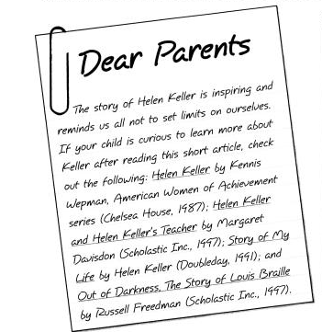 | Reading Skills  - ELA.RC.6A Establish purposes for reading selected texts based upon own or others’ desired outcome to enhance comprehension.  - ELA.6.1A and C Adjust fluency (rate, accuracy, expression, appropriate phrasing) when reading aloud grade-level text based on the reading purpose and the nature of the text (e.g., using background knowledge; visualizing; rereading a portion aloud; generating questions).  - Ⓡ ELA.6.10A Summarize the main ideas and supporting details in text, demonstrating an understanding that a summary does not include opinions.  Tip of the Week  As your child reads this week, try not to correct mispronunciations, omitted or added words, etc. Instead, see if your child is actually “listening to herself” read. If so, he will hear that what he has just read doesn’t make sense and self-correct without prompting. If you note that your child is not hearing the error, please let me know. The biggest issue here is helping your child be engaged in the reading, to listen to herself, and to realize that all reading makes sense.

THIS WEEK’S QUESTIONS

Part 1 -- VOCABULARY: The word bleak in paragraph two means_________________________. The context words that help you determine the word’s meaning are: ____________________________.

Part 2:First, write TEN FACTS about Helen Keller on the lines below. You do not have to write in complete sentences.

- _______________________________________  ___________________________________________ | - _______________________________________  ___________________________________________
- _______________________________________  ___________________________________________ | - _______________________________________  ___________________________________________
- _______________________________________  ___________________________________________ | - _______________________________________  ___________________________________________
- _______________________________________  ___________________________________________ | - _______________________________________  ___________________________________________
- _______________________________________  ___________________________________________ | - _______________________________________  ___________________________________________

Now that you have listed your TEN FACTS about Helen Keller, CIRCLE the number of each of the THREE FACTS that you think are the most important ones that someone would need to know if they had never heard of this remarkable lady. These are the MAIN IDEAS of the article. All of the rest of the facts you have listed are SUPPORTING DETAILS.

REMEMBER THAT ACTIVE READERS SET A PURPOSE FOR THEIR READING. Your PURPOSE for this reading is to be able to point out IMPORTANT FACTS about Helen Keller.

Remember – you are reading this OUT LOUD to a parent.
Please pay attention to your reading rate and expression.

