

LOVETT ELEMENTARY SCHOOL
HOUSTON INDEPENDENT SCHOOL DISTRICT
SDMC MEETING AGENDA
April 15, 2021

Introductions of members

Proposed Meeting Times/Dates: 3rd Thursday in September, October, November, January, February, March, and April, May

General Updates
- Enrollment projections for 21-22 is 670 including pre-k; requested increase from 650
  - Current f2f enrollment: 393 (increase of 32 students)
  - Currently 479 students in person

Budget Overview and Discussion
- $130 Reduction in per pupil funding
- Magnet Funding is being discussed and you will start to hear conversations around phasing out and not providing magnet funding. Fine Arts magnets however will still be funded.
- Currently we two positions not funded (clerk, PE)
  - Will need to look at possible hourly support for clerical position if remains unfunded
  - Will need to potentially change our PE rotation to once/week; this has other implications such as the need to add another rotation into ancillary time
- Other impact may include reducing # of students we serve for intervention, no budget for extra duty pay for teachers, general supply funds minimal, No PD funds

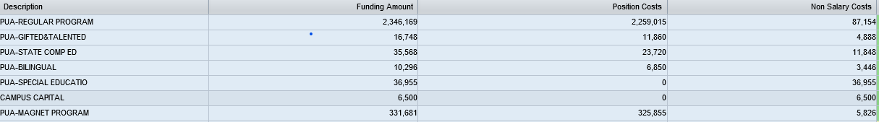

STARR Testing
- May 11-15
- Grades 3-5
- TEA has provided districts with waivers to conduct asynchronous instruction for certain grades based on the number of personnel and space need to keep safety protocols in place. Waivers on our campus will potentially impact K-2 classrooms
- Will communicate plan to parents on Friday April 16th newsletter

SIP 20-21
- From October to May 2021, teachers will participate in four professional development sessions related to differentiating for learners to help ALL learners meet rigorous standards.

- In the 20-21 school year, the percentage of students scoring at the master's level on STAAR Math will increase from 49% to 54%

- In the 20-21 school year students will show at least one year's worth of growth on STAAR Reading, increasing accountability points in Domain 2 from 77 in reading to 87 and increasing students scoring at the master's level from 42% to 47%

- During the 20-21 School Year, Lovett will develop a new section of our Lovett website dedicated to online learning

- Measured by monthly attendance rates and EOY average attendance rates.

- In the 20-21 school year, the percentage of students receiving an "Outstanding" award will increase from 85% in 2019-2020 to 100% in 2020-2021.

- In the 20-21 school year, Lovett will stablish baseline data to identify the percentage of students reporting a bullying incident in a 30-day period and the percentage of those bullying incidents that are accurate in being described as bullying

- At least 50% of English Language Learners in grades 1-5 will progress at least one proficiency level on their TELPAS Composite Rating

