Charles H. Milby H.S. Communication Applications  | It takes two to speak truth, one to speak and another to hear. --Henry David Thoreau

Valkeith D. Winters Rm.130
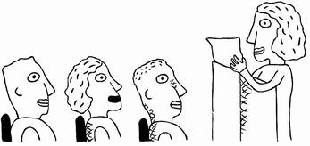
Course Description
The Communication Applications course is a semester long class designed to help students develop effective communication skills. Some of these skills include but are not limited to: public speaking, nonverbal behavior, electronic communication, writing and listening. Students enrolled in Communication Applications will be expected to identify, analyze, develop, and evaluate communication skills needed for professional and social success in interpersonal situations, group interactions, and personal and professional presentations.
Materials Needed
Binder or folder for class notes, handouts, assignments, etc.
Paper. This may be notebook or spiral paper.
Pen or pencil
Communication Applications textbook — Class Room Set
Areas of Study
Communication Process
Interpersonal Communication
Refining speaking skills
Group Communication
Corporate Culture
Propaganda Techniques
Electronic Media
Film
Major Projects and Presentations
Group News Cast
Informative presentation
Persuasive presentation
Non-Verbal Group presentation
How to presentation (Food Dish)
Music Video
Short Film

