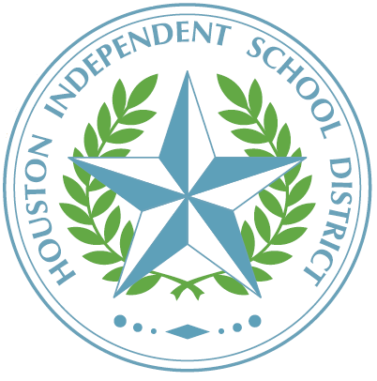 | Tanglewood Middle School  An International Baccalaureate World School  5215 San Felipe Street  Houston, Texas 77056
TITLE I, PART A, PARENT AND FAMILY ENGAGEMENT PROGRAM

October 2023

TO: Parents of Students Tanglewood Middle School

SUBJECT: 2023–2024 TITLE I STATUS NOTIFICATION

This is to inform you that Tanglewood Middle School is a schoolwide Title I, Part A campus, and as a parent, you have the right to be involved in the planning, review, and improvement of the Title I program.

Title I, Part A, is a federally funded program that provides resources and opportunities to improve the academic achievement of economically disadvantaged students. Title I ensures that all children have a fair, equal, and significant opportunity to obtain a high-quality education based on the Texas Essential Knowledge and Skills (TEKS) and reach, at a minimum, proficiency on the State of Texas Assessments of Academic Readiness (STAAR).

Under the Every Student Succeeds Act (ESSA), Title I funds enable schools to employ and train highly qualified teachers and paraprofessionals, purchase instructional materials, update technology in the classroom, and sponsor parental involvement activities. To increase student academic achievement, Title I funds supplement various academic programs offered at Tanglewood Middle School:

- Credit Recovery
- Interventions
- Professional Development
- Parenting Support
- Social Emotional Education

If you have any questions regarding this information, please contact Monica Narvaez at 713-625-1411 or email at mnarvae1@houstonisd.org for the Title I contact person at your campus.

Sincerely,

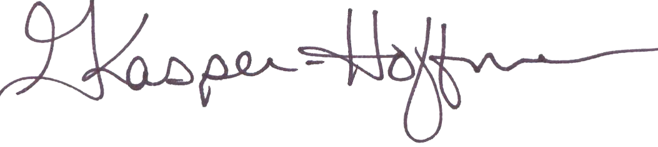
Gretchen Kasper-Hoffman, Principal

