Writing content for the web
Use Bulleted lists
Using bulleted lists allows you to highlight important information and make it stand out from the rest of your text without being too wordy.
One exception: Avoid using bulleted lists if the information contained is made up of long sentences or many sentences. Then it’s best to use paragraph form.

Keep it short
Users rarely read web pages the way they do books and other forms of printed materials. They scan to search for individual phrases and keywords. One study found that 79 percent of the test users always scanned any new page they came across; only 16 percent read word-by-word.
There are exceptions to this rule. In some instances, it may be necessary to write longer entries, but a good standard for one of our regular blog entries is about 6-8 paragraphs.

Try the inverted pyramid method
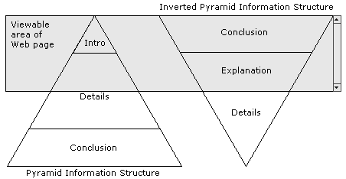
We’re taught to write background info that gradually builds to a conclusion and summary. For the web, the reverse is true. The most relevant info should be at the top, with background info at the bottom. Content “above the fold” (the area of a webpage that is visible without scrolling) is the most prominent reading area, and as such is where the meat of your story should reside. As the chart below shows, users spend 80.3 % of their time in the upper half of a webpage.
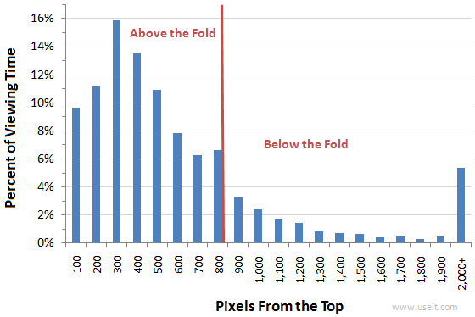

Use hyperlinks
Providing SEO-friendly hyperlinks (using keywords as a part of the link) is an effective means of leading readers to expanded internal content.
Self-edit your posts
It is important to read your blog entry after you have saved the draft but before you have posted it. Look for not only grammatical and spelling errors, but story flow and the Who?What?When?Where? of the post.
Use single quotes in headlines
When using quotation marks in a headline they are ALWAYS single quote marks. Examples: Chavez High School Students Achieve ‘Complete Success’ at Texas Mile or ‘Teach Like A Champion’ Author Gains Insight from HISD Middle Schools

Don’t bury the lead
Is your story about teachers taking part in specialized training in New York? Then that information should be at the top of the post, not behind three paragraphs of quotes. Remember – web readers want the meat of the story up front.
And speaking of quotes – don’t overuse them
When you overuse quotes, you are suggesting to your reader that you don’t really understand the material and are just copying it directly from the source. Consider paraphrasing or summarizing the material. Use quotes when:
- you can’t paraphrase or summarize without fear of changing the author’s intent
- you can’t paraphrase or summarize concisely
- You need to lend expert authority for an assertion in the material. For instance, a quote from Dr. Grier to backup an article about the Effective Teachers Initiative.
Flow
Paragraphs should flow from one to the next. Disparate paragraphs need a connector, so the story doesn’t become just a list or sequence of events.

DIFFERENCES IN WEB CONTENT VS. PRINT/TV CONTENT
PRINT (& TV) | WEB
Passive audience: The audience lets you lead them through a predefined experience . | Active audience: Web users create their own unique experience by constructing their own path in and around your site.
Pre-defined narrative: Print stories start out with a goal in mind (example: telling the story of a kitten in a tree leading to dramatic rescue). | User-driven narrative: Web stories weave various components (video, related stories, audio) to build the narrative. Users can then choose how they experience the article.
Information-oriented: Users can read in a chronological, Intro→Body→Conclusion format. Stories are in long-form. | Task-oriented: Web users typically go to websites to “do” something. One study found that “users do not navigate on these sites searching for information, but rather interact with an online application to complete certain tasks.” They want actionable content (here’s how you can contribute, here’s where to find info about this event etc).
Print stories contain:  Formal language  Longer text  “Clever” headlines  Linear storyline | Web stories contain:  More bulleted lists  Less formal language  Concise text  Meaningful headlines

For more information:
- Stanford University/Poynter Institute eye tracking studies
- How Users read on the Web
- Web writing best practices

