**[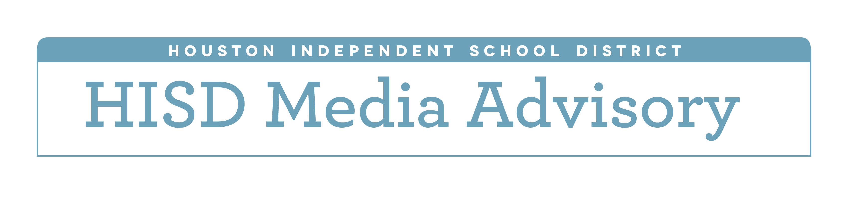](http://www.houstonisd.org/HISDmedia) HISD students receive free bikes for**

**achieving their literacy goals**

|  |  |
| --- | --- |
| **What:** | Hundreds of Houston Independent School District elementary students will be awarded bicycles for achieving their reading goals for the semester.  CYCLE, (Changing Young Children’s Lives through Education) a local charity, provides free bicycles to kindergarten through third-grade students attending high-poverty schools in the greater Houston area.  In an effort to improve literacy, CYCLE gives students the opportunity to earn a bicycle if they meet the literacy goals given to them by their teachers.  This year, five HISD schools were chosen by CYCLE to be awarded bicycles. The organization will hand out 1,800 bikes to HISD students on Saturday, Dec. 10. The generous donations are made possible thanks to Lyondellbasell, ExxonMobil and Newfield Foundation. |
| **Who:** | HISD students and administrators and CYCLE Executive Director **Rebecca Roberts** |
| **When:** | **Saturday, December 10, 8:30 a.m.** |
| **Where:** | Sherman Elementary  1909 McKee St., 77002  Burnett Elementary  5403 Canal St., 77011  Crespo Elementary  7500 Office City Dr., 77012  Benbrook Elementary  4026 Bolin Rd., 77092  Neff Early Learning Center  8200 Carvel Ln., 77036 |