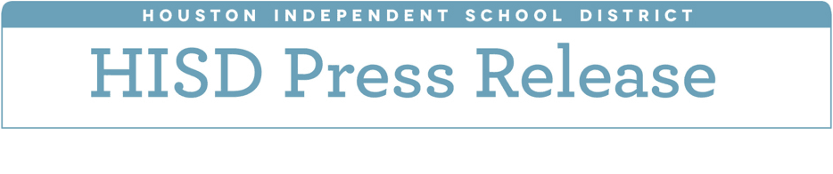

**HISD Board of Education will not vote on partnership for “Improvement Required” campuses**

*HISD will not submit any plans to the Texas Education Agency related to SB 1882*

*April 25, 2018 -* The Houston Independent School District Board of Education on Tuesday adjourned without approving a contract to partner with the governing board of Energized for STEM Academy as part of Senate Bill 1882. The district will no longer pursue this proposal, nor will the district submit plans for partnerships to the TEA.

The proposal was intended to give HISD a two–year pause on accountability from the Texas Education Agency (TEA) and prevent sanctions from the state related to House Bill 1842.

HISD will continue to operate and manage the 10 campuses that have been in Improvement Required (IR) status with the state for four years or more. Those campuses are: Blackshear, Dogan, Highland Heights, Mading, and Wesley elementary schools, Henry Middle School, Woodson PK-8, and Kashmere, Wheatley, and Worthing high schools. The district’s goal is to help these 10 schools exit IR and continue to meet yearly standards.

“We are not bringing another partnership proposal to the Board, nor will there be another meeting to consider partnerships for the 10 schools,” said Interim Superintendent Grenita Lathan. “Instead, we will continue to reinforce our commitment to helping students, staff, and families of our Achieve 180 schools continue the hard work they’ve done this year to transform their campuses and increase student achievement.”

HISD will make the necessary changes to the Achieve 180 framework to ensure the district provides them with the additional resources and supports they need to be successful. District administration will be holding meetings with staff and parents at these 10 schools to discuss Achieve 180 plans for their campuses in the 2018-2019 school year. Staff will remain in place at these 10 campuses unless a position is closed as part of the reduction in force HISD is experiencing across the district due to the $115 million budget shortfall.