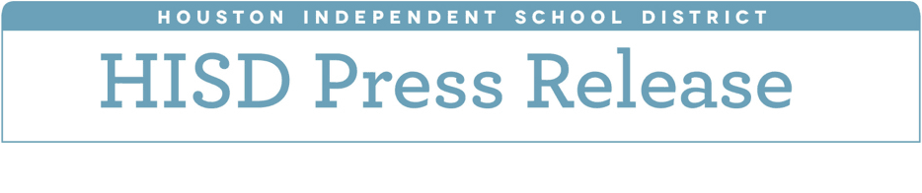

**High marks for HISD in U.S. News & World Report’s Best High Schools Rankings**

*May 11, 2018* – Carnegie Vanguard High School has been ranked as the 15th best high school in the country and fourth best in Texas, according to the U.S. News & World Report’s 2018 Best High Schools rankings.

Three additional Houston Independent School District schools were ranked in the top 100 nationally — DeBakey High School for Health Professions  was ranked 38th, Eastwood Academy was ranked 56th, and Challenge Early College High School  was ranked 91st. In statewide rankings, DeBakey ranked seventh, Eastwood ranked 11th, and Challenge ranked 15th.

The U.S. News & World Report rankings are designed to identify great high schools that serve all students — no matter their socioeconomic status. The list is determined by looking at results from state assessments, as well as the degree to which students at each school are prepared for college-level work. Graduation rates were also included as a factor in the rankings.

A total of 21 HISD schools were included on the 2018 list, which recognized nearly 6,000 top public high schools from across the country. Eight received Gold Medal Designations, indicating the greatest level of college readiness. Nine received Silver Medal Designations, and four received Bronze Medal Designations.

“This kind of recognition on a national level is a testament to HISD’s commitment to prepare our students to succeed after graduation - whether they go into a career or college,” Interim Superintendent Grenita Lathan said. “We’re elated to see several of our schools rose significantly on the list. That shows we’re doing something right on our campuses.”

Eighteen of these schools also were included on the U.S. News & World Report lists for Best Magnet, Charter, and STEM (Science, Technology, Engineering and Math) schools. Carnegie Vanguard secured a fifth-place spot on the Best Magnet Schools list. DeBakey earned a ninth-place spot on the Best Magnet Schools list and a 10th-place spot on the list of Best STEM Schools. Eastwood took home 20th place on the Best Charter Schools list.

The complete list of rankings is available at <https://www.usnews.com/education/best-high-schools/rankings-overview>. HISD high schools included in rankings are listed below.

2018 Best High Schools List – HISD high schools

**Gold Medal Designations**

Carnegie Vanguard High School (U.S. rank: 15; Texas rank: 4; Magnet: 5; STEM: 199)

DeBakey High School for Health Professions (U.S. rank: 38; Texas: 7; Magnet: 9; STEM: 10)

Eastwood Academy (U.S. rank: 56; Texas: 11; Charter: 20)

Challenge Early College High School (U.S. rank: 91; Texas: 15; Magnet: 25; Charter: 30)

The High School for the Performing and Visual Arts (U.S. rank: 232; Texas: 46; Magnet: 54)

North Houston Early College High School (U.S. rank: 311; Texas: 52; Magnet: 63; Charter: 95)

East Early College High School (U.S. rank: 315; Texas: 53; Magnet: 64; Charter: 97)

Energized for STEM Academy West High School (U.S. rank: 372; Texas: 61; Charter: 106)

**Silver Medal Designations**

Young Women’s College Preparatory Academy (U.S. rank: 609; Texas: 85; Magnet: 98)

Sharpstown International School (U.S. rank: 615; Texas: 87; Magnet: 99)

Bellaire High School (U.S. rank: 655; Texas: 92; Magnet: 103)

Houston Academy for International Studies (U.S. rank: 736; Texas: 98; Magnet: 108; Charter: 159)

Westside High School (U.S. rank: 838; Texas: 106; Magnet: 121)

High School for Law & Justice (U.S. rank: 1,173; Texas: 137; Magnet: 157)

Heights (formerly Reagan) High School: (U.S. rank: 2,081; Texas: 188; Magnet: 262)

Mount Carmel Academy (U.S. rank: 2,306; Texas: 207; Charter: 290)

South Early College High School (U.S. rank: 2,515; Texas: 216; Magnet: 292)

**Bronze Medal Designations**

Energized for STEM Academy Central High School (U.S. rank: Recognized; Texas: Recognized)

Energy Institute High School (U.S. rank: Recognized; Texas: Recognized)

Long Academy (U.S. rank: Recognized; Texas: Recognized)

Mickey Leland College Preparatory Academy (U.S. rank: Recognized; Texas: Recognized)