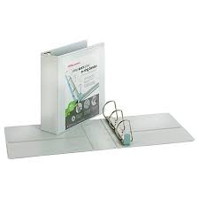2- Large 3-Ring Binder with plastic cover

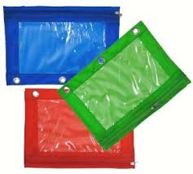1- Soft pencil pouch with holes

2-12pk #2 Pencils

2-Box of Tissues

4- Glue Sticks

2- Bottles of glue

1- Pair of scissors

1- Pack of Colored pencils

1- Pack of markers

1- Pack of 24ct Crayons

2- Bottles of Hand Sanitizer

1- Pack of erasers

1. Ruler

3- 3rd Grade Writing Spiral tablets

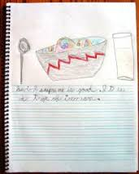 1 Writing Journal (blank at the top)