**ELA Choice Board #6 *Directions:* Students please complete the activities from ELA/Social Studies board in the order that you prefer. Submit evidence of completion by May 22, 2020 on Google Class or Class Dojo.**

|  |  |  |
| --- | --- | --- |
| **#1 Vocabulary**  **Select a text to read.** [**www.storyonline.com**](http://www.storyonline.com)  **Today you will use clues to figure out words you do not know.**  **Read the tip below to know how to use clues to help you think about what to do when you find a word that you do not know. Now use the chart below to show your understanding of the word** | **#2.**  **Writing**  **READ the information below.**  “**A family doesn’t need to be perfect; it just needs to be united. “ –Anonymous**  **THINK about the importance of family in your life.**  **WRITE about how the importance of family. Explain what makes your family important.**  **Be sure to ― • clearly state your central idea • include details to support your central idea • organize your writing • choose your words carefully • use correct spelling, capitalization, punctuation, grammar and sentences** | **#3.**  **Social Studies**  **Inventors are Heroes**  **See: Describe what you see in the picture.**  **Think: Where was this picture taken? Wonder: What questions do you have?**  **Be a hero to your parent. Clean your room.** |
| **#4. Social Studies**  **Inventors are Heroes**  **Read:**  **Hero is a powerful word. It makes you think of courage, honor, and being smart. Anyone can be a hero – even you. Heroes believe in helping others.**  **Helping Others:**  **Be a hero to your parent. Wash the dishes**.  **Help mom fold the clothes.**  **Help your younger sister or brother with homework.** | **#5 Free Space**  **FREE FUN SPACE**  Education Back To School Clipart Clipartix_clipartix | **#6. Imagine Reading**  **The student will engage with Imagine Learning platform for 45 minutes every day.** |
| **#7** **What’s the Central Idea?**  **Today you will find the central idea of your text.**  **Read the tip below in Problem Solving #7 to understand how to use the topic and evidence to find the central idea.**  **As you read, use the following questions to help you think about the central idea of your selection:**  **What is the topic?**  **What the text is mostly about?**  **What facts and details help me find the central idea?**  **Read the text below and underline details and facts that support the topic and central idea.**  **Be sure to write the topic and central idea in the spaces below. •** | **#8. Make Inferences About Text**  **Today you will make inferences about the text you read.**  **Read the tip on the right to understand how to use clues from the book and what you already know to make an inference.**  **Read the text below in Strategies to Solve the Problems #8 and underline the clues that support your inference.**  **Ask yourself:**  **What clues can I find to support my inference?**  **Do my clues match my inference?**  **Does my inference make sense?** | |
| **#9.**   **Cause and Effect**  **Today you will find the cause and effect of your text.**  **Read the tip on the right to understand how to find the cause and effect.**  **Use the following questions to help you think about the cause and effect as you read:**  **What happened?**  **Why did this happen?**  **Use the chart below to write about cause and effect relationships you found as you read.** |  | |

***Use these Strategies to help you Solve the Problems for ELA Above***

***Problem #1Vocabulary Building***

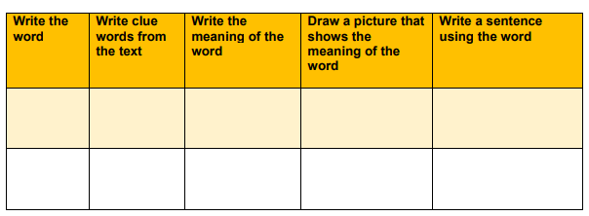

***Problem #7 Central Idea***

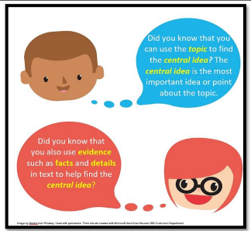

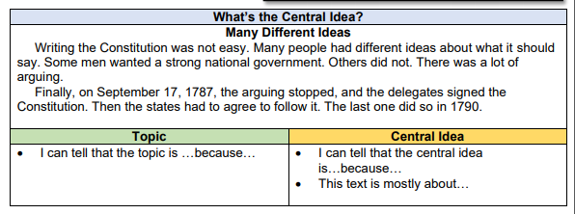

**Problem #8 Inference**

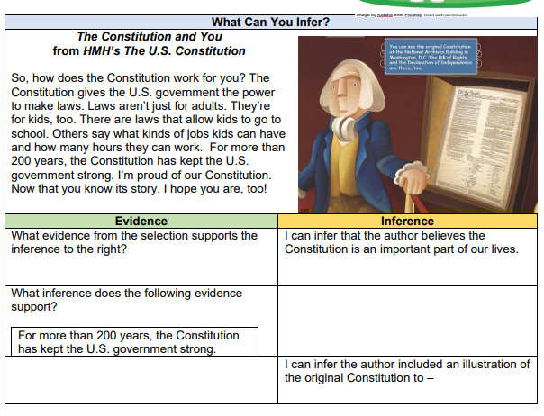

**Problem #9 Cause and Effect**

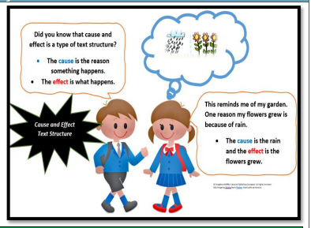

Name \_\_\_\_\_\_\_\_\_\_\_\_\_\_\_\_\_\_\_\_\_\_\_\_\_ **MATH Choice Board**

***Directions:* Students please complete the activities from MATH board in the order that you prefer. Submit evidence of completion by May 22, 2020 on Google Class or Class Dojo.**

|  |  |  |
| --- | --- | --- |
| **#1 3- Dimensional Figures**  **I can classify 3- dimensional figures by their attributes. MATH.3.6B**  **Find the missing side in the given polygons using the known perimeter and sides.** | **#2 3- Dimensional Figures**  **Joe created the bird house below. He has 78 inches of wood that can build the perimeter of the bird house. Find the missing length of the unknown side of the bird house.** | **#3 3- Dimensional Figures**  **The perimeter of the rectangle is 46 feet. The length of the rectangle is 13 feet. Using this information, find the width of the rectangle**.  **Width = \_\_\_\_\_\_\_** |
| **#4 Word Problem**  **Dot Plot – A graph that uses dots to show how data is clustered Frequency Table: A table that shows how often an item, a number, or a range of numbers occurs (tallies and counts are used to record frequencies) Tally Chart: A graph that uses tally marks to represent a group of observations** | **#5 FREE FUN SPACE**    **Any Activity you want Ms. Joseph to See** **on Class Dojo** | **#6 Imagine Math**  **Do Imagine Math for at least 45 minutes.** |
| **#7 Graphs**  **Data – A collection of information Tally Chart – A graph that uses tally marks to represent a group of observations**  **Bar Graph – A graph that uses bars to represent data**  **Pictograph - A graph that uses pictures to show comparisons between categories of data**  **The 3rd grade students at Willow Elementary did a survey to see the student’s favorite pets. Below is a tally chart of the data collected of the favorite pets the students chose.**  **Create a bar graph and pictograph using the data from the tally chart. Use the handout to help in creating a both graphs.**  **Answer the following questions after creating your graphs.**  **1. How many students were there total? \_\_\_\_\_\_\_\_\_\_\_\_\_\_\_\_\_\_\_\_\_\_\_\_\_\_\_\_\_**  **2. Which two pets were the least favorite? \_\_\_\_\_\_\_\_\_\_\_\_\_\_\_\_\_\_\_\_\_\_\_\_\_\_\_\_**  **3. Which two pets were the most favorite?** \_\_\_\_\_\_\_\_\_\_\_\_\_\_\_\_\_\_\_\_\_\_\_\_\_\_\_\_ | **#8 I can find the Area of a Rectangle**  **Area: The number of square units that cover the inside of a determined space Rectangles: A two-dimensional shape with 4 sides and 4 vertices; opposite sides are equal in length; all angles are congruent** | |
| **#9 Science Create a Poster**  **Objective: Create a poster for your family about conservation of resources.**  **Think About It! What are different ways to conserve resources? What are the 3 R’s? Reuse, Recycle, Reduce If you can, discuss these questions and share your thinking with someone in your home! Do It!**  **What you need: • Science notebook /Paper • Pencil • Crayons, markers, or color pencils, if available. • Reusable cardboard or resource that you can use to create a poster. • Items that you can reuse to create your poster. What to do: • Create a poster to share with your family about the importance of Conserving Resources: Reduce, Reuse, and Recycle! • Give your poster a “catchy” title to attract your family’s attention. • Reuse materials that you have in your home to design and decorate your poster. • Draw pictures to show examples of conserving resources**  **Understand It! • Present your poster to your family. Discuss what you know about the 3 R’s: Reduce, Reuse, Recycle! • Give examples of ways to reduce the amount of resources you use in your home. • Give examples of ways to reuse items to use them in another way. • Give examples of ways to recycle resources in the recycle bin, so these resources can be broken down and be made into something new. • Ask your family where everyone can place resources to be recycled in your home. Apply It!**  **Journal Entry:**  **After presenting your poster to your family, write a reflection in your science notebook. What did you learn about conservation after presenting your poster? What did you learn from someone in your family about conservation? How will you and your family conserve resources in your home?**  **I learned \_\_\_\_\_\_\_\_\_\_\_\_\_\_\_\_\_\_\_\_\_\_\_\_\_\_\_\_ about conservation of resources. I learned \_\_\_\_\_\_\_\_\_\_\_\_\_\_\_\_\_\_\_\_\_\_\_\_\_\_\_\_\_\_\_\_ about conservation from \_\_\_\_\_\_\_\_\_\_\_\_\_\_\_\_\_\_\_\_\_. My family and I will \_\_\_\_\_\_\_\_\_\_\_\_\_\_\_\_\_\_\_\_\_\_\_\_\_\_\_\_\_\_\_\_ to conserve resources in our home.** | | |

***Use these Strategies to help you Solve the Problems for Math/Science Above***

**Problem # 7 Bar Graph**

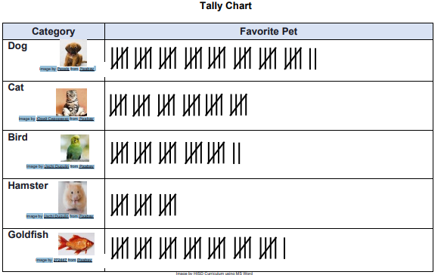

**Problem # 4 Tally and Frequency Graph**

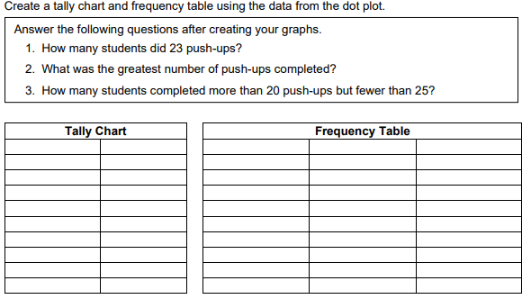

**Science Problem #9 Use this as an Example to Create your poster to show your family**

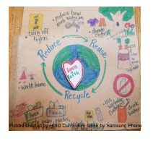

## **Project: Due May 22, 2020 Activity 1.) When Pigasso Met Mootisse**

**Activity:** **HENRI MATISSE: Drawing with scissors – Matisse style!**  
**PROCEDURE --**(Students should not draw the shapes. Instruct them to use scissors only)  
**Directions: Step 1:**Have students cut out simple geometric shapes using different colored paper (squares, rectangles, triangles). They will need to have enough cut outs to cover the large art paper.  
**Step 2:**Glue the shapes on the art paper, overlapping and leaving gaps.  
**Step 3:**Cut out more intricate shapes on the colored paper, such as hearts, lightning bolts, letters, etc.  
**Step 4:**Glue these shapes on top of the layer of geometric shapes.

RESOURCE: [www.storyonline.com](http://www.storyonline.com)

Hey Little Musicians!!!

Ms. Timmons has found some fun videos for you to sing and dance to today! Click these links to clap and sing along! (Grades PK and K)

Patty Shukla “Germs”

<https://youtu.be/jPpBrBd4s58>

Patty Shukla “Are you Sleeping”

<https://youtu.be/OrF6VjGHJK8>

Patty Shukla “Simon Says Song”

<https://youtu.be/OkO8DaPIyXo>

Parents, here’s a great website for fun activities that link classical music with guided body movements. [www.gonoodle.com](http://www.gonoodle.com). It’s a quick, free registration and your kiddos will tell you which ones they like to play from Ms. T’s Music Class!

For grades 1-5, check out Clever.com to login to Quaver’s Marvelous World of Music. Make sure you select the option “Without Flash,” and follow the prompts for this week’s lesson! “4th” be with you!

Keep singing!

Ms. T.