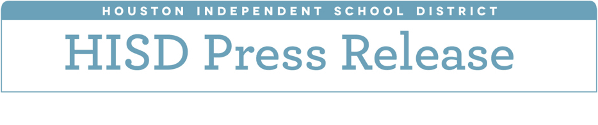

**Award-winning artwork to be displayed during annual HISD Visual Arts Spring Showcase**

*May 15, 2018 -* Student artwork lines the hallways of HISD’s Hattie Mae White Educational Support Center for the 2018 Visual Arts Spring Showcase. This is eighth year of the showcase, and it’s the largest to date, with more than 700 pieces of art from Pre-K through 12th grade.

“This has been a pinnacle year for the visual arts of HISD,” visual arts curriculum specialist Rickey Polidore said. “We created this year’s curriculum with hopes that we would highlight the effect visual arts has on student achievement.”

This was the first year of the visual arts curriculum department, which is under the umbrella of the district-wide Fine Arts department that was also established this school year. Under the leadership of this department, HISD student artwork has won awards at the Art Car Parade, received the Houston Livestock Show and Rodeo Art Contest Super Show Award for the first time in district history, and been chosen as the exclusive artwork of the new wing of Texas Children’s Hospital.

“We are excited to see the positive effects that our new Visual Arts Curriculum has had on campus culture and teacher identity,” Polidore said. “We created this year’s curriculum with the goal of highlighting the positive effects of visual arts instruction on student achievement and efficacy. The quality of this year’s work emphasizes the achievement of our intent to saturate campuses with quality visual arts instruction.”

The art has been on display at the Hattie Mae White Educational Support Center since April 30 and will remain until May 18. The district will host a reception for the student artists and their families on **Thursday, May 17, 2018 from 6 to 7:30 p.m.**

Interim Superintendent **Grenita Lathan** will greet the families and deliver opening remarks. The reception will also feature the Booker T. Washington High School jazz band and Westbury High School jazz ensemble.