*May 23, 2016—* The Harris County District Attorney’s Office has accepted criminal charges against a Sharpstown High School tutor following an HISD Police investigation into reports that he engaged in an inappropriate relationship with a student.

Aldo Leiva, 51, is facing a felony charge of sexual performance by a child and possession of child pornography. A criminal warrant was issued Friday, and he is expected to soon be taken into custody.

The allegations of inappropriate conduct were first reported in February. School administrators immediately notified HISD Police.  Mr. Leiva resigned when he was made aware of the allegations.

HISD Police conducted a thorough investigation and presented the findings to the District Attorney’s Office. The charges were accepted and a warrant was issued Friday.

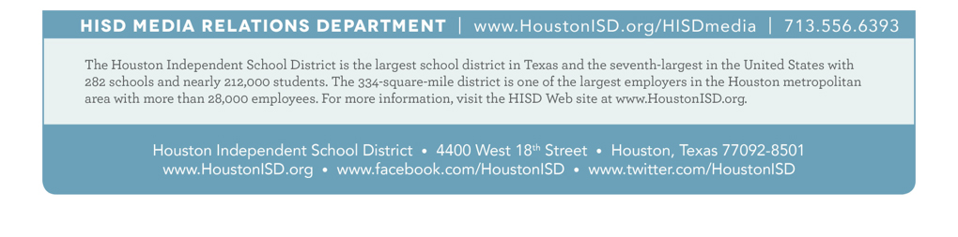HISD takes situations such as this very seriously, as the safety of students is always the district’s top priority. 