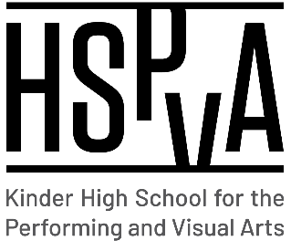

Kinder High School for the Performing and Visual Arts

Shared Decision-Making Committee (SDMC)

Wednesday, April 27, 2022

**AGENDA**

1. Call to Order
2. Welcome
3. Approve minutes from previous SDMC meeting (March 1, 2022)

Approved

1. Approve agenda for scheduled SDMC meeting (April 27, 2022)
2. New Business

* Budget
  + Back to PUA structure. Dr. Rivas has a budget meeting on May 3 to finalize.
* Staffing Updates:
  + Looking for full-time math, full-time theatre, full-time creative writing. Already hired Band Director.
* ESSER Funds - Wraparound
  + Purchasing uniform/school shirts and club equipment
* COVID Updates
  + Covid cases rising slightly

1. Q&A
2. Adjourn

**Thank you for your service during the 2021-2022 school year!**